|  |  |  |
| --- | --- | --- |
| **S.No** | **Function name** | **Package required** |
| 1 | reduce | from functools import reduce |
| 2 | chain | from itertools import chain |
| 3 | SparkContext() | from pyspark import SparkContext |
| 4 | SQLContext() | from pyspark.sql import SQLcontext |
| 5 | StreamListener | from tweepy.streaming import StreamListener |
| 6 | OAuthHandler | from tweepy import OAuthHandler |
| 7 | Stream | from tweepy import Stream |
| 8 | load_iris | from sklearn.datasets import load_iris |
| 9 | seaborn | import seaborn |
| 10 | LinearRegression | from sklearn.linear_model import LinearRegression |
| 11 | neighbors.KNeighborsClassifier | from sklearn import neightbors |
| 12 | SVC | from sklearn.svm import SVC |
| 13 | RandomForestRegressor | from sklearn.ensemble import RandomForestRegressor |
| 14 | RandomForestClassifier | from sklearn.ensemble import RandomForestClassifier |
| 15 | loads, dumps | import pickle |
| 16 |  | from sklearn.externals import joblib |
| 17 | PCA | from sklearn.decomposition import PCA |
| 18 | Kmeans | from sklearn.cluster import Kmeans |
| 19 | confusion_matrix | from sklearn.metrics import confusion_matrix |
| 20 | accuracy_score | from sklearn.metrics import accuracy_score |
| 21 | train_test_split | from sklearn.cross_validation import train_test_split |
| 22 | Isomap | from sklearn.manifold import Isomap |
| 23 | make_blobs | from sklearn.datasets.samples_generator import make_blobs |
| 24 | visualize_tree, plot_tree_interactive | from fig_code import visualize_tree, plot_tree_interactive |
| 25 | DecisionTreeClassifier | From sklearn.tree import DecisionTreeClassifier |
| 26 | logging | import logging |
| 27 | threading | import threading |
| 28 | auditlog | from cc_audit_log import auditlog |
| 29 | subprocess | import subprocess |
| 30 | stats | from scipy import stats |
| 31 | seaborn | import seaborn |
| 32 | make_blobs | from sklearn.datasets.samples_generator import make_blobs |
| 33 | mplot3d | from mpl_toolkits import mplot3d |
| 34 | sent_tokenize | from nltk.tokenize import sent_tokenize |
| 35 | word_tokenize | from nltk.tokenize import word_tokenize |
| 36 | wordnet | from nltk.corpus import wordnet |
| 37 | ZipFile | from zipfile import ZipFile |
| 38 | datetime | import datetime |
| 39 | LinearRegression | from sklearn.linear_model import LinearRegression |
| 40 | mean_squared_error,r2_score | from sklearn.metrics import mean_squared_error, r2_score |
| 41 | genism.models.Word2Vec | import gensim |
| 42 | sched.scheduler | import sched |
| 43 | base64.b64encode | import base64 |
| 44 | Flask,request,session,json | from flask import Flask,request,session,json |
| 45 | Response | from flask import Response |
| 46 | Statsmodels | import statsmodels |
| 47 | rcParams | from matplotlib.pylab import rcParams |
| 48 | seasonal_decompose | from statsmodels.tsa.seasonal import seasonal_decompose |
| 49 | acf,pacf | from statsmodels.tsa.stattools import acf,pacf |
| 50 | ARIMA | from statsmodels.tsa.arima_model import ARIMA |
| 51 | StandardScalar | from sklearn.preprocessing import StandardScalar |
| 52 | Sequential | from keras.models import Sequential |
| 53 | Dense | from keras.layers import Dense |
| 54 | confusion_matrix,precision_score,  recall_score,cohen_kappa_score | from sklearn.metrics import confusion_matrix, precision_score, recall_score, f1_score, cohen_kappa_score |
| 55 | StratifiedKFold | from sklearn.model_selection import StratifiedKFold |
| 56 | PorterStemmer | from nltk.stem.porter import PorterStemmer |
| 57 | WordNetLemmatizer | from nltk.stem.wordnet import WordNetLemmatizer |
| 58 | LabelEncoder | from sklearn.preprocessing import LabelEncoder |
| 59 | Tokenizer | from keras.preprocesing.text import Tokenizer |
| 60 | TSNE | From sklearn.manifold import TSNE |
| 61 | BeautifulSoup | from bs4 import BeautifulSoup |
| 62 | CountVectorizer | from sklearn.feature_extraction.text import CountVectorizer |
| 63 | TfidfVectorizer | From sklearn.feature_extraction.text import TfidfVectorizer |
| 64 | get_file | from keras.utils.data_utils import get_file |

**Must watch videos:**

<https://www.youtube.com/watch?v=F1ka6a13S9I>

**Github profiles:**

[DistrictDataLabs](https://github.com/DistrictDataLabs)/[PyCon2016](https://github.com/DistrictDataLabs/PyCon2016)

sys.getsizeof() -> returns the memory utilization of the given object

>>> import sys

>>> lst =[1,2,'sara']

>>> sys.getsizeof(lst)

48

**Difference between += and append in lists:**

A minor detail to note is the difference between the "+=" and "append" when it comes to Python lists. In many applications the two are interchangeable, but here they are not. If you are appending a list of lists to another list of lists, "append" will only append the first list; you need to use "+=" in order to join all of the lists at once.

>>> a = [[1,2,3],['sara','shalya']]

>>> b=[[4,5,6],['erere','tyty']]

>>> a.append(b)

>>> a

[[1, 2, 3], ['sara', 'shalya'], [[4, 5, 6], ['erere', 'tyty']]]

>>> a = [[1,2,3],['sara','shalya']]

>>> b=[[4,5,6],['erere','tyty']]

>>> a+=b

>>> a

[[1, 2, 3], ['sara', 'shalya'], [4, 5, 6], ['erere', 'tyty']]

**BeautifulSoup:**

from bs4 import BeautifulSoup

example = BeautifulSoup(train[“review”][0]).get_text()

print(example) 🡺 prints the text by removing html tags or markups

print("List of dropped columns:", end = " ")

Python’s print() function comes with a parameter called ‘end’. By default, the value of this parameter is ‘\n’, i.e. the new line character. You can end a print statement with any character/string using this parameter.

**LabelEncoder:**

>>> from sklearn.preprocessing import LabelEncoder

>>> encoder = LabelEncoder()

>>> encoder.fit([1,2,3,3])

LabelEncoder()

>>> encoder.classes_

array([1, 2, 3])

>>> encoder.transform([3,2])

array([2, 1], dtype=int32)

>>> encoder.inverse_transform([0,1])

array([1, 2])

>>>

>>>

>>> # it can be used for non-numerical labels tranformation

...

>>> encoder.fit(['Saranya','Shalya','Amma','Daddy'])

LabelEncoder()

>>> encoder.classes_

array(['Amma', 'Daddy', 'Saranya', 'Shalya'],

dtype='<U7')

>>> encoder.transform(['Shalya','Amma'])

array([3, 0], dtype=int32)

>>> encoder.inverse_transform([1,3])

array(['Daddy', 'Shalya'],

dtype='<U7')

**Chain rule or outside inside rule:**

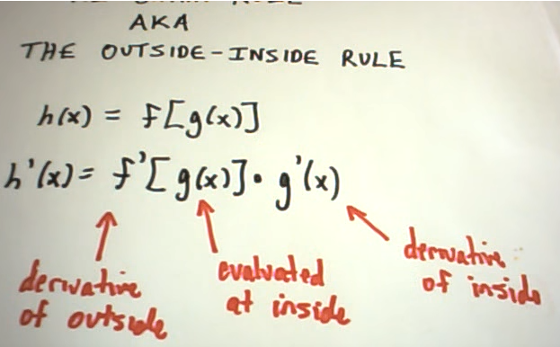

**Eg:**

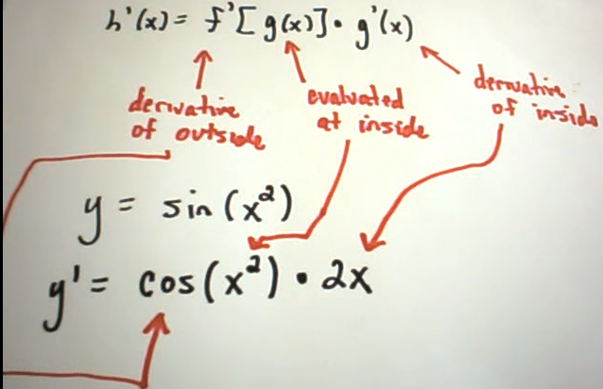

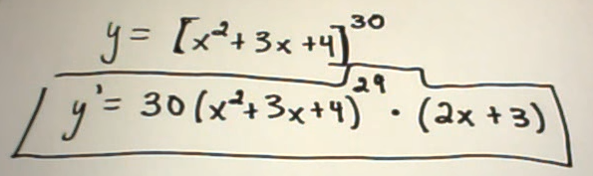

**String interpolation or .format():**

>>> print("My name is {}".format("saranya"))

My name is Saranya

>>> print("My name is {}, my number is {}".format("saranya","10"))

My name is saranya, my number is 10

>>> print("first :{x} , Second :{y}".format(x="XXX",y="YYY"))

first :XXX , Second :YYY

>>> print("first :{y} , Second :{x}".format(x="XXX",y="YYY"))

first :YYY , Second :XXX

>>> a

10.034

>>> print("Acc : {:.2f}".format(a))

Acc : 10.03

02d formats an integer (d) to a field of minimum width 2 (2), with zero-padding on the left (leading 0):

>>> print(" {:02d}".format(7))

07

>>> print(" {:02d}".format(0))

00

>>> print(" {:02d}".format(234))

234

>>> print(" {:02d}".format(2344343))

2344343

>>> print(" {:02d}".format(23))

23

**Deepcopy explanation:**

<https://www.python-course.eu/deep_copy.php>

The following script uses our example above and this method: 

from copy import deepcopy

lst1 = ['a','b',['ab','ba']]

lst2 = deepcopy(lst1)

lst2[2][1] = "d"

lst2[0] = "c";

print lst2

print lst1

If we save this script under the name of deep_copy.py and if we call the script with "python deep_copy.py", we will receive the following output:

$ python deep_copy.py

['c', 'b', ['ab', 'd']]

['a', 'b', ['ab', 'ba']]

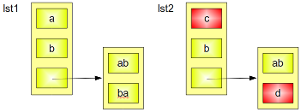

**random.shuffle():**

>>> from random import shuffle

>>> x = [i for i in range(10)]

>>> x

[0, 1, 2, 3, 4, 5, 6, 7, 8, 9]

>>> x = [[i] for i in range(10)]

>>> x

[[0], [1], [2], [3], [4], [5], [6], [7], [8], [9]]

>>> shuffle(x)

>>> x

[[5], [1], [3], [0], [6], [4], [8], [7], [9], [2]]

>>> x

[[5], [1], [3], [0], [6], [4], [8], [7], [9], [2]]

>>> shuffle(x)

>>> x

[[3], [4], [7], [0], [8], [9], [5], [6], [2], [1]]

>>> x

[[3], [4], [7], [0], [8], [9], [5], [6], [2], [1]]

>>>

**Difference between descriptive, predictive and prescriptive analysis:**

The purpose of descriptive analytics is to basically summarize or turn data into relevant information; in other words, to summarize what has occurred. In past tense, this has some meaningful impact but won’t be used to forecast. Over 80% of business analytics are descriptive.

Predictive analytics get much more complex. It involves utilizing a variety of statistical, modeling, data mining, and machine learning techniques to dig into historical data and allows analysts to make predictions. Predictive analytics can only forecast what might happen in the future since they are probabilistic. Nobody should think predictive analytics will 100% tell you what will happen in the future.

The emerging technology of prescriptive analytics goes even further than descriptive and predictive models by recommending one or more courses of action or best course of action-- and showing the likely outcome of each decision. Since a prescriptive model is able to predict the possible consequences based on different choice of action, it can also recommend the best course of action for any pre-specified outcome.

**Standardizing values: (StandardScalar)**

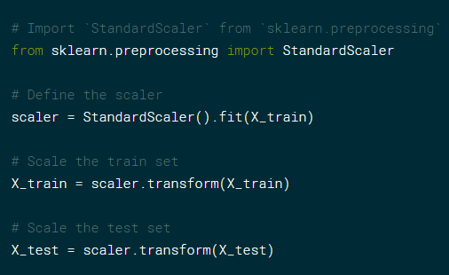

**MinMaxScalar() can also be used for scaling.**

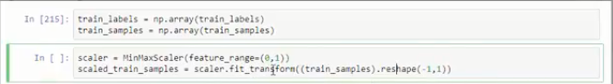

**reshape(-1,1):** fit_transform doesn’t allow 1D array, so as technical formality, need to reshape it to (-1,1)

**base64:**

Encode a string use Base64.

base64 encoding takes 8-bit binary byte data and encodes it uses only the characters A-Z, a-z, 0-9, +, /* so it can be transmitted over channels that do not preserve all 8-bits of data, such as email. Hence, it wants a string of 8-bit bytes. You create those in Python 3 with the b'' syntax. If you remove the b, it becomes a string. A string is a sequence of Unicode characters. base64 has no idea what to do with Unicode data, it's not 8-bit. It's not really any bits, in fact.

>>> import base64

>>> encoded = base64.b64encode(b'Saranya Shalya')

>>> encoded

b'U2FyYW55YSBTaGFseWE='

>>> encoded = base64.b64encode('Saranya Shalya')

*Traceback (most recent call last):*

*File "<stdin>", line 1, in <module>*

*File "D:\Python\lib\base64.py", line 58, in b64encode*

*encoded = binascii.b2a_base64(s, newline=False)*

*TypeError: a bytes-like object is required, not 'str'*

**Sessions:**

 session data gets stored somewhere on the server and indexed by a unique identifier (hash of some sort). This identifier gets passed back and forth between the client and server, usually as a cookie or as part of the query string (the URL). For security's sake, you'll want to use an SSL connection or validate the session ID with some other piece of data (e.g. IP address).

>>>import sessions

**HTTP Requests are Stateless:** Web requests are stateless. 'stateless' means 'memory-less'. The 'state' of the world-- all variables-- is lost on each request.  
The server doesn't remember variables on each browser request. Your server code may have data members, but they're re-initialized on each request.

**Session Variables:** Session variables are the way to get around the statelessness of web requests.  
Session variables remember data from request to request, and specifically for each user. Account info is one type of data stored in a session object.  
  
Session variables live for a user session. Typically, a user session will time out after some period of user inactivity (e.g., 30 minutes). As session variables are user-specific, they cannot be used to share data between users-- for that the web app stores data in a database.  
Session variables sometimes use [cookies](http://en.wikipedia.org/wiki/HTTP_cookie) to record information. Cookies are little bits of information stored on the client's computer. Session variables are generally key-value pairs.

**nohup: ( No Hangup)**

when you are executing unix jobs in the background using & or bg command, and logout from the session, your process will get killed. Executing the job with nohup will keep the job running even if you logout.

**Syntax:**

nohup command-with-options &

nohup is very useful when you have to execute a shell script or command that take long time to finish. In that case, you don’t want to be connected to the shell and waiting for the command to complete. Instead, execute it with nohup, exit the shell and continue with other work.

https://linux.101hacks.com/unix/nohup-command/

**Python Pandas:**

Series can be assessed through dot notation and through brackets.

**Curl command:**

To execute windows commands from unix environment.

-H 🡺 to specify Content-type

-d 🡺 to specify data

-X 🡺 to specify request method

-I 🡺 to view response http header

curl -H "Content-type: application/json" \

-X POST http://127.0.0.1:5000/messages -d '{"message":"Hello Data"}'

Status code in response :

notfound = 404

invalid = 403

ok = 200

**Other status code details:**

<http://www.flaskapi.org/api-guide/status-codes/>

**Difference between ast.eval() and ast.literal_eval():**

|  |  |
| --- | --- |
| ccepted | datamap = eval(raw_input('Provide some data here: ')) means that you actually evaluate the code *before* you deem it to be unsafe or not. It evaluates the code as soon as the function is called. See also [the dangers of eval](http://nedbatchelder.com/blog/201206/eval_really_is_dangerous.html).  ast.literal_eval raises an exception if the input isn't a valid Python datatype, so the code won't be executed if it's not.  Use ast.literal_eval whenever you need eval. You shouldn't usually evaluate literal Python statements. |

**eval:** This is very powerful, but is also very dangerous if you accept strings to evaluate from untrusted input. Suppose the string being evaluated is "os.system('rm -rf /')" ? It will really start deleting all the files on your computer.  
  
**ast.literal_eval:**Safely evaluate an expression node or a string containing a Python literal or container display. The string or node provided may only consist of the following Python literal structures: strings, bytes, numbers, tuples, lists, dicts, sets, booleans, None, bytes and sets.  
  
**Syntax:**

>>>eval(expression, globals=None, locals=None)

>>>ast.literal_eval(node_or_string)

**seaborn:**

import seaborn as sns

iris = sns.load_dataset(“iris”) 🡺 loads dataset from online repository, needs internet connection

sns.pairplot(data = dataframe, hue = column_name )

**data** : DataFrame , Tidy (long-form) dataframe where each column is a variable and each row is an observation.

**hue** : string (variable name), optional, Variable in data to map plot aspects to different colors.

Eg: sns.pairplot(iris, hue ="species");

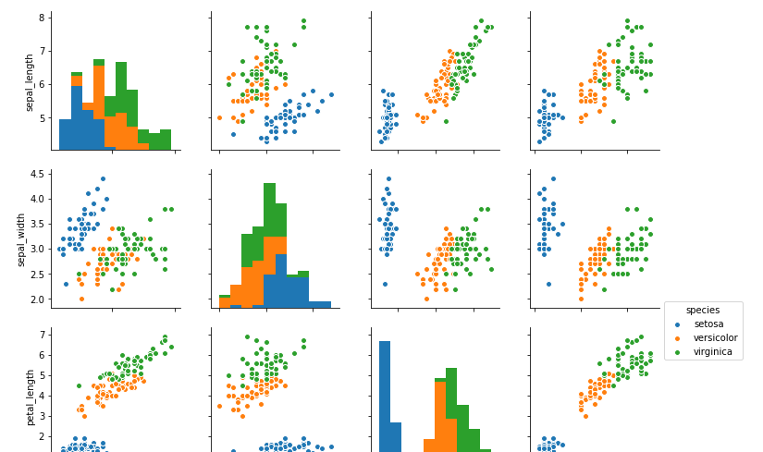

**Multiprocessing:**

<https://pymotw.com/2/multiprocessing/basics.html>

**Python Pandas:**

Eg:

**print(ufo.City)**

or **print(ufo[‘City’])**

dot notation cannot be used in below scenarios:

1. If the series name has spaces
2. If the series name is same as builtin attribute of dataframe
3. If we are creating new series name in a dataframe.

Methods come with parenthesis , attributes don’t

print(movies.describe()) 🡪 method  
print(movies.shape) 🡪 attribute  
print(movies.dtypes)🡪 attribute

**Axis:**

**Axis =0, columnwise,**

**Axis =1, rowwise**

df.mean() 🡪 by default axis =0 ie. Mathematical operation takes top to down direction

df.mean(axis = 0) / df.mean(axis =’index’)🡪 will give the same result

df.mean(axis = 1) / df.mean(axis =’column’) 🡪 mathematical operation takes left to right direction.

API reference link : <https://pandas.pydata.org/pandas-docs/stable/api.html>

ravel() , flatten() function flattens the array to single row.

Ref link: <https://github.com/kuleshov/cs228-material/blob/master/tutorials/python/cs228-python-tutorial.ipynb>

To assign default value to dictionary:

Dictionary don’t retain any order. If you print, we may not get the same sequence at which we added the elements.

d = {**'k1'**:**'a'**,**'k2'**:**'b'**}  
print(d)  
print(d[**'k1'**])  
print(d.get(**'k3'**,**'No value'**))

**o/p:**

{'k1': 'a', 'k2': 'b'}

a

No value

Sets are unordered unlike lists:

animals = {**'cat'**,**'dog'**,**'fish'**}  
**for** i,x **in** enumerate(animals):  
 print(**"#%d %s"** %(i,x))

**o/p:**

#0 dog

#1 cat

#2 fish

**Dropna:**

a = pd.DataFrame({‘sno’:[1,2,3,4],’Name’:[‘saranya’,’shalya’,’ram’,np.nan])

a.dropna(axis = 0, inplace = True) 🡺 deletes the complete row with np.nan and stores the result back to a.

**Subplot:**

plt.subplot(411) 🡺 4 – rows, 1 – column, 1 -> refers to the first diagram

plt.plot(ts_log,label=’Original’)

plt.legend(loc =’best’)

plt.subplot(412)

plt.plot(trend,label =’Trend’)

plt.legend(loc =’best’)

**To Clear screen in python command prompt:**

import os

os.system(‘cls’)

**Tuples:**

Tuples are immutable.

t = (1,2)  
print(id(t))  
t +=(3,4)  
print(id(t))  
o/p

25590480

25502992

Lists are mutable.  
l=[1,2]  
print(id(l))  
l +=[3,4]  
print(id(l))

o/p

23787080

23787080

**Default Dictionary:**

**from** collections **import** defaultdict  
my_dict = defaultdict(**lambda** : 0)  
my_dict[**"saranya"**] = **"infosys"**print(my_dict[**"shalya"**])  
**for** foo, bar **in** my_dict.items():  
 print(**"%s--> %r"** %(foo,bar))

**o/p:**

0

saranya--> 'infosys'

shalya--> 0

To assign empty list by default,

>>> a = defaultdict(list)

>>> a

defaultdict(<class 'list'>, {})

>>> a[0]="saranya"

>>> a

defaultdict(<class 'list'>, {0: 'saranya'})

>>> print(a[1])

[]

>>> a

defaultdict(<class 'list'>, {0: 'saranya', 1: []})

zip() to generate bigrams or trigrams:

>>> a =list(range(10))

>>> a

[0, 1, 2, 3, 4, 5, 6, 7, 8, 9]

>>> b =zip(a,a[1:]) # zip(a,a[1:],a[2:] 🡪 generates trigrams.

>>> b

<zip object at 0x0AD63300>

>>> for i,j in b:

... print(i,j)

...

0 1

1 2

2 3

3 4

4 5

5 6

6 7

7 8

8 9

>>>

**Example 2:**

>>> l1 = [1,2,3]

>>> l2=[4,5,6]

>>> r = zip()

>>> rl = list(r)

>>> print(rl)

[]

>>> result = zip(l1,l2)

>>> result

<zip object at 0x07AA1D28>

>>> resultSet = set(result)

>>> print(resultSet)

{(2, 5), (3, 6), (1, 4)}

>>>

**Lists of different size – zip:**

>>> l3=["Saranya","shalya","Ram"]

>>> new_zip = zip(l1,l2,l3)

>>> print(set(new_zip))

{(2, 5, 'shalya'), (3, 6, 'Ram'), (1, 4, 'Saranya')}

>>> l3=["Saranya","shalya"]

>>> new_zip = zip(l1,l2,l3)

>>> print(set(new_zip))

{(2, 5, 'shalya'), (1, 4, 'Saranya')}

>>>

**Unzipping the values using zip():**

>>> l1

[1, 2, 3]

>>> l2

[4, 5, 6]

>>> result = list(zip(l1,l2))

>>> result

[(1, 4), (2, 5), (3, 6)]

>>> zip(*result)

<zip object at 0x07AA1F08>

>>> l3,l4 = zip(*result)

>>> l3

(1, 2, 3)

>>> l4

(4, 5, 6)

>>>

**Numpy:**

**Link : https://docs.scipy.org/doc/**

**Rank 1 array: - it has one axis**

my_arr = np.array([1,2,3])  
print(type(my_arr), my_arr.shape)

o/p:

<class 'numpy.ndarray'> (3,) 🡪 axis has length of 3.

**arange takes 3 aruguments:**

>>> w = np.arange(start =1,stop =10,step = 2)

>>> w

array([1, 3, 5, 7, 9])

**linspace: -> used to split the dataset into sections., includes the last element.**

>>> np.linspace(1,10,3)

array([ 1. , 5.5, 10. ])

>>> np.linspace(1,10,2)

array([ 1., 10.])

>>> v= np.arange(10)

>>> v

array([0, 1, 2, 3, 4, 5, 6, 7, 8, 9])

>>> v[4:7]

array([4, 5, 6])

>>> v[4:]

array([4, 5, 6, 7, 8, 9])

>>> v[:4]

array([0, 1, 2, 3])

>>> v.reshape(5,2) 🡪 one way of creating matrix

array([[0, 1],

[2, 3],

[4, 5],

[6, 7],

[8, 9]])

>>> np.matrix([[1,2],[3,4],[5,6]]) 🡪 second way of creating matrix

matrix([[1, 2],

[3, 4],

[5, 6]])

>>> v[:]

array([0, 1, 2, 3, 4, 5, 6, 7, 8, 9])

>>> v[::-2]

array([9, 7, 5, 3, 1])

>>> v[::]

array([0, 1, 2, 3, 4, 5, 6, 7, 8, 9])

>>> v[::-1]

array([9, 8, 7, 6, 5, 4, 3, 2, 1, 0])

>>> v.dtype 🡪 provides the datatype of the elements

dtype('int32')

>>> type(v) -> provides the type of the object.

<class 'numpy.ndarray'>

a = np.zeros((3,3))  
print(a)

[[ 0. 0. 0.]

[ 0. 0. 0.]

[ 0. 0. 0.]]

b = np.ones((1,2))  
print(b)  
[[ 1. 1.]]

c = np.full((2,2),7)  
print(c)

[[7 7]

[7 7]]

d = np.eye(2)  
print(d)

[[ 1. 0.]

[ 0. 1.]]

e = np.random.random((2,2))  
print(e)

[[ 0.9450325 0.83137749]

[ 0.71427377 0.63312875]]

>>> mat = np.random.rand(3,5)

>>> mat

array([[0.02790231, 0.86540865, 0.9072219 , 0.54570939, 0.14674913],

[0.55203261, 0.58808778, 0.39950262, 0.9483772 , 0.34783704],

[0.17588663, 0.40568905, 0.52322809, 0.39692166, 0.25052361]])

>>> mat = np.random.randint(10,50,size =4)

>>> mat

array([28, 48, 33, 14])

print(a)

[[1 2 3 4]

[5 6 7 8]

[4 3 2 1]]

print(a[1,:]) 🡪 rank 1 view of second row of a

[5 6 7 8]

print(a[1:2,:]) 🡪 rank 2 view of second row of a  
[[5 6 7 8]]

print(a[[1],:]) 🡪 rank 2 view of second row of a

[[5 6 7 8]]

Similarly for columns:

print(a[:, 1]) 🡪 rank 1 view for second column of a

[2 6 3]

print(a[:, 1:2]) 🡪 rank 2 view for second column of a

[[2]

[6]

[3]]

**np.nonzero():**

Each element of the tuple contains one of the indices for each nonzero value. Therefore, the length of each tuple element is the number of nonzeros in the array.

From below example, the indices of the nonzeros are [0, 0], [1, 0], and [1, 1]. The first element of the tuple is the first index for each of the nonzero values: ([0, 1, 1]), and the second element of the tuple is the second index for each of the nonzero values: ([0, 0, 1]).

>>> x

array([[5, 0],

[9, 8]])

>>> np.nonzero(x) #or x.nonzero()

(array([0, 1, 1], dtype=int32), array([0, 0, 1], dtype=int32))

>>> x[x.nonzero()]

array([5, 9, 8])

**Reading from txt file and converting as numpy array:**

np.genfromtxt 🡺 contains dtype column which will automatically detect the datatype of fields.

**import** numpy **as** np  
  
iris_ds = np.genfromtxt(**r'C:\Users\saranya_govindaraj\Desktop\data.txt'**,dtype=**None**,names=(**'sepal length'**, **'sepal width'**, **'petal length'**, **'petal width'**, **'label'**),delimiter=**','**,encoding=**None**)  
  
print(iris_ds[0])  
print(iris_ds)

**data.txt:**

5.1,3.5,1.4,0.2,Iris-setosa

4.9,3.0,1.4,0.2,Iris-setosa

5.8,2.7,4.1,1.0,Iris-versicolor

6.2,2.2,4.5,1.5,Iris-versicolor

6.4,3.1,5.5,1.8,Iris-virginica

6.0,3.0,4.8,1.8,Iris-virginica

**o/p:**

**(5.1, 3.5, 1.4, 0.2, 'Iris-setosa')**

**[(5.1, 3.5, 1.4, 0.2, 'Iris-setosa') (4.9, 3. , 1.4, 0.2, 'Iris-setosa')**

**(5.8, 2.7, 4.1, 1. , 'Iris-versicolor')**

**(6.2, 2.2, 4.5, 1.5, 'Iris-versicolor')**

**(6.4, 3.1, 5.5, 1.8, 'Iris-virginica')**

**(6. , 3. , 4.8, 1.8, 'Iris-virginica')]**

**np.unique():**

**>>>** np.unique([1, 1, 2, 2, 3, 3])

array([1, 2, 3])

**>>>** a = np.array([[1, 1], [2, 3]])

**>>>** np.unique(a)

array([1, 2, 3])

Return the unique rows of a 2D array

**>>>** a = np.array([[1, 0, 0], [1, 0, 0], [2, 3, 4]])

**>>>** np.unique(a, axis=0)

array([[1, 0, 0], [2, 3, 4]])

Return the indices of the original array that give the unique values:

**>>>** a = np.array(['a', 'b', 'b', 'c', 'a'])

**>>>** u, indices = np.unique(a, return_index=**True**)

**>>>** u

array(['a', 'b', 'c'],

dtype='|S1')

**>>>** indices

array([0, 1, 3])

**>>>** a[indices]

array(['a', 'b', 'c'],

dtype='|S1')

Reconstruct the input array from the unique values:

**>>>** a = np.array([1, 2, 6, 4, 2, 3, 2])

**>>>** u, indices = np.unique(a, return_inverse=**True**)

**>>>** u

array([1, 2, 3, 4, 6])

**>>>** indices

array([0, 1, 4, 3, 1, 2, 1])

**>>>** u[indices]

array([1, 2, 6, 4, 2, 3, 2])

**ord() and chr():**

>>> ord('a') # returns the ascii code

97

>>> chr(97) # returns character corresponding to the given ascii code

'a'

**os.path.splitext(): splits root + extension in the path**

>>> os.path.splitext(r"C:\Program Files\abc.txt")

('C:\\Program Files\\abc', '.txt')

>>> os.path.split(r"C:\Program Files\abc.txt") 🡪 Splits the head and tail, tail is the last pathname component and head is everything leading up to that.

('C:\\Program Files', 'abc.txt')

>>>

>>> os.path.splitdrive(r"C:\Program Files\abc.txt") 🡪 splits the drive letter from rest

('C:', '\\Program Files\\abc.txt')

>>> os.path.basename(r"C:\Program Files\abc.txt") 🡪gives the file name.

'abc.txt'

**namedtuple():**

<https://pymotw.com/2/collections/namedtuple.html>

named tuple are immutable. You cannot assign a new value to the existing named tuple. It will result in error. We can convert the named tuple as dictionary using ._asdict() and apply all dict related functions.

>>> Person = namedtuple('Person','name age sal')

>>> P1 = Person('Saranya',28,80000)

>>> P1

Person(name='Saranya', age=28, sal=80000)

>>> P1.age

28

>>> P1[2]

80000

>>> P1[0]='Shalya' 🡪 new assignment throws error

Traceback (most recent call last):

File "<stdin>", line 1, in <module>

TypeError: 'Person' object does not support item assignment

>>> P1.name='Shalya' 🡪 new assignment throws error

Traceback (most recent call last):

File "<stdin>", line 1, in <module>

AttributeError: can't set attribute

>>> P2 = P1._asdict() 🡪 converting as dictionary

>>> P2

OrderedDict([('name', 'Saranya'), ('age', 28), ('sal', 80000)])

>>> P2['name']

'Saranya'

>>> P2['name']='Shalya'

>>> P2

OrderedDict([('name', 'Shalya'), ('age', 28), ('sal', 80000)])

**itertools.islice():**

**syntax : islice(iterator, start,stop, step)**

>>> import itertools

>>> l =[ 1,2,3,4,5,6]

>>> b = itertools.islice(l,1,4)

>>> b

<itertools.islice object at 0x017EA7B0>

>>> list(b)

[2, 3, 4]

>>> c = itertools.islice(l,1)

>>> list(c)

[1]

>>> c = itertools.islice(l,1,None)

>>> list(c)

[2, 3, 4, 5, 6]

>>> c = itertools.islice(l,1,None,2)

>>> list(c)

[2, 4, 6]

>>>

**Attributes: shape, size, transpose**

>>> a = np.matrix([[1,2],[3,4],[5,6]])

>>> a.shape

(3, 2)

>>> a.size

6

>>> a.T

matrix([[1, 3, 5],

[2, 4, 6]])

>>>

**Choosing elements based on condition:**

>>> a = np.array([1,2,3,4])

>>> a[np.array([False,True,False,True])]

array([2, 4])

>>> a

array([1, 2, 3, 4])

>>> a[(a>2) & (a<4)]

array([3])

**Arithmetic operations:**

>>> mat1 = np.random.randint(10,50,size=4)

>>> mat2 = np.random.randint(10,50,size=4)

>>> mat1

array([17, 36, 15, 32])

>>> mat2

array([30, 37, 13, 48])

>>> mat1-mat2

array([-13, -1, 2, -16])

>>> mat1*mat2

array([ 510, 1332, 195, 1536])

>>> mat1/mat2

array([0.56666667, 0.97297297, 1.15384615, 0.66666667])

>>> mat1+mat2

array([47, 73, 28, 80])

>>> mat1%mat2

array([17, 36, 2, 32], dtype=int32)

>>>

**Statistical operations:**

>>> np.sum(mat1)

100

>>> np.mean(mat1)

25.0

>>> np.cumsum(mat1)

array([ 17, 53, 68, 100], dtype=int32)

>>> np.median(mat1)

24.5

**Tile:**

v = [1,2,3]  
vv = np.tile(v,(4,1))  
print(vv)

o/p:

[[1 2 3]

[1 2 3]

[1 2 3]

[1 2 3]]

**np.newaxis:**

[newaxis](https://docs.scipy.org/doc/numpy/reference/arrays.indexing.html#numpy.newaxis) is used to increase the dimension of the existing array by one more dimension, when used once. Thus,

* 1D array will become 2D array
* 2D array will become 3D array
* 3D array will become 4D array

and so on.

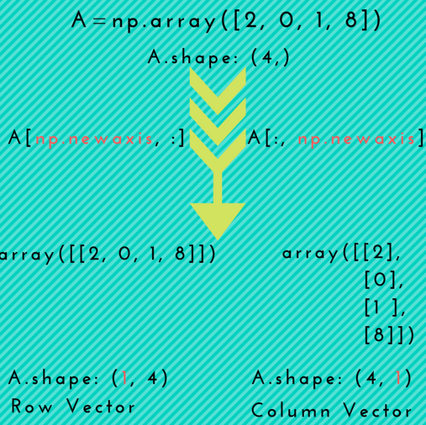

Number of square brackets indicates number of dimensions.

>>> arr = np.arange(6)

>>> arr

array([0, 1, 2, 3, 4, 5]) 🡺 1D array

>>> arr.shape

(6,)

>>> b = arr[np.newaxis,:]

>>> b

array([[0, 1, 2, 3, 4, 5]]) 🡺 2D array

>>> b.shape

(1, 6)

>>> c = b[np.newaxis,:]

>>> c

array([[[0, 1, 2, 3, 4, 5]]]) 🡺 3D array

>>> c.shape

(1, 1, 6)

>>> d = arr[:,np.newaxis]

>>> d

array([[0],

[1],

[2],

[3],

[4],

[5]])

>>> d.shape

(6, 1)

>>>

**isinstance: used to check the datatype. Similar to type()**

**Note: similar to class() function in R**

>>> a= 5

>>> if isinstance(a,int):

... print("int")

... else:

... print("not int")

...

o/p: int

**parallel_coordinates:**

Using parallel coordinates points are represented as connected line segments. Each vertical line represents one attribute. One set of connected line segments represents one data point. Points that tend to cluster will appear closer together.

**In [89]: from** **pandas.plotting** **import** parallel_coordinates

**In [90]:** data = pd.read_csv('data/iris.data')

**In [91]:** plt.figure()

**Out[91]:** <Figure size 640x480 with 0 Axes>

**In [92]:** parallel_coordinates(data, 'Name')

Out[92]: <matplotlib.axes._subplots.AxesSubplot at 0x1278f6320>

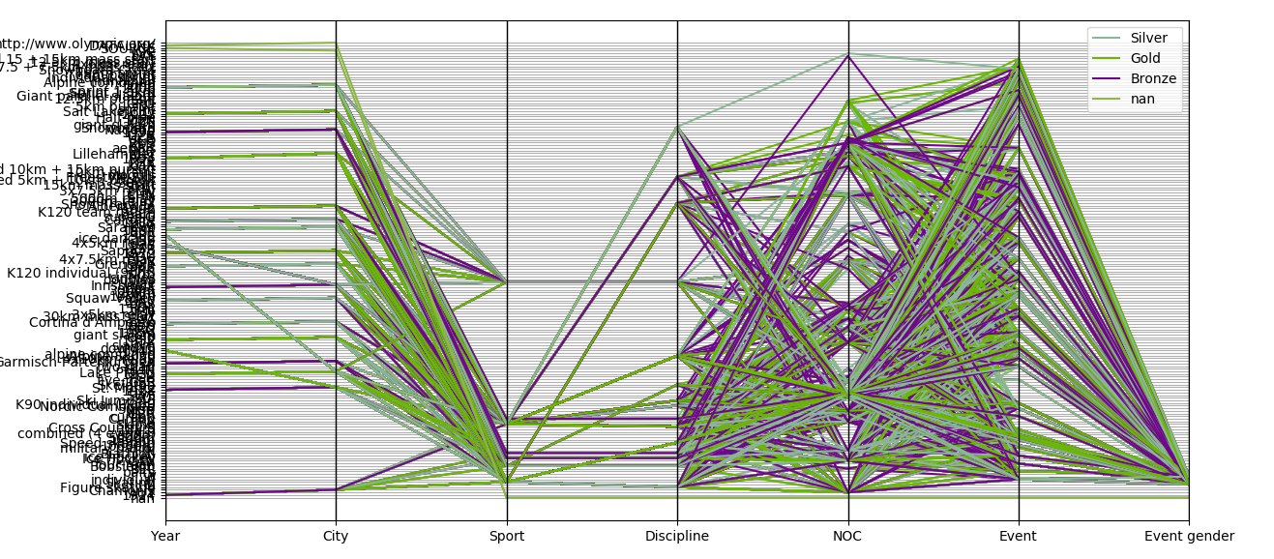

**Clip function:**

Clip function takes min and max values and values smaller than min values will become min value and values larger the max value will become max value

>>> a

array([0, 1, 2, 3, 4, 5, 6])

>>> a.clip(3,4)

array([3, 3, 3, 3, 4, 4, 4])

Good reference link: <http://anandology.com/python-practice-book/working-with-data.html>

>>> s = pd.Series(list('abca')) # always single parameter should be passed for list even if it numeric. Eg: s = pd.Series(list(‘1234’))

>>> s

0 a

1 b

2 c

3 a

dtype: object

>>> pd.get_dummies(s) # transforms single column into multiple columns with each unique entries

a b c

0 1 0 0

1 0 1 0

2 0 0 1

3 1 0 0

**Series is ndarray-like and dict-like**

Pandas Series objects are amphibian in character, exhibiting both ndarray-like and dict-like properties.

The basic method to create a Series:

- s = Series(data, index=index)

Here, data can be different things, including:

- a list

- an array

- a dictionary

# type of series is pandas series

>>>type(s1s)

pandas.core.series.Series

>>> x = np.array([1,2,3,4])

>>> x

array([1, 2, 3, 4])

>>> s = pd.Series(x)

>>> s

0 1

1 2

2 3

3 4

dtype: int32

>>> s.values # values returns the values of the series

array([1, 2, 3, 4])

>>> type(s.values)

<class 'numpy.ndarray'>

>>> s.index # index returns the index of the series.

RangeIndex(start=0, stop=4, step=1)

**# Creating meaningful index**

>>> s = pd.Series(data = x, index = ['Mon','Tue','Wed','Thu'])

>>> s

Mon 1

Tue 2

Wed 3

Thu 4

dtype: int32

>>> s.name = 'Daily temperatures' # name used to assign name to the series

>>> s.index.name='Weekday' # index.name is used to specify name to the index column

>>> s

Weekday

Mon 1

Tue 2

Wed 3

Thu 4

Name: Daily temperatures, dtype: int32

**#Creating series from dictionary:**

>>> dict ={'M':30,'T':50,'W':60}

>>> dict

{'M': 30, 'T': 50, 'W': 60}

>>> s2 = pd.Series(dict)

>>> s2

M 30

T 50

W 60

dtype: int64

**# vectorised operations:**

>>> np.log(s2)

M 3.401197

T 3.912023

W 4.094345

dtype: float64

>>> s2

M 30

T 50

W 60

dtype: int64

>>> s2 *2

M 60

T 100

W 120

dtype: int64

>>> s2

M 30

T 50

W 60

dtype: int64

>>> s2[1]

50

>>> s2.median()

50.0

>>> s2.mean()

46.666666666666664

>>> s2.max()

60

>>> s2.min()

30

>>> s2.cumsum()

M 30

T 80

W 140

dtype: int64

>>> for i,v in enumerate(s2): #Note: enumerate is ignoring actual series index and starting from 0 onwards

... print(i,v)

...

0 30

1 50

2 60

>>> for i,k in s2.iteritems(): # inorder to get actual index,use iteritems()on series

... print(i,k)

...

M 30

T 90

W 60

>>> new_list =[x**2 for x in s2]

>>> new_list

[900, 2500, 3600]

>>> 'T' in s2

True

>>> 50 in s2

False

>>> s2['T']

50

>>> s2['T'] = 90

>>> s2

M 30

T 90

W 60

dtype: int64

**copy() 🡪 creates a new memory allocation.**

>>> a = np.arange(5)

>>> a

array([0, 1, 2, 3, 4])

>>> b =a

>>> c = a.copy()

>>> b[0] = 10

>>> c[0] = 15

>>> a

array([10, 1, 2, 3, 4])

>>> c

array([15, 1, 2, 3, 4])

>>> b

array([10, 1, 2, 3, 4])

**Arrany/Image splitting:**

For splitting

hsplit -> columnwise split

vsplit -> rowwise split

for merging

hstack -> columnwise merge

vstack -> rowwise merge

**Linear algebra:**

>>> mat1 = np.arange(4).reshape(2,2)

>>> mat2 = (np.arange(4)*2).reshape(2,2)

>>> mat3 = (np.arange(4)*3).reshape(2,2)

>>> mat1

array([[0, 1],

[2, 3]])

>>> mat2

array([[0, 2],

[4, 6]])

>>> mat3

array([[0, 3],

[6, 9]])

>>> np.linalg.multi_dot([mat1,mat2,mat3])

array([[ 36, 66],

[132, 234]])

>>>

**Matrix determination:**

[a, b

C, d] 🡺 ad –bc

>>> np.linalg.det(mat1)

-2.0

**Pandas Dataframe:**

* Open source library.

The DataFrame data structure in Pandas is a two-dimensional labeled array.

* Data in the array can be of any type (integers, strings, floating point numbers, Python objects, etc.).
* Data within each column is homogeneous.
* By default, Pandas creates a numerical index for the rows in sequence 0...n
* Dataframe is a heterogeneous object.

>>> import datetime

>>> import pandas as pd

>>> dt = datetime.datetime(2018,12,1)

>>> end = datetime.datetime(2018,12,5)

>>> step = datetime.timedelta(days = 1)

>>> dates =[]

>>> while dt <end:

... dates.append(dt.strftime('%m-%d-%Y'))

... dt +=step

...

>>> dates

['12-01-2018', '12-02-2018', '12-03-2018', '12-04-2018']

A [timedelta](https://docs.python.org/2/library/datetime.html#datetime.timedelta) object represents a duration, the difference between two dates or times.

*class*datetime.timedelta([*days*[, *seconds*[, *microseconds*[, *milliseconds*[, *minutes*[, *hours*[, *weeks*]]]]]]])

**Creation of dataframe:**

>>> d = {'Date':dates,'Tokoyo':[1,3,2,1,2],'Mumbai':[23,22,21,24,22]}

>>> d

{'Date': ['12-01-2018', '01-05-2019', '02-09-2019', '03-16-2019', '04-20-2019'],

'Tokoyo': [1, 3, 2, 1, 2], 'Mumbai': [23, 22, 21, 24, 22]}

>>> temp = pd.DataFrame(d)

>>> temp # Note default index starting 0 is assigned

Date Mumbai Tokoyo

0 12-01-2018 23 1

1 01-05-2019 22 3

2 02-09-2019 21 2

3 03-16-2019 24 1

4 04-20-2019 22 2

>>> temp['Tokoyo']

0 1

1 3

2 2

3 1

4 2

Name: Tokoyo, dtype: int64

>>> temp = temp.set_index('Date')

>>> temp

Mumbai Tokoyo

Date

12-01-2018 23 1

01-05-2019 22 3

02-09-2019 21 2

03-16-2019 24 1

04-20-2019 22 2

**Data frame creation from list of dictionary:**

Keys will be considered as column name

In below screenshot, Though the values are integers in the dictionary, when we create data frame, we can see that values are in float because, the NaN value is not known. If Nan is there, by default it takes float, In case the other row also has integer values, then the value will be int and not float.

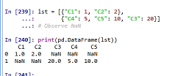

**Dataframe creation from list:**

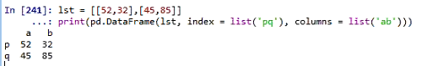

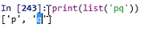

**Text value will be replicated in dataframe, but list elements should match the count.**

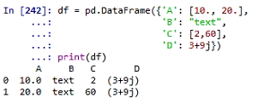

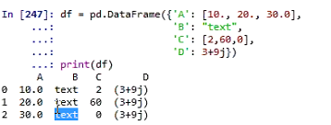

**To view datatypes of dataframe:**

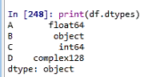

**info() 🡺 returns memory and datatype details**

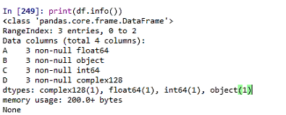

**Index and columns:**

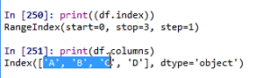

**Values:**

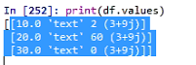

**len(dataframe) 🡪 returns the number of rows**

**dataframe.index -> returns the index values, start value, stop and step.**

**dataframe.columns -> returns the column names**

**dataframe.info() -> infor about columns and datatype**

**eg:**

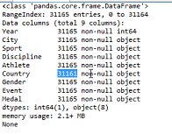

In above example, country is having null values that’s why less number of entries

dataframe.describe() 🡪 works only with numbers or integers, gives the summary

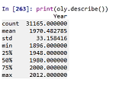

**Dataframe.head() -> returns 5 by default.**

**Dataframe.tail() -> returns last 5 by default.**

**Series -> 1D array of indexed data**

**Dataframe[“columnname”]**

**Dataframe[‘columnname’]**

**Or**

**Dataframe.columnname 🡪 this should be used only when there is no space in the column name.**

**Shape of dataframe**

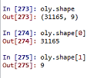

**Slicing dataset by label:**

**Selecting City column with all rows and in second line selecting Year and city columns**

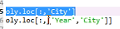

**Accessing 50th row elements.**

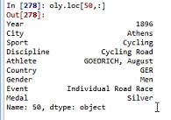

**Slicing dataset by position:**

**iloc is used**

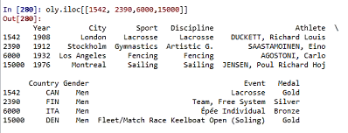

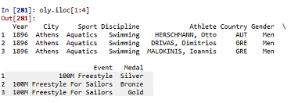

**Using regex to select columns:**

**Finds the columns which are starting with letter C**

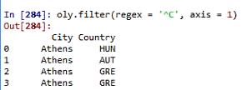

**Group by:**

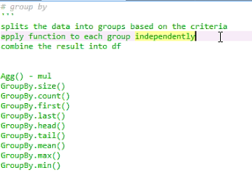

**Eg:**

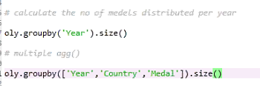

**Reshaping:**

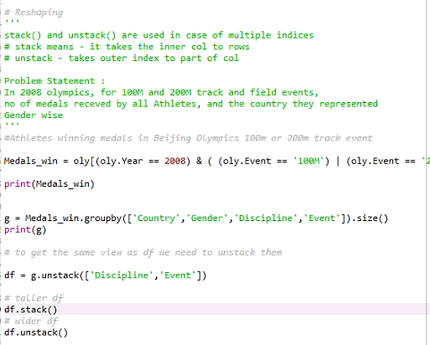

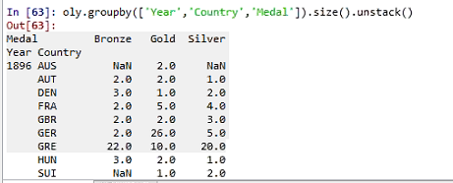

**In unstack it considers the very last column which is medal as columns (Bronze, Gold and Silver)**

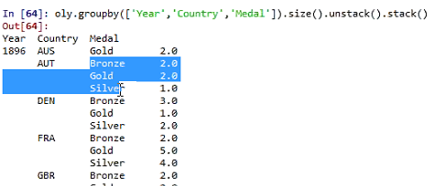

**Pivot and Pivot table:**

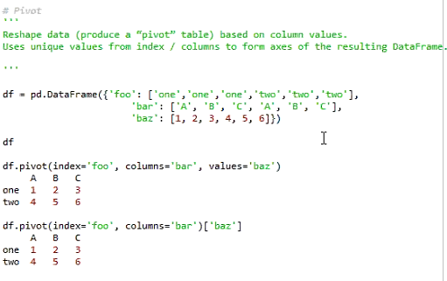

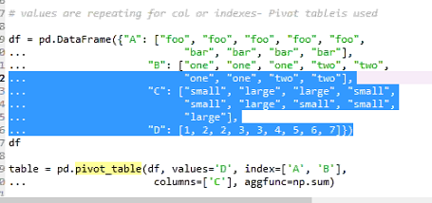

In pivot table, multiple indexes and columns can be used but not in Pivot.

**Basic Analysis:**

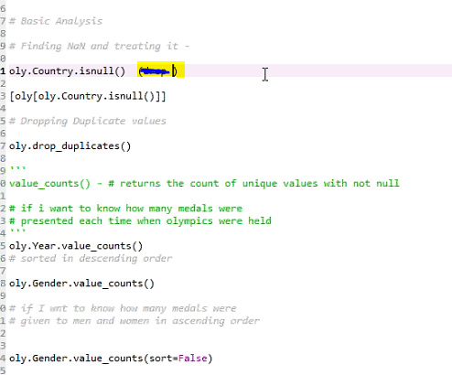

dropna() and fillna() 🡪 functions are also available.

**String Handling:**

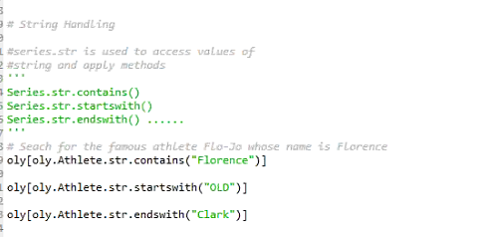

**Pandas subset handling:**

Link : <https://medium.com/dunder-data/selecting-subsets-of-data-in-pandas-6fcd0170be9c>

**Merging:**

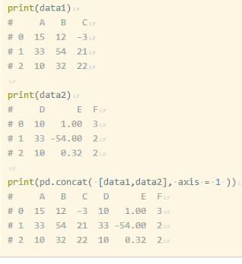

**Visualization:**

**Matplotlib**

**Line chart:**

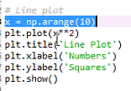

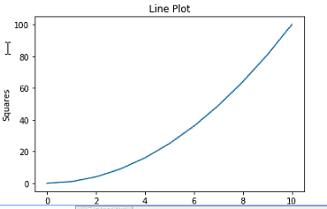

**Mulitple line plot:**

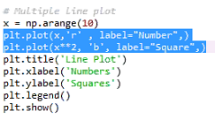

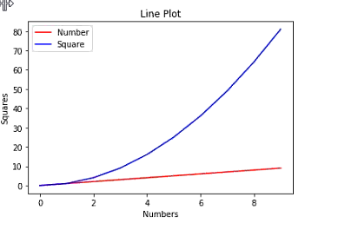

**Barplot:**

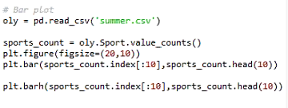

**plt.figure 🡪 for reshaping the plot.**

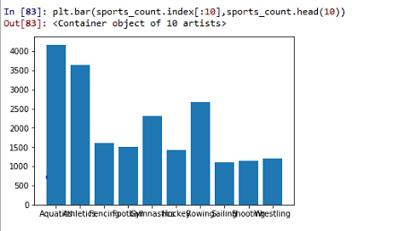

**Horizontal bars 🡪 use plt.barh**

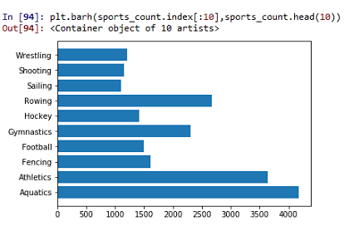

**Pie plot:**

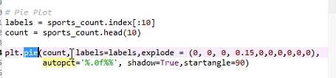

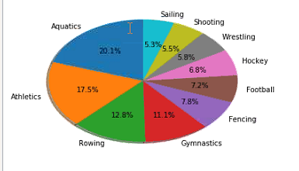

**Startangle indicates from where the slicing should start.**

**Explode will take out the slice:**

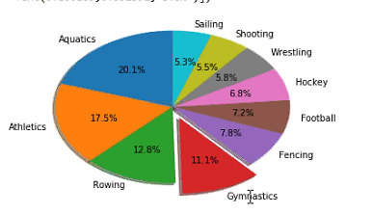

**If explode value is increased, the slice goes away**

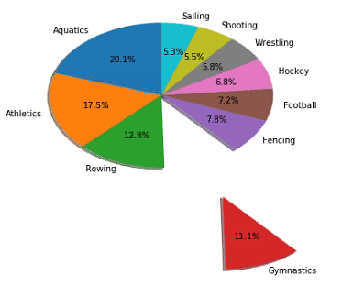

**Box plot: To identify outlier, for analyzing numerical value.**

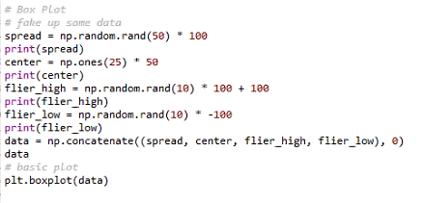

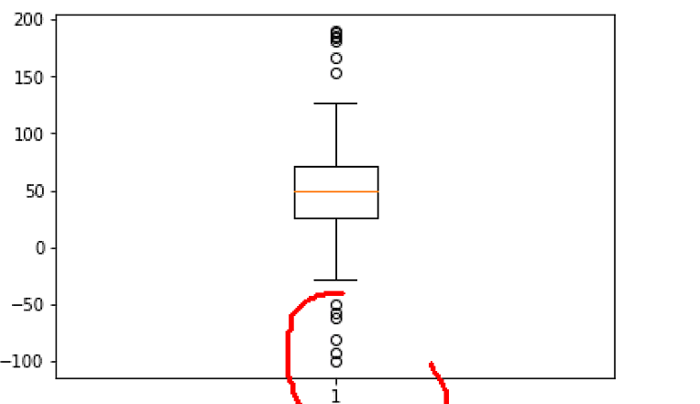

**Multiple plots / Integrated plot:**

**subplot(rows,columns, part of subplot)**

**plt.subplot(221) -> totally 2 rows and 2 columns and first part.**

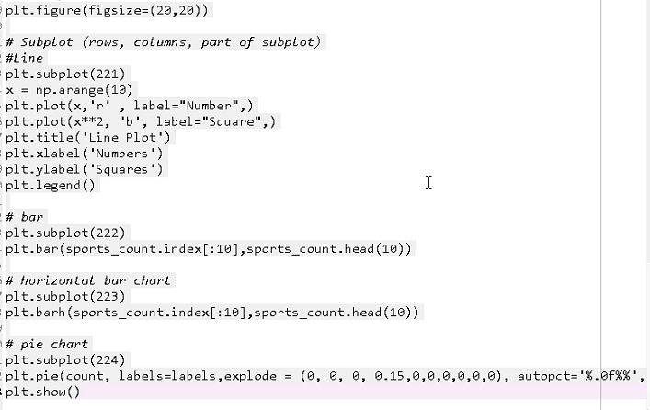

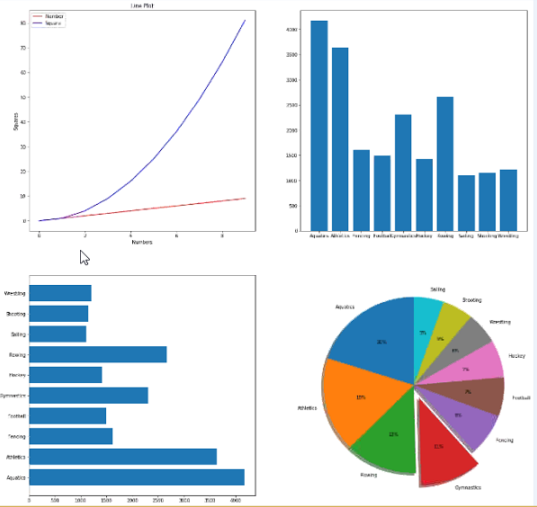

**Machine learning steps:**

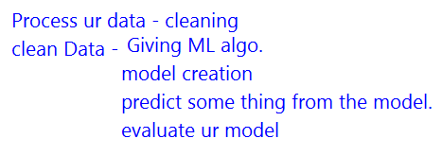

**Sample Linear Regression Model:**

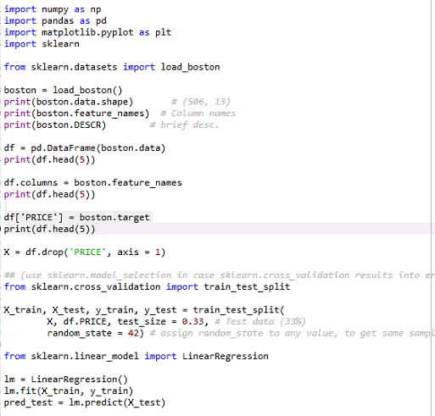

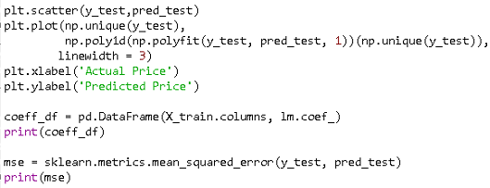

**#value_counts returns unique values in that Series.**

>>> temp.Mumbai.value_counts

<bound method IndexOpsMixin.value_counts of Date

12-01-2018 23

01-05-2019 22

02-09-2019 21

03-16-2019 24

04-20-2019 22

Name: Mumbai, dtype: int64>

>>> temp

Mumbai Tokoyo

Date

12-01-2018 23 1

01-05-2019 22 3

02-09-2019 21 2

03-16-2019 24 1

04-20-2019 22 2

>>> temp.values

array([[23, 1],

[22, 3],

[21, 2],

[24, 1],

[22, 2]], dtype=int64)

>>> temp.index

Index(['12-01-2018', '01-05-2019', '02-09-2019', '03-16-2019', '04-20-2019'], dt

ype='object', name='Date')

>>>

**groupby in dataframe:**

**>>>** mlb

| **bike.id** | **model** | **category1** | **category2** | **frame** | **price** |
| --- | --- | --- | --- | --- | --- |
| **0** | 1 | Supersix Evo Black Inc. | Road | Elite Road | Carbon | 12790 |
| **1** | 2 | Supersix Evo Hi-Mod Team | Road | Elite Road | Carbon | 10660 |
| **2** | 3 | Supersix Evo Hi-Mod Dura Ace 1 | Road | Elite Road | Carbon | 7990 |
| **3** | 4 | Supersix Evo Hi-Mod Dura Ace 2 | Road | Elite Road | Carbon | 5330 |
| **4** | 5 | Supersix Evo Hi-Mod Utegra | Road | Elite Road | Carbon | 4260 |
| **5** | 6 | Supersix Evo Red | Road | Elite Road | Carbon | 3940 |

>>> grouped = mlb.groupby(‘frame’)

>>> type(grouped)

pandas.core.groupby.DataFrameGroupBy

>>>for k,group in grouped:

print k

print group

# Aluminium and Carbon are the k values(distinct values) and rest of the dataframe values comes under group

**Aluminum**

bike.id model category1 category2 frame \

10 11 CAAD12 Black Inc Road Elite Road Aluminum

11 12 CAAD12 Disc Dura Ace Road Elite Road Aluminum

12 13 CAAD12 Red Road Elite Road Aluminum

**Carbon**

bike.id model category1 category2 \

0 1 Supersix Evo Black Inc. Road Elite Road

1 2 Supersix Evo Hi-Mod Team Road Elite Road

2 3 Supersix Evo Hi-Mod Dura Ace 1 Road Elite Road

3 4 Supersix Evo Hi-Mod Dura Ace 2 Road Elite Road

# generator comprehension for retrieving highest price player by year

>>>t = (group.sort_values(by='price', ascending=False)[:1] for yr,group in grouped)

>>>t

<generator object <genexpr> at 0x7f7a067d29b0>

|  |  |
| --- | --- |
| **List comprehension** | **Generator Comprehension** |
| Returns all values as list in one go. | A generator expression is like a list comprehension, but instead of finding all the items you're interested and packing them into list, it waits, and yields each item out of the expression, one by one. |
| >>> my_list = [1, 3, 5, 9, 2, 6]  >>> filtered_list = [item for item in my_list if item > 3]  >>> print filtered_list  [5, 9, 6]  >>> len(filtered_list)  3 | >>> filtered_gen = (item for item in my_list if item > 3)  >>> print filtered_gen # notice it's a generator object  <generator object at 0xb7d5e02c>  >>> len(filtered_gen) # So technically, it has no length  Traceback (most recent call last):  File "<stdin>", line 1, in <module>  TypeError: object of type 'generator' has no len()  >>> # We extract each item out individually. We'll do it manually first.  ...  >>> filtered_gen.__next__()  5  >>> filtered_gen.__next__()  9  >>> filtered_gen.__next__()  6  >>> filtered_gen.__next__() # Should be all out of items and give an error  Traceback (most recent call last):  File "<stdin>", line 1, in <module>  StopIteration  __next__() is the special method used to retrieve each generator object value in python 3. While next() was used in python2(). |
|  | Because a generator expression only has to yield one item at a time, it can lead to big savings in memory usage. |
|  | Lazy list comprehension as it returns the values one after another. |
| %**time** sum([x for x in range(100000)])  CPU times: user 24 ms, sys: 4 ms, total: 28 ms  Wall time: 27.4 ms  Out[3]: 4999950000 | %**time** sum(x for x in range(100000))  CPU times: user 8 ms, sys: 0 ns, total: 8 ms  Wall time: 8.11 ms  Out[4]:4999950000 |

**Reset index:**

>>> df = pd.DataFrame({'a' :['sara','shalya','maha'],'b':[100,200,300]},index=[1

,2,3])

>>> df

a b

1 sara 100

2 shalya 200

3 maha 300

>>> df = df.drop(2)

>>> df

a b

1 sara 100

3 maha 300

>>> df.reset_index()

index a b

0 1 sara 100

1 3 maha 300

**Multiprocessing – cpu:**

>>> import multiprocessing

>>> multiprocessing.cpu_count() 🡪 returns number of cores.

4

**Difference between single and double square brackets:**

>>> df = pd.DataFrame({'M1':[1,2,3],'M2':['sddf','erer','ytyty']})

>>> df

M1 M2

0 1 sddf

1 2 erer

2 3 ytyty

>>> df['M1']

0 1

1 2

2 3

Name: M1, dtype: int64

>>> type(df['M1'])

<class 'pandas.core.series.Series'> # if single square bracket is passed, result will be series

>>> df[['M1']]

M1

0 1

1 2

2 3

>>> type(df[['M1']])

<class 'pandas.core.frame.DataFrame'> # if double square bracket is passed, result will be dataframe. Actually, we are passing a list (with single square bracket) as parameter. There is no [[]] double square bracket

Just to seal up any possible confusion, the first form is equivalent to column = 'Brains'; df[column], and the second is equivalent to subset = ['Brains']; df[subset]. The first passes a string, the second passes a list. It is not that using [[ and ]] does a special form of indexing, but rather that the object passed is of a different type.

Note: In R, if [[]] is used, then the result will be a vector, single [] returns a dataframe if fetched from a dataframe. This is opposite behavior when compared to Python.

**Subset of dataframe:**

>>>yr2010 = mlb[mlb.frame=='Aluminum']

>>>yr2010 = yr2010.set_index(‘model’)

>>>yr2010.head()

| **bike.id** | **category1** | **category2** | **frame** | **price** |
| --- | --- | --- | --- | --- |
| **model** |  |  |  |  |  |
| **CAAD12 Black Inc** | 11 | Road | Elite Road | Aluminum | 5860 |
| **CAAD12 Disc Dura Ace** | 12 | Road | Elite Road | Aluminum | 4260 |
| **CAAD12 Red** | 13 | Road | Elite Road | Aluminum | 3200 |
| **CAAD Disc Ultegra** | 14 | Road | Elite Road | Aluminum | 2660 |
| **CAAD12 Ultegra** | 15 | Road | Elite Road | Aluminum | 2240 |

>>>yr2010.sort_index().head()

|  | **bike.id** | **category1** | **category2** | **frame** | **price** |
| --- | --- | --- | --- | --- | --- |
| **model** |  |  |  |  |  |
| **Bad Habit 1** | 79 | Mountain | Trail | Aluminum | 3200 |
| **Bad Habit 2** | 80 | Mountain | Trail | Aluminum | 2660 |
| **Beast of the East 1** | 76 | Mountain | Trail | Aluminum | 2770 |
| **Beast of the East 2** | 77 | Mountain | Trail | Aluminum | 2130 |
| **Beast of the East 3** | 78 | Mountain | Trail | Aluminum | 1620 |

#sort column labels

>>>yr2010.sort_index(axis=1).head()

| **bike.id** | **category1** | **category2** | **frame** | **price** |
| --- | --- | --- | --- | --- |
| **model** |  |  |  |  |  |
| **CAAD12 Black Inc** | 11 | Road | Elite Road | Aluminum | 5860 |
| **CAAD12 Disc Dura Ace** | 12 | Road | Elite Road | Aluminum | 4260 |
| **CAAD12 Red** | 13 | Road | Elite Road | Aluminum | 3200 |
| **CAAD Disc Ultegra** | 14 | Road | Elite Road | Aluminum | 2660 |
| **CAAD12 Ultegra** | 15 | Road | Elite Road | Aluminum | 2240 |

# sort_values used to sort using a particular column.

>>> yr2010.price.sort_values(ascending=False).head()

>>>type(yr2010.price.sort_values(ascending=False).head())

pandas.core.series.Series

>>>sorted_yr2010 = yr2010.sort_values(ascending=False, by = ['price'])

>>>sorted_yr2010.head()

| **bike.id** | **category1** | **category2** | **frame** | **price** |
| --- | --- | --- | --- | --- |
| **model** |  |  |  |  |  |
| **CAAD12 Black Inc** | 11 | Road | Elite Road | Aluminum | 5860 |
| **CAAD12 Disc Dura Ace** | 12 | Road | Elite Road | Aluminum | 4260 |
| **Fat CAAD1** | 74 | Mountain | Fat Bike | Aluminum | 3730 |
| **Scalpel 29 4** | 65 | Mountain | Cross Country Race | Aluminum | 3200 |
| **Scalpel-Si 5** | 61 | Mountain | Cross Country Race | Aluminum | 3200 |

>>>yr2010.sort_values(ascending=[False,True], by =['price', 'bike.id']).head()

| **bike.id** | **category1** | **category2** | **frame** | **price** |
| --- | --- | --- | --- | --- |
| **model** |  |  |  |  |  |
| **CAAD12 Black Inc** | 11 | Road | Elite Road | Aluminum | 5860 |
| **CAAD12 Disc Dura Ace** | 12 | Road | Elite Road | Aluminum | 4260 |
| **Fat CAAD1** | 74 | Mountain | Fat Bike | Aluminum | 3730 |
| **CAAD12 Red** | 13 | Road | Elite Road | Aluminum | 3200 |
| **Scalpel-Si 5** | 61 | Mountain | Cross Country Race | Aluminum | 3200 |

# ipython magic for inline plots

>>>%pylab inline

# Set default option for Pandas

pd.set_option('display.max_rows',10)

>>> import numpy as np

>>> np.invert(True)

False

>>> np.invert(False)

True

<http://nbviewer.jupyter.org/github/jvns/pandas-cookbook/tree/master/cookbook/>

**Python iloc, loc, ix explanation:**

<https://stackoverflow.com/questions/31593201/pandas-iloc-vs-ix-vs-loc-explanation>

loc => works on labels in the index..looks for exact value match and returns till that

iloc => works on positions of the index( so it only takes integers)

ix => tries to behave as loc but falls back to behaving like iloc if the labels are of mixed type.

>>> import numpy as np

>>> s = pd.Series(np.nan, index=[49,48,50,17,18,3,2,1])

>>> s

49 NaN

48 NaN

50 NaN

17 NaN

18 NaN

3 NaN

2 NaN

1 NaN

dtype: float64

>>> s.iloc[:3]

49 NaN

48 NaN

50 NaN

dtype: float64

>>> s.loc[:3]

49 NaN

48 NaN

50 NaN

17 NaN

18 NaN

3 NaN

dtype: float64

>>> s.ix[3]

nan

>>> s.ix[:3]

49 NaN

48 NaN

50 NaN

17 NaN

18 NaN

3 NaN

dtype: float64

>>> s = pd.Series(np.nan, index=['a','t',49,48,50,17,18,3,2,1])

>>> s.ix[:3]

a NaN

t NaN

49 NaN

dtype: float64

Imputing missing values:

>>> import numpy as np

>>> from sklearn.preprocessing import Imputer

>>> X = np.array([[1,2],[3,4],['NaN','NaN'],[5,6]])

>>> imp = Imputer(missing_values ='NaN',strategy ='mean',axis =0 )

>>> X = imp.fit_transform(X)

>>> X

array([[ 1., 2.],

[ 3., 4.],

[ 3., 4.],

[ 5., 6.]])

>>> imp = Imputer(missing_values ='NaN',strategy ='median',axis =0 )

>>> X = imp.fit_transform(X)

>>> X

array([[ 1., 2.],

[ 3., 4.],

[ 3., 4.],

[ 5., 6.]])

>>> imp = Imputer(missing_values ='NaN',strategy ='most_frequent',axis =0 )

>>> X = imp.fit_transform(X)

>>> X

array([[ 1., 2.],

[ 3., 4.],

[ 3., 4.],

[ 5., 6.]])

>>>

**\*range:**

Range prints the range of characters specified with given separator

if __name__ == '__main__':

n = int(input())

print(*range(1,n+1),sep= '')

**o/p:**

3

123

>>> print(*range(2,6)) 🡪 default separator is space

2 3 4 5

>>> print(*range(2,6),sep = '')

2345

>>> print(*range(2,6),sep = '*')

2*3*4*5

>>> print(*range(2),sep = '*')

0*1

**yield:**

To understand what yield does, you must understand what *generators* are. And before generators come *iterables*.

**Iterables**

When you create a list, you can read its items one by one. Reading its items one by one is called iteration:

>>> mylist = [1, 2, 3]

>>> for i in mylist:

... print(i)

1

2

3

mylist is an *iterable*. When you use a list comprehension, you create a list, and so an iterable:

>>> mylist = [x*x for x in range(3)]

>>> for i in mylist:

... print(i)

0

1

4

Everything you can use "for... in..." on is an iterable; lists, strings, files...

These iterables are handy because you can read them as much as you wish, but you store all the values in memory and this is not always what you want when you have a lot of values.

**Generators**

Generators are iterators, a kind of iterable **you can only iterate over once**. Generators do not store all the values in memory, **they generate the values on the fly**:

>>> mygenerator = (x*x for x in range(3))

>>> for i in mygenerator:

... print(i)

0

1

4

It is just the same except you used () instead of []. BUT, you **cannot** perform for i in mygenerator a second time since generators can only be used once: they calculate 0, then forget about it and calculate 1, and end calculating 4, one by one.

**Yield**

yield is a keyword that is used like return, except the function will return a generator.

>>> def createGenerator():

... mylist = range(3)

... for i in mylist:

... yield i*i

...

>>> mygenerator = createGenerator() # create a generator

>>> print(mygenerator) # mygenerator is an object!

<generator object createGenerator at 0xb7555c34>

>>> for i in mygenerator:

... print(i)

0

1

4

Here it's a useless example, but it's handy when you know your function will return a huge set of values that you will only need to read once.

To master yield, you must understand that **when you call the function, the code you have written in the function body does not run.** The function only returns the generator object, this is a bit tricky :-)

Then, your code will be run each time the for uses the generator.

**Now the hard part:**

The first time the for calls the generator object created from your function, it will run the code in your function from the beginning until it hits yield, then it'll return the first value of the loop. Then, each other call will run the loop you have written in the function one more time, and return the next value, until there is no value to return.

The generator is considered empty once the function runs but does not hit yield anymore. It can be because the loop had come to an end, or because you do not satisfy an "if/else" anymore.

**Underscore**

<https://hackernoon.com/understanding-the-underscore-of-python-309d1a029edc>

|  |  |
| --- | --- |
| **_ (single underscore)** | The python interpreter stores the last expression value to the special variable called ‘_’.  The *underscore* is also used for ignoring the specific values. If you don’t need the specific values or the values are not used, just assign the values to *underscore*.  Note: In R, last expression value gets stored in .Last.value |
| **_single_leading_underscore** | used for declaring private variables, functions, methods and classes in a module. |
| **single_trailing_underscore_** | This convention could be used for avoiding conflict with Python keywords or built-ins. You might not use it often. |
| **__double_leading_underscore** | This is about syntax rather than a convention. *double underscore*willmangle the attribute names of a class to avoid conflicts of attribute names between classes. (so-called “mangling” that means that the compiler or interpreter modify the variables or function names with some rules, not use as it is)  The mangling rule of Python is adding the “_ClassName” to front of attribute names are declared with *double underscore.* That is, if you write method named “__method” in a class, the name will be mangled in “_ClassName__method” form. |
| **__double_leading_and_trailing_underscore__** | This convention is used for special variables or methods (so-called “magic method”) such as__init__, __len__. These methods provides special syntactic features or does special things. For example, __file__ indicates the location of Python file, __eq__ is executed when a == b expression is executed. |
|  |  |

**Python** **method types:**

Regular methods -> pass instance(self) as their default first argument.

Class methods -> pass class(cls) as their default first argument

Static methods -> don’t pass anything like self or cls. It is included in class because it has logical connection with the class.

**Types of strings within print:**

1. f string (formatted string)
2. r string( raw string)
3. b string(byte string)
4. u string(Unicode string) -> only on python 2..

Every model is a python class.

**NLTK:**

**Ref link:**

[**http://www.nltk.org/book/ch03.html**](http://www.nltk.org/book/ch03.html)

**Text Pre-Processing:**

It is predominantly comprised of three steps:

* Noise Removal
* Lexicon Normalization
* Object Standardization

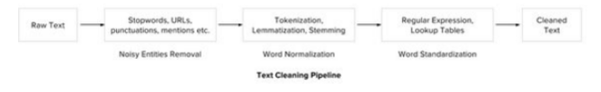

**Word tokenizing/tokenization:**

**3 ways:**

**from** nltk.tokenize **import** word_tokenize  
**from** nltk.tokenize **import** TreebankWordTokenizer  
**from** nltk.tokenize **import** WordPunctTokenizer  
  
parag = **"My name is saranya. I'm learning Python. It's interesting!!"**print(sent_tokenize(parag))  
print(word_tokenize(parag))  
tok2 = TreebankWordTokenizer()  
tok3 = WordPunctTokenizer()  
print(tok2.tokenize(parag))  
print(tok3.tokenize(parag))

**o/p:**

['My', 'name', 'is', 'saranya', '.', 'I', "'m", 'learning', 'Python', '.', 'It', "'s", 'interesting', '!', '!']

['My', 'name', 'is', 'saranya.', 'I', "'m", 'learning', 'Python.', 'It', "'s", 'interesting', '!', '!']

['My', 'name', 'is', 'saranya', '.', 'I', "'", 'm', 'learning', 'Python', '.', 'It', "'", 's', 'interesting', '!!']

**Lexicon Normalizing techniques:**

**Stemming and Lemmatizing:**

The most common lexicon normalization practices are :

* Stemming:  Stemming is a rudimentary rule-based process of stripping the suffixes (“ing”, “ly”, “es”, “s” etc) from a word.
* Lemmatization: Lemmatization, on the other hand, is an organized & step by step procedure of obtaining the root form of the word, it makes use of vocabulary (dictionary importance of words) and morphological analysis (word structure and grammar relations).

>>> from nltk.stem.wordnet import WordNetLemmatizer

>>> lem=WordNetLemmatizer()

>>> lem.lemmatize("multiplying","v")

'multiply'

>>> from nltk.stem.porter import PorterStemmer

>>> ps = PorterStemmer()

>>> ps.stem("multiplying")

'multipli'

>>>

**Nltk wordnet.synsets:**

>>> from nltk.corpus import wordnet

>>> myw

'Dragon'

>>> wordnet.synsets(myw)

[Synset('dragon.n.01'), Synset('dragon.n.02'), Synset('draco.n.02'), Synset('dra

gon.n.04')]

>>> syn = wordnet.synsets(myw)

>>> syn[0]

Synset('dragon.n.01')

>>> syn[0].name()

'dragon.n.01'

>>> syn[0].definition()

'a creature of Teutonic mythology; usually represented as breathing fire and hav

ing a reptilian body and sometimes wings'

>>> syn[0].examples()

[]

>>> syn[1].name()

'dragon.n.02'

>>> syn[1].lemmas()[0].name() # Lemma is the normalized form of a word

'dragon'

>>> syn[1].lemmas()[0]

Lemma('dragon.n.02.dragon')

>>> w1 = wordnet.synset('ship.n.01')

>>> w2 = wordnet.synset('boat.n.01')

>>> w1.wup_similarity(w2) # Wu and Palmer similarity test

0.9090909090909091

>>> syn[1].pos()

'n'

n-> noun, a -> adjective, r -> adverb, v-> verb (Parts of speech –pos)

**Difference between synsets and synset:**

>>> w1 = wordnet.synset('cat.n.01') # with synset, we need to give in complete format..ie. word.pos

>>> w1

Synset('cat.n.01')

>>> syn = wordnet.synsets('weapon') # synsets used to get the synonyms set for a word.

>>> syn

[Synset('weapon.n.01'), Synset('weapon.n.02')]

>>>

**hypernyms and hyponyms:**

>>> myw ='cat'

>>> syn = wordnet.synsets(myw)

>>> syn

[Synset('cat.n.01'), Synset('guy.n.01'), Synset('cat.n.03'), Synset('kat.n.01'),

Synset('cat-o'-nine-tails.n.01'), Synset('caterpillar.n.02'), Synset('big_cat.n

.01'), Synset('computerized_tomography.n.01'), Synset('cat.v.01'), Synset('vomit

.v.01')]

>>> s = syn[0]

>>> s.hypernyms() # returns super class of the variable

[Synset('feline.n.01')]

>>> s.hyponyms() # returns the subclasses of the variable

[Synset('domestic_cat.n.01'), Synset('wildcat.n.03')]

**Textonyms:**

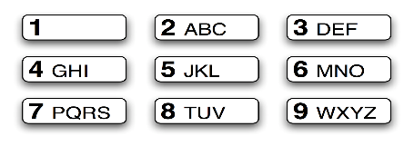

***Figure 3.5****: T9: Text on 9 Keys*

Two or more words that are entered with the same sequence of keystrokes are known as textonyms. For example, both **hole** and **golf** are entered by pressing the sequence 4653. What other words could be produced with the same sequence? Here we use the regular expression «^[ghi][mno][jlk][def]$»:

|  |  |
| --- | --- |
| |  | | --- | | **>>> [w for w in wordlist if re.search('^[ghi][mno][jlk][def]$', w)]**  **['gold', 'golf', 'hold', 'hole']** | |

**POS tagger:**

The process of classifying words into their parts of speech and labeling them accordingly is known as **part-of-speech tagging,****POS-tagging, or simply****tagging**. Parts of speech are also known as **word classes or****lexical categories**. The collection of tags used for a particular task is known as a **tagset.**

|  |  |  |
| --- | --- | --- |
| |  |  | | --- | --- | |  | **>>> text = word_tokenize("And now for something completely different")**  **>>> nltk.pos_tag(text)**  **[('And', 'CC'), ('now', 'RB'), ('for', 'IN'), ('something', 'NN'),**  **('completely', 'RB'), ('different', 'JJ')]** | |

CC – Coordinating Conjunction

RB – Adverb

IN – Preposition

NN –Noun

JJ – Adjective

VBP – Present tense verb

>>>nltk.help.upenn_tagset() # This command lists all POS tags.

>>> my_Sent = "This is me saranya. I'm reading Python! It's really interesting"

>>> tokens = nltk.word_tokenize(my_Sent)

>>> tokens

['This', 'is', 'me', 'saranya', '.', 'I', "'m", 'reading', 'Python', '!', 'It',

"'s", 'really', 'interesting']

>>> tagged = nltk.pos_tag(tokens)

>>> tagged

[('This', 'DT'), ('is', 'VBZ'), ('me', 'PRP'), ('saranya', 'JJ'), ('.', '.'), ('

I', 'PRP'), ("'m", 'VBP'), ('reading', 'VBG'), ('Python', 'NN'), ('!', '.'), ('I

t', 'PRP'), ("'s", 'VBZ'), ('really', 'RB'), ('interesting', 'JJ')]

**Synonymns and Antonyms:**

>>> from nltk.corpus import wordnet

>>> sArr = wordnet.synsets('win')

>>> sArr

[Synset('win.n.01'), Synset('winnings.n.01'), Synset('win.v.01'), Synset('acquir

e.v.05'), Synset('gain.v.05'), Synset('succeed.v.01')]

>>> sArr[2]

Synset('win.v.01')

>>> woi = sArr[2]

>>> woi

Synset('win.v.01')

>>> woi.pos()

'v'

>>> woi.definition()

'be the winner in a contest or competition; be victorious'

>>> woi.name()

'win.v.01'

>>> woi.lemmas()

[Lemma('win.v.01.win')]

>>> woi.lemmas()[0]

Lemma('win.v.01.win')

>>> synArr = [] # empty array to store synonyms

>>> antArr = [] # empty array to store antonyms

>>>

>>> for syn in sArr:

... for lem in syn.lemmas():

... synArr.append(lem.name())

...

>>> synArr

['win', 'winnings', 'win', 'profits', 'win', 'acquire', 'win', 'gain', 'gain', '

advance', 'win', 'pull_ahead', 'make_headway', 'get_ahead', 'gain_ground', 'succ

eed', 'win', 'come_through', 'bring_home_the_bacon', 'deliver_the_goods']

>>> set(synArr)

{'gain', 'winnings', 'come_through', 'acquire', 'pull_ahead', 'advance', 'make_h

eadway', 'deliver_the_goods', 'get_ahead', 'bring_home_the_bacon', 'gain_ground'

, 'win', 'succeed', 'profits'}

>>> len(synArr)

20

>>> len(set(synArr))

14

>>> #Antonym

...

>>> woi

Synset('win.v.01')

>>> woi.lemmas()

[Lemma('win.v.01.win')]

>>> woi.lemmas()[0].name()

'win'

>>> woi.lemmas()[0].antonyms()

[Lemma('lose.v.02.lose')]

>>> woi.lemmas()[0].antonyms()[0].name()

'lose'

>>> for syn in sArr:

... for lem in syn.lemmas():

... for ant in lem.antonyms():

... antArr.append(ant.name())

...

>>> antArr

['losings', 'lose', 'lose', 'fall_back', 'fail']

>>> set(antArr)

{'lose', 'fall_back', 'losings', 'fail'}

>>> len(antArr)

5

>>> len(set(antArr))

4

>>>

**Subprocess:**

[**http://www.pythonforbeginners.com/os/subprocess-for-system-administrators**](http://www.pythonforbeginners.com/os/subprocess-for-system-administrators)

**Python Logger:**

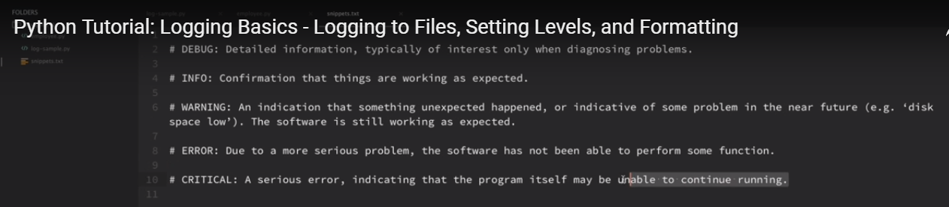

Default logging level is warning. So any warning or higher levels, will only be displayed to console.

logging.debug and logging.info would not be printed to console.

Inorder to change the default logging level, 

Note: logging.DEBUG, DEBUG is caps, this is different from logging.debug() method. DEBUG is a constant at background and logging levels are all multiples of 10. DEBUG is 10, INFO 20, WARNING 30, ERROR 40, CRITICAL 50

Once logging.DEBUG is added to basicConfig, we can see the debug messages to the console. If we want to add the logs to a file, use below config in basicConfig



All the logs, gets stored in test.log. and it gets appended with all the changes.

Inorder to change the format of logs,



We can get different logging attributes from below link

<https://docs.python.org/2/library/logging.html>

Drawback of not having logger:

Lets say, we are importing another .py file into our file and both has logging.basicConfig, the one that we invoke will become the root logger and the one from which we invoked may not be printed if the logging level is lower than the invoked function.

In order to avoid all these confusions, we create a logger for each module.

As you can see below, basicConfig is replaced with logger and FileHandler

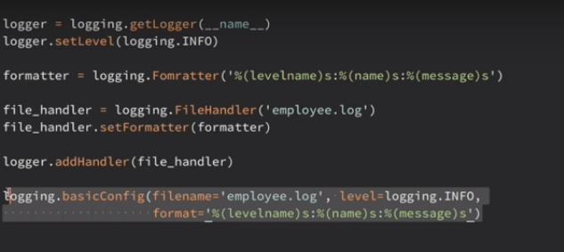

logging.error() 🡺 returns the message that we have given.

logging.exception() 🡺 returns the traceback exception as well in the logs.

StreamHandler():

Stream handler is allows us to log other logging levels(Other than what we have given in FileHandler) to the console.

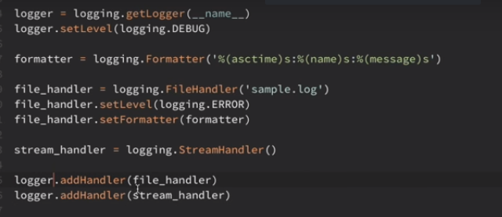

Scikit learn tutorial link:

<https://github.com/jakevdp/sklearn_pycon2015/blob/master/notebooks/>

<https://github.com/ogrisel/parallel_ml_tutorial/tree/master/notebooks>

Isomap -> non-linear dimentionality reduction algorithm

<http://scikit-learn.org/stable/tutorial/machine_learning_map/>

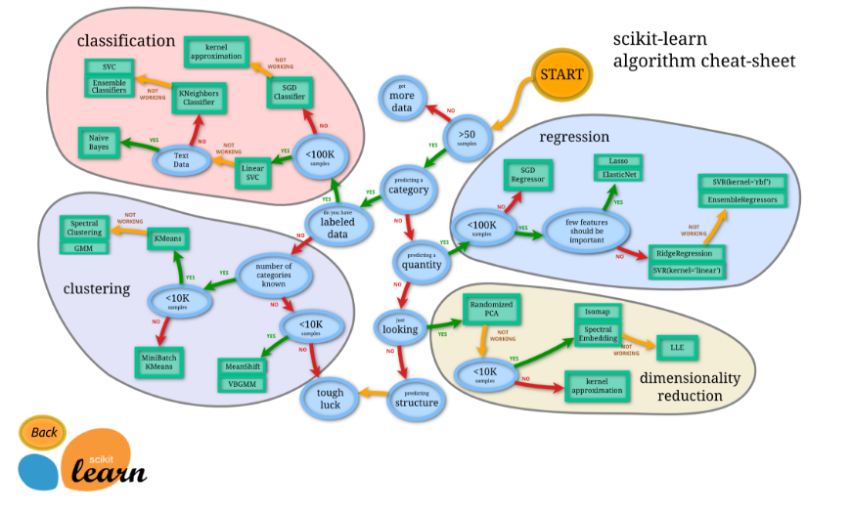

**Train_test_split:**

X_train, X_test, y_train, y_test = train_test_split(X, y, test_size=0.33, random_state=42)

Random_state -> similar to set.seed(42) In order to replicate the same data selection everytime, we set random_state to some random number.

**Deep Learning:**

**Material:** [https://www.manning.com/books/deep-learning-**with**-python](https://www.manning.com/books/deep-learning-with-python)

**Unsupervised learning:**

If we want to identify patterns in the data -> we can use RBM(Restricted Boltzmann Machine) or Autoencoders.

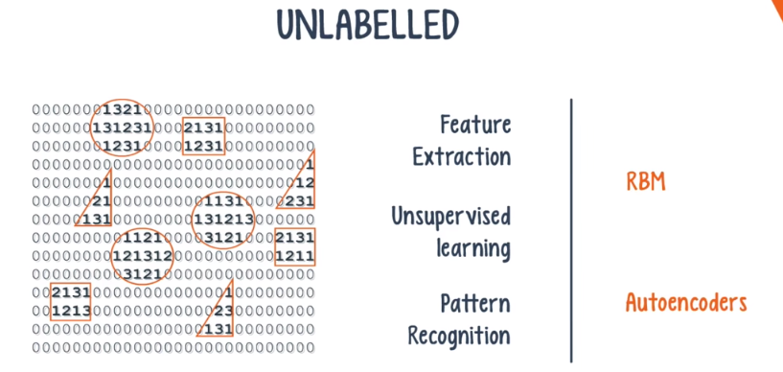

**RBM: (overcomes vanishing gradient problem)**

* 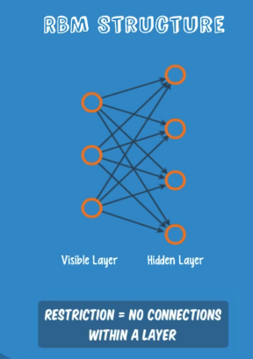
* RBM has 2 layers, visible layer and hidden layer. Each nodes from visible layer is connected with hidden layer. Ie. Inputs from visible layer gets converted to a number which corresponds to the hidden layer. In back propagation, from the numbers, we regenerate the input. Weight and bias plays important role.
* Through several forward and backward passes, an RBM is trained to reconstruct the input data. Three steps are repeated over and over through the training process:
* a) With a forward pass, every input is combined with an individual weight and one overall bias, and the result is passed to the hidden layer which may or may not activate.
* b) Next, in a backward pass, each activation is combined with an individual weight and an overall bias, and the result is passed to the visible layer for reconstruction.
* c) At the visible layer, the reconstruction is compared against the original input to determine the quality of the result. RBMs use a measure called KL Divergence for step c);
* steps a) thru c) are repeated with varying weights and biases until the input and the re-construction are as close as possible.

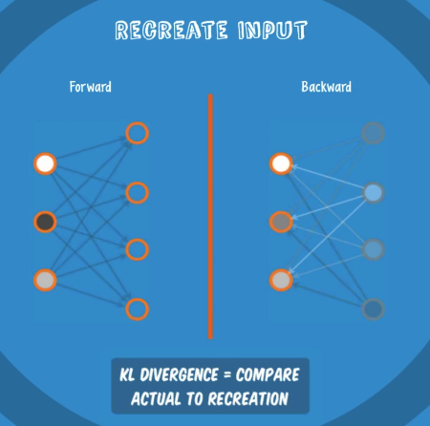

**How RBM helps with vanishing gradient problem?**

* By combining RBMs together and introducing a clever training method, we obtain a powerful new model that finally solves our problem. Deep belief Network

**Deep Belief Network:**

* In terms of network structure, a DBN is identical to an MLP. But when it comes to training, they are entirely different. In fact, the difference in training methods is the key factor that enables DBNs to outperform their shallow counterparts.
* A deep belief network can be viewed as a stack of RBMs, where the hidden layer of one RBM is the visible layer of the one "above" it. A DBN is trained as follows:
* a) The first RBM is trained to re-construct its input as accurately as possible
* b) The hidden layer of the first RBM is treated as the visible layer for the second and the second RBM is trained using the outputs from the first RBM
* c) This process is repeated until every layer in the network is trained
* An important note about a DBN is that each RBM layer learns the entire input.
* The reason that a DBN works so well is highly technical, but suffice it to say that a stack of RBMs will outperform a single unit – just like a Multilayer perceptron was able to outperform a single perceptron working alone.
* After this initial training, the RBMs have created a model that can detect inherent patterns in the data. But we still don’t know exactly what the patterns are called. To finish training, we need to introduce labels to the patterns and fine-tune the net with supervised learning.
* To do this, you need a very small set of labeled samples so that the features and patterns can be associated with a name. The weights and biases are altered slightly, resulting in a small change in the net’s perception of the patterns, and often a small increase in the total accuracy. Fortunately, the set of labelled data can be small relative to the original data set, which as we’ve discussed, is extremely helpful in real-world applications.

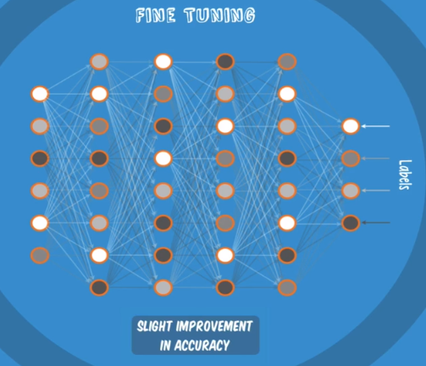

**How Colour images are stored:**

3 layer of pixels with red,green and blue color component in each layer.

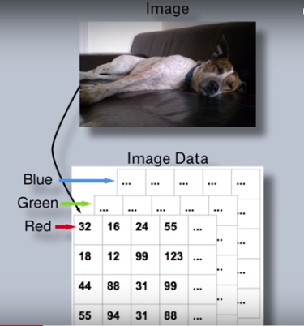

**Convolutin :**

Small tensor that can be multiplied over little sections of the main image.

eg: It’s a 2*2 convolution for detecting horizontal line. The numerical value in the convolution determine what pattern it detects.

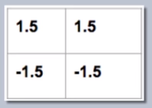

**Convolutional Net:**

* There are many component layers to a CNN, and we will explain them one at a time. Let’s start with an analogy that will help describe the first component, which is the “convolutional layer”
* Imagine that we have a wall, which will represent a digital image. Also imagine that we have a series of flashlights shining at the wall, creating a group of overlapping circles.



* The purpose of these flashlights is to seek out a certain pattern in the image, like an edge or a color contrast for example. Each flashlight looks for the exact same pattern as all the others, but they all search in a different section of the image, defined by the fixed region created by the circle of light. When combined together, the flashlights form what’s a called a filter. A filter is able to determine if the given pattern occurs in the image,and in what regions. What you see in this example is an 8x6 grid of lights, which is all considered to be one filter.
* Now let’s take a look from the top. In practice, flashlights from multiple different filters will all be shining at the same spots in parallel, simultaneously detecting a wide array of patterns.

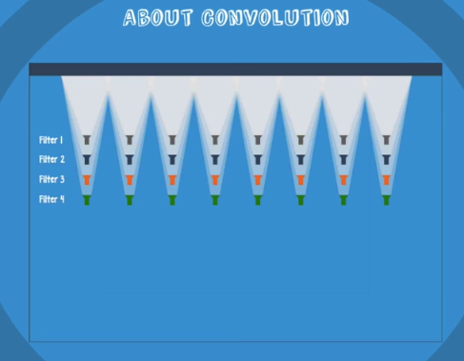

* In this example, we have four filters all shining at the wall, all looking for a different pattern. So this particular convolutional layer is an 8x6x4, 3-dimensionsal grid of these flashlights.
* Now let’s connect the dots of our explanation: - Why is it called a convolutional net? The net uses the technical operation of convolution to search for a particular pattern. While the exact definition of convolution is beyond the scope of this video, to keep things simple, just think of it as the process of filtering through the image for a specific pattern.
* Although one important note is that the weights and biases of this layer affect how this operation is performed: tweaking these numbers impacts the effectiveness of the filtering process.



* Each flashlight represents a neuron in the CNN. Typically, neurons in a layer activate or fire. On the other hand, in the convolutional layer, neurons perform this “convolution” operation. We're going to draw a box around one set of flashlights to make things look a bit more organized.

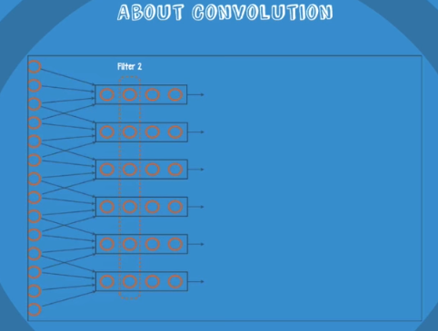

* Unlike the nets we've seen thus far where every neuron in a layer is connected to every neuron in the adjacent layers, a CNN has the flashlight structure. Each neuron is only connected to the input neurons it "shines" upon.

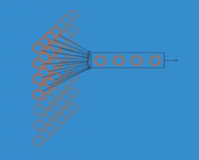

* The neurons in a given filter share the same weight and bias parameters. This means that, anywhere on the filter, a given neuron is connected to the same number of input neurons and has the same weights and biases. This is what allows the filter to look for the same pattern in different sections of the image. By arranging these neurons in the same structure as the flashlight grid, we ensure that the entire image is scanned.
* 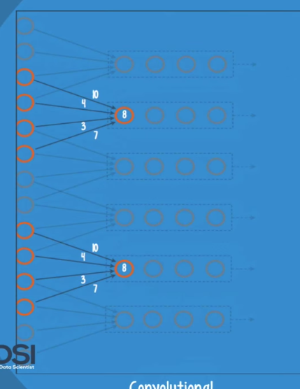
* The next two layers that follow are RELU and pooling, both of which help to build up the simple patterns discovered by the convolutional layer. Each node in the convolutional layer is connected to a node that fires like in other nets. The activation used is called RELU, or rectified linear unit.
* 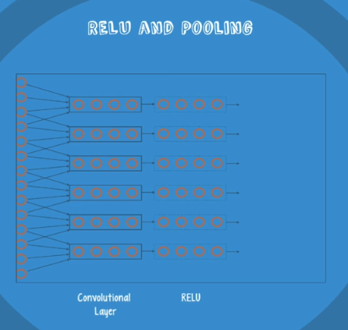
* CNNs are trained using backpropagation, so the vanishing gradient is once again a potential issue. For reasons that depend on the mathematical definition

of RELU, the gradient is held more or less constant at every layer of the net. So the RELU activation allows the net to be properly trained, without harmful slowdowns in the crucial early layers.

* The pooling layer is used for dimensionality reduction. CNNs tile multiple instances of convolutional layers and RELU layers together in a sequence, in order to build more and more complex patterns. The problem with this is that the number of possible patterns becomes exceedingly large.
* 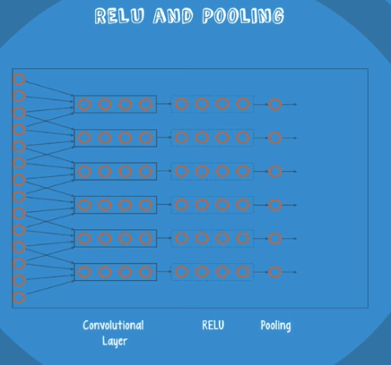
* By introducing pooling layers, we ensure that the net focuses on only the most relevant patterns discovered by convolution and RELU. This helps limit both the memory and processing requirements for running a CNN.
* Together, these three layers can discover a host of complex patterns, but the net will have no understanding of what these patterns mean. So a fully connected layer is attached to the end of the net in order to equip the net with the ability to classify data samples.

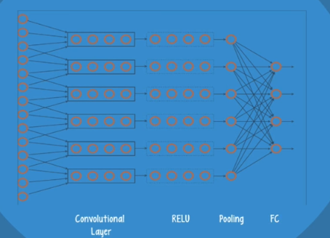

* Let’s recap the major components of a CNN. A typical deep CNN has three sets of layers – a convolutional layer, RELU, and pooling layers – all of which are repeated several times. These layers are followed by a few fully connected layers in order to support classification.
* 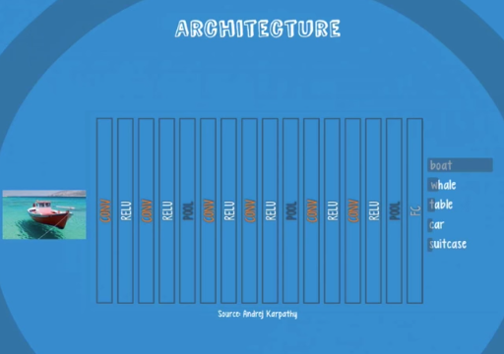
* Since CNNs are such deep nets, they most likely need to be trained using server resources with GPUs.
* Despite the power of CNNs, these nets have one drawback. Since they are a supervised learning method, they require a large set of labelled data for training, which can be challenging to obtain in a real-world application.

**Convolutional net in text processing:**

[**http://www.wildml.com/2015/11/understanding-convolutional-neural-networks-for-nlp/**](http://www.wildml.com/2015/11/understanding-convolutional-neural-networks-for-nlp/)

**Recurrent Net/Recurrent Neural Net (RNN):**

**Ref links:** [**https://iamtrask.github.io/2015/11/15/anyone-can-code-lstm/**](https://iamtrask.github.io/2015/11/15/anyone-can-code-lstm/)

[**http://karpathy.github.io/2015/05/21/rnn-effectiveness/**](http://karpathy.github.io/2015/05/21/rnn-effectiveness/)

* What do you do if the patterns in your data change with time? In that case, your best bet is to use a recurrent neural network. This deep learning model has a simple structure with a built-in feedback loop, allowing it to act as a forecasting engine.
* Recurrent neural networks, or RNNs, have a long history, but their recent popularity is mostly due to the works of Juergen Schmidhuber, Sepp Hochreiter, and Alex Graves. Their applications are extremely versatile – ranging from speech recognition to driverless cars.
* All the nets we’ve seen up to this point have been feedforward neural networks. In a feedforward neural network, signals flow in only one direction from input to output, one layer at a time. In a recurrent net, the output of a layer is added to the next input and fed back into the same layer, which is typically the only layer in the entire network.
* You can think of this process as a passage through time – shown here are 4 such time steps. At t = 1, the net takes the output of time t = 0 and sends it back into the net along with the next input. The net repeats this for t = 2, t = 3, and so on.
* 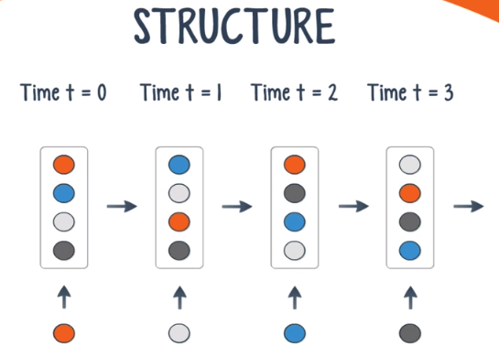
* Unlike feedforward nets, a recurrent net can receive a sequence of values as input, and it can also produce a sequence of values as output. The ability to operate with sequences opens up these nets to a wide variety of applications. Here are a few examples.
* When the input is singular and the output is a sequence, a potential application is image captioning.
* 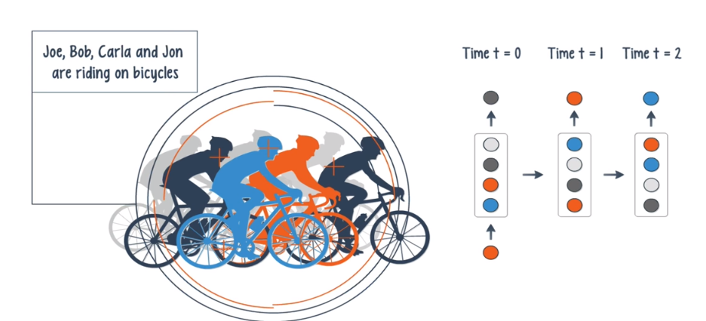
* A sequence of inputs with a single output can be used for document classification.
* 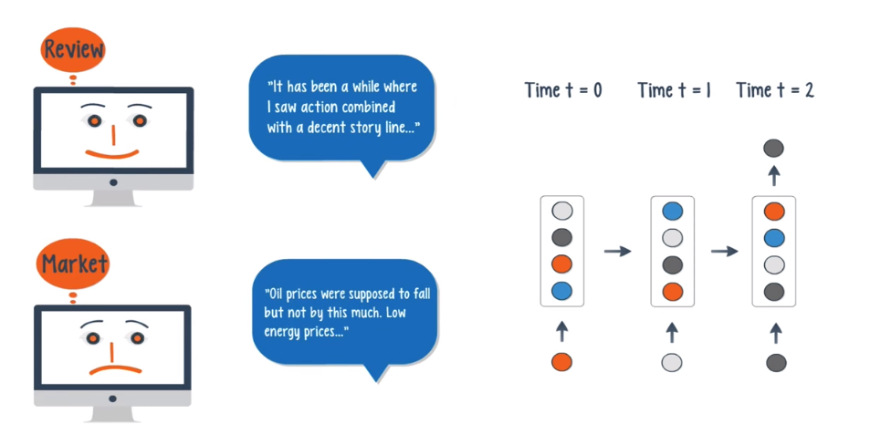
* When both the input and output are sequences, these nets can classify videos frame by frame.
* 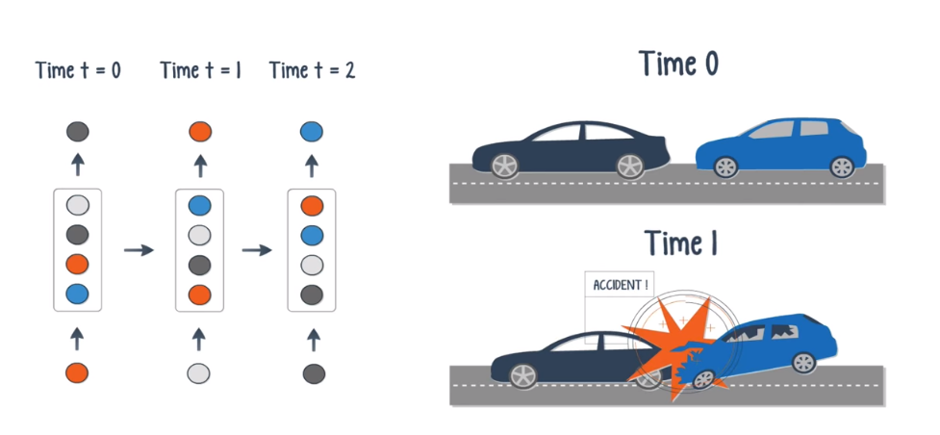
* If a time delay is introduced, the net can statistically forecast the demand in supply chain planning.

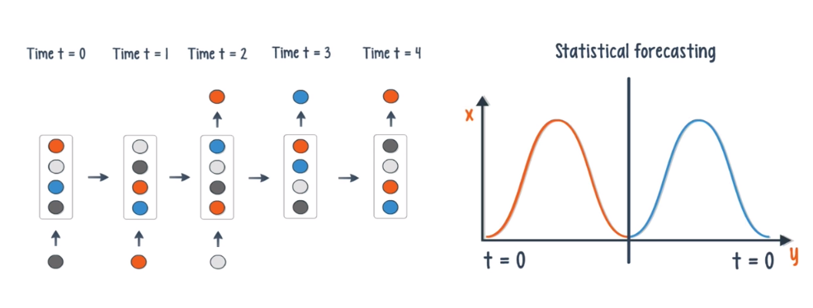

* Like we’ve seen with previous deep learning models, by stacking RNNs on top of each other, you can form a net capable of more complex output than a single RNN working alone.
* Typically, an RNN is an extremely difficult net to train. Since these nets use backpropagation, we once again run into the problem of the vanishing gradient. Unfortunately, the vanishing gradient is exponentially worse for an RNN. The reason for this is that each time step is the equivalent of an entire layer in a feedforward network. So training an RNN for 100 time steps is like training a 100-layer feedforward net – this leads to exponentially small gradients and a decay of information through time.

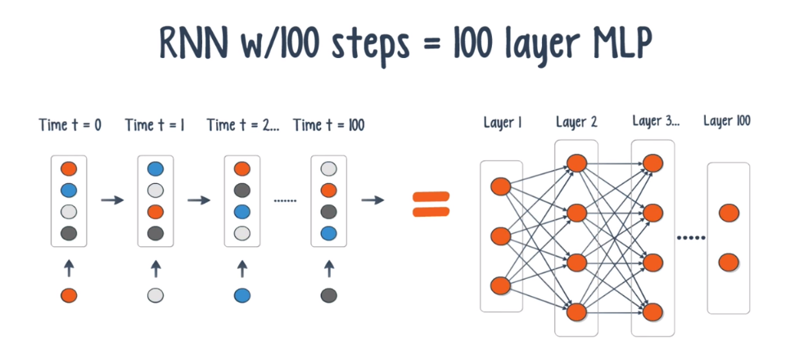

* There are several ways to address this problem - the most popular of which is **gating**. Gating is a technique that helps the net decide when to forget the current input, and when to remember it for future time steps. The most popular gating types today are **GRU(Gated Recurrent Unit) and LSTM(Long Short Term Memory)**. Besides gating, there are also a few other techniques like **gradient clipping, steeper gates, and better optimizers.**
* When it comes to training a recurrent net, GPUs are an obvious choice over an ordinary CPU. This was validated by a research team at Indico, which uses these nets on text processing tasks like sentiment analysis and helpfulness extraction. The team found that GPUs were able to train the nets 250 times faster! That’s the difference between one day of training, and over eight months!
* So under what circumstances would you use a recurrent net over a feedforward net? We know that a feedforward net outputs one value, which in many cases was a class or a prediction.
* A recurrent net is suited for time series data, where an output can be the next value in a sequence, or the next several values. So the answer depends on whether the application calls for classification, regression, or forecasting.

RNNs (Link: <http://www.wildml.com/2015/09/recurrent-neural-networks-tutorial-part-1-introduction-to-rnns/>)

RNNs are called *recurrent* because they perform the same task for every element of a sequence, with the output being depended on the previous computations. Another way to think about RNNs is that they have a “memory” which captures information about what has been calculated so far.

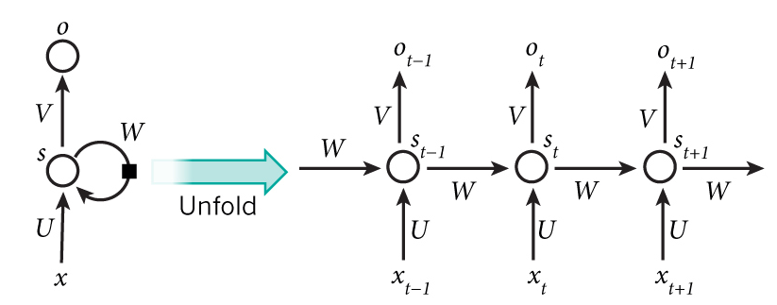

For example, if the sequence we care about is a sentence of 5 words, the network would be unrolled into a 5-layer neural network, one layer for each word. The formulas that govern the computation happening in a RNN are as follows:

*  is the input at time step . For example,  could be a one-hot vector corresponding to the second word of a sentence.
*  is the hidden state at time step . It’s the “memory” of the network.  is calculated based on the previous hidden state and the input at the current step: . The function  usually is a nonlinearity such as [tanh](https://reference.wolfram.com/language/ref/Tanh.html) or [ReLU](https://en.wikipedia.org/wiki/Rectifier_(neural_networks)).  , which is required to calculate the first hidden state, is typically initialized to all zeroes.
*  is the output at step . For example, if we wanted to predict the next word in a sentence it would be a vector of probabilities across our vocabulary. .

There are a few things to note here:

* You can think of the hidden state  as the memory of the network.  captures information about what happened in all the previous time steps. The output at step  is calculated solely based on the memory at time . As briefly mentioned above, it’s a bit more complicated  in practice because  typically can’t capture information from too many time steps ago.
* Unlike a traditional deep neural network, which uses different parameters at each layer, a RNN shares the same parameters ( above) across all steps. This reflects the fact that we are performing the same task at each step, just with different inputs. This greatly reduces the total number of parameters we need to learn.
* The above diagram has outputs at each time step, but depending on the task this may not be necessary. For example, when predicting the sentiment of a sentence we may only care about the final output, not the sentiment after each word. Similarly, we may not need inputs at each time step. The main feature of an RNN is its hidden state, which captures some information about a sequence.

RNNs used in :

* 1. Language Modelling

Given a sequence of words we want to predict the probability of each word given the previous words.

* 1. Machine Translation

Machine Translation is similar to language modeling in that our input is a sequence of words in our source language (e.g. German). We want to output a sequence of words in our target language (e.g. English). A key difference is that our output only starts after we have seen the complete input, because the first word of our translated sentences may require information captured from the complete input sequence.

* 1. Speech recognition

Given an input sequence of acoustic signals from a sound wave, we can predict a sequence of phonetic segments together with their probabilities.

* 1. Generating Image Descriptions

Together with convolutional Neural Networks, RNNs have been used as part of a model to [generate descriptions](http://cs.stanford.edu/people/karpathy/deepimagesent/) for unlabeled images. It’s quite amazing how well this seems to work. The combined model even aligns the generated words with features found in the images.

**RNNs extensions:**

1. **Bidirectional RNN:**

**Bidirectional RNNs** are based on the idea that the output at time  may not only depend on the previous elements in the sequence, but also future elements. For example, to predict a missing word in a sequence you want to look at both the left and the right context. Bidirectional RNNs are quite simple. They are just two RNNs stacked on top of each other. The output is then computed based on the hidden state of both RNNs.

[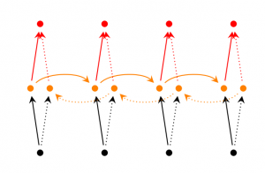](http://d3kbpzbmcynnmx.cloudfront.net/wp-content/uploads/2015/09/bidirectional-rnn.png)

1. **Deep (Bidirectional) RNNs** are similar to Bidirectional RNNs, only that we now have multiple layers per time step. In practice this gives us a higher learning capacity (but we also need a lot of training data).

[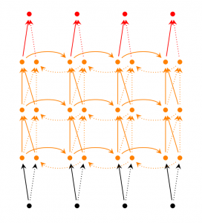](http://d3kbpzbmcynnmx.cloudfront.net/wp-content/uploads/2015/09/Screen-Shot-2015-09-16-at-2.21.51-PM.png)

1. **LSTM networks** are quite popular these days and we briefly talked about them above. LSTMs don’t have a fundamentally different architecture from RNNs, but they use a different function to compute the hidden state. The memory in LSTMs are called *cells* and you can think of them as black boxes that take as input the previous state  and current input . Internally these cells  decide what to keep in (and what to erase from) memory. They then combine the previous state, the current memory, and the input. It turns out that these types of units are very efficient at capturing long-term dependencies.

**Autoencoders:**

* There are times when it’s extremely useful to figure out the underlying structure of a data set. Having access to the most important data features gives you a lot of flexibility when you start applying labels. Autoencoders are an important family of neural networks that are well-suited for this task.
* In a previous video we looked at the Restricted Boltzmann Machine, which is a very popular example of an autoencoder. But there are other types of autoencoders like **denoising and contractive**, just to name a few. Just like an RBM, an autoencoder is a neural net that takes a set of typically unlabelled inputs, and after encoding them, tries to reconstruct them as accurately as

possible. As a result of this, the net must decide which of the data features are the most important, essentially acting as a feature extraction engine.

* Autoencoders are typically very shallow, and are usually comprised of an input layer, an output layer and a hidden layer. An RBM is an example of an autoencoder with only two layers. Here is a forward pass that ends with a reconstruction of the input. There are two steps - the encoding and the decoding. Typically, the same weights that are used to encode a feature in the hidden layer are used to reconstruct an image in the output layer.
* 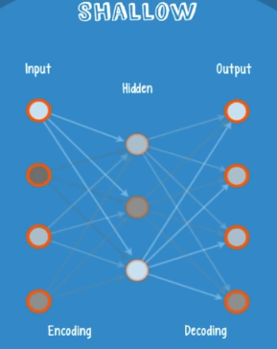
* Autoencoders are trained with backpropagation, using a metric called “loss”. As opposed to “cost”, loss measures the amount of information that was lost when the net tried to reconstruct the input. A net with a small loss value will produce reconstructions that look very similar to the originals.
* 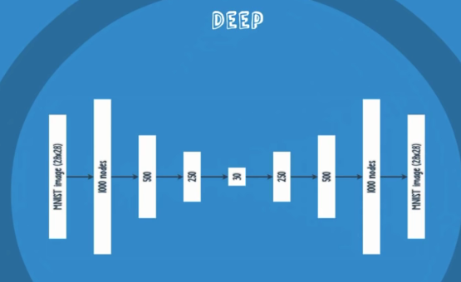
* Not all of these nets are shallow. In fact, deep autoencoders are extremely useful tools for dimensionality reduction. Consider an image containing a 28x28 grid of pixels. A neural net would need to process over 750 input values just for one image – doing this across millions of images would waste significant amounts of memory and processing time. A deep autoencoder could encode this image into an impressive 30 numbers, and still maintain information about the key image features. When decoding the output, the net acts like a two-way translator. In this example, a well-trained net could translate these 30 encoded numbers back into a reconstruction that looks similar to the original image. Certain types of nets also introduce random noise to the encoding-decoding process, which has been shown to improve the robustness of the resulting patterns.
* Deep autoencoders perform better at dimensionality reduction than their predecessor, principal component analysis, or PCA. Below is a comparison of two letter codes for news stories of different topics – generated by both a deep autoencoder and a PCA. Labels were added to the picture for illustrative purposes.
* 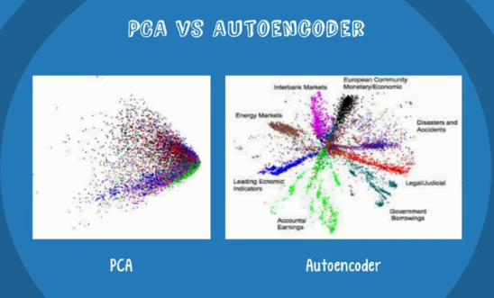

**Recursive Neural Tensor Nets:**

* Sometimes it’s useful to discover the hierarchical structure of a set of data, such as the parse trees of a group of sentences. In these cases, Recursive Neural Tensor Networks, or RNTNs, are a better fit than feedforward or recurrent nets. Let’s take a closer look and see why.
* RNTNs were conceived by Richard Socher of MetaMind as part of his PhD thesis at Stanford.
* The purpose of these nets was to analyze data that had a hierarchical structure. Originally, they were designed for sentiment analysis, where the sentiment of a sentence depends not just on its component words, but on the order in which they’re syntactically grouped.
* 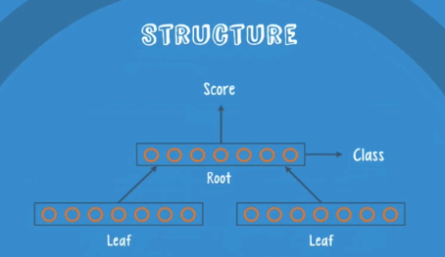
* So let’s take a look at the structure of an RNTN. An RNTN has three basic components – a parent group, which we’ll call the root, and the child groups, which we’ll call the leaves. Each group is simply a collection of neurons, where the number of neurons depends on the complexity of the input data. As you can see, the root is connected to both leaves, but the leaves are not connected to each other. Technically speaking, the three components form what’s called a binary tree. In general, the leaf groups receive input, and the root group uses a classifier to fire out a class and a score. We’ll get to the significance of these two values in a moment.
* An RNTN’s structure may seem simple, but just like a recurrent net, the complexity comes from the way in which data moves throughout the network.
* In the case of an RNTN, this process is recursive. To see how this recursion works, let’s take a look at an example. Let’s feed an English sentence into the net, and receive the sentence’s parse tree as output. At step one, we feed the first two words into leaf groups one and two, respectively. As a practical note, the leaf groups do not actually receive the words per say, but rather vector representations of the words. A vector is just an ordered set of numbers, and it’s been shown that these nets work best with very specific vector representations – particularly, good results are achieved when the numbers in the two vectors encode the similarities between the two words, when compared to other words in the vocabulary. The exact details of this process are beyond the scope of this video.

* The two vectors move across the net to the root, which processes them and fires out two values – the class and the score. The score represents the quality of the current parse, and the class represents an encoding of a structure in the current parse. This is the point where the net starts the recursion. At the next step, the first leaf group now receives the current parse, rather than a single word. The second leaf group receives the next word in the sentence. At this point, the root group would output the score of a parse that is three words long. This continues until all the inputs are used up, and the net has a parse tree with every single word included.
* 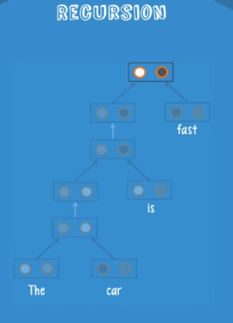
* This simplified example illustrates the main idea behind an RNTN; but in a practical application, we typically encounter more complex recursive processes. Rather than use the next word in the sentence for the second leaf group, an RNTN would try all of the next words, and eventually, vectors that represent entire sub-parses. By doing this at every step of the recursive process, the net is able to analyze – and score – every possible syntactic parse.
* Shown here are three possible parse trees for the same sentence. To pick the best one, the net relies on the score value produced by the root group. By using this score to select the best substructure at each step of the recursive process, the net will produce the highest-scoring parse as its final output.
* 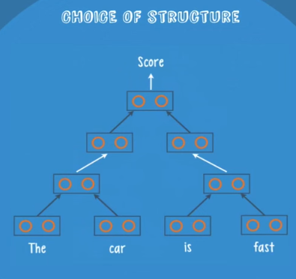
* 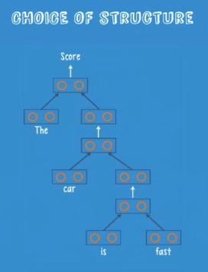
* Once the net has the final structure, it backtracks through the parse tree in order to figure out the right grammatical label for each part of the sentence. Here, it does that one first and labels it as a noun phrase. Then it works on this, and you get a verb phrase. It then works its way up, and when it reaches the top, it adds a special label that signifies the beginning of the parse structure.
* 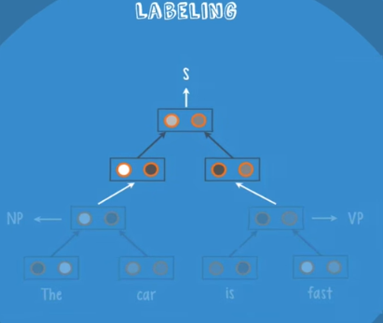
* RNTNs are trained with backpropagation by comparing the predicted sentence structure with the proper sentence structure obtained from a set of labelled training data. Once trained, the net will give a higher score to structures that are more similar to the parse trees that it saw in training.
* RNTNs are used in natural language processing for both syntactic parsing and sentiment analysis.
* 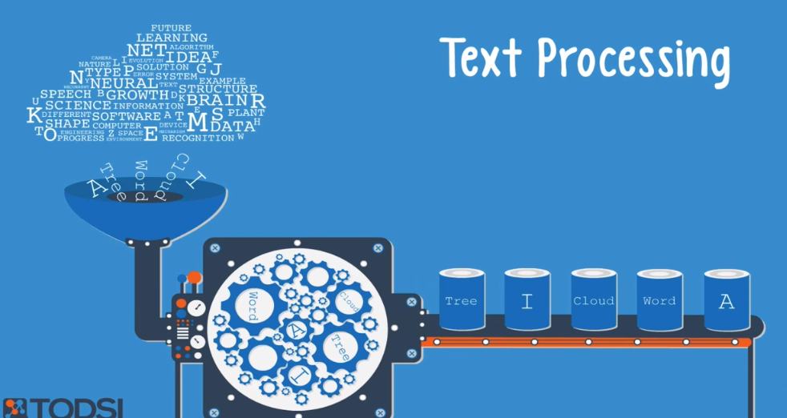
* They are also used to parse images, typically when an image contains a scene with many different components.
* 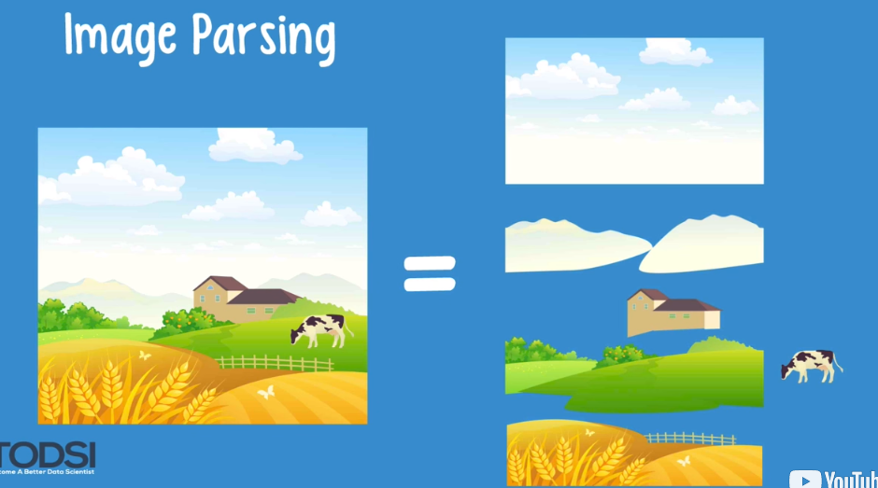

**Supervised learning:**

* For text processing tasks like sentiment analysis, parsing, and named entity recognition – use a Recurrent Net or a Recursive Neural Tensor Network, which we’ll refer to as an RNTN.

1. RNTN – Recursive Neural Tensor Network
2. Character level model – Recurrent net

* For Image recognition:

1. DBN – Deep Belief Network
2. Convolutional Network

* For Object recognition:

1. Convolutional Net
2. RNTN – Recursive Neural Tensor Network

* For Speech recognition:
  1. Recurrent Net

Deep Network training process utilizes something called a gradient, which measures the rate at which the cost will change with respect to a change in a weight or a bias. When gradient is large, net will train quickly, if gradient is small, net will train slowly.

Process used for training neural network is back propagation or back prop

In general,

|  |  |
| --- | --- |
| Classification | MLP(Multi –Layer Perceptron with Rectified Linear units(RELU) or DBN(Deep Belief Networks) |
| Time Series Analysis | Recurrent Net |

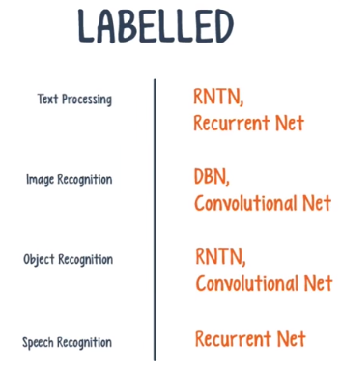

**In summary:**

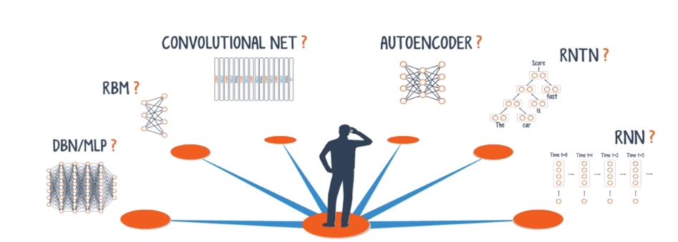

**Deep learning platforms:**

**2 types:**

1. Full Platform

Deep Learning platform provides a set of tools and an interface for building custom deep nets. Typically, they provide a user with a selection of deep nets to choose from, along with the ability to integrate data from different sources, manipulate data, and manage models through a UI. Some platforms also help with performance if a net needs to be trained with a large data set.

 A platform is an out-of-the-box application that lets you configure

a deep net’s hyper-parameters through an intuitive UI; with a platform, you don’t need to know anything about coding in order to use the tools. The downside is that you are constrained by the platform’s selection of deep nets as well as the configuration options. But for anyone looking to quickly deploy a deep net, a platform is the best way to go.

1. Software libraries

A software library is a set of functions and modules that you can call through your own code in order to perform certain tasks. Deep net libraries give you a lot of extra flexibility with net selection and hyper-parameter configuration. For example, there aren’t many platforms

that let you build a Recursive Neural Tensor Net, but you can code your own with the right deep net library! The obvious downside to libraries is the coding experience required to use them, but if you need the flexibility, they really are a great resource.

**H2O:**

* If you need to run different learning models alongside a deep net – perhaps as an ensemble – then H2O.ai might be a good choice. This software platform offers one deep net – the multilayer perceptron – and a few other machine learning algorithms.
* H2O started out as an open-source machine learning platform, with deep nets being a recent addition. Besides a set of machine learning algorithms, the platform offers several useful features, such as data pre-processing.
* Currently, the only deep net supported by H2O is the multilayer perceptron. Despite this, the platform has sophisticated data munging capabilities as well as an intuitive model management UI. The other supported machine learning models include a GLM, a Distributed Random Forest, K-Means clustering, a gradient boosting machine that uses an ensemble of decision trees, a cox proportional hazard, and a Naïve Bayes classifier.
* Training with backpropagation is performed by means of the L-BFGS algorithm.
* Thankfully, H2O comes with built-in integration tools for platforms like HDFS, Amazon S3, SQL, and NoSQL.
* While the platform has an intuitive UI, you can access the tools through a familiar programming environment like R, Python, JSON, and several others. You can even model and analyze data with Tableau, Microsoft Excel, and R Studio. H2O also offers ensemble training, which allows you to obtain a model with the optimal set of hyper-parameters.
* Unlike Ersatz, H2O is provided as a downloadable software package, which you'll need to deploy and manage on your own hardware infrastructure. To help with this, the platform provides an in-memory map-reduce capability, distributed parallel processing, and columnar compression.
* These additions should help speed up your training significantly. The creators’ hope was that search and analytics would be interactive, but this does not apply to training; instead, they hoped that the trained nets could make predictions about new data on the fly, perhaps even in nano-seconds. As one final note, it’s not clear whether or not GPU support is built-in to the platform at this time. Although, you can access your deep net programmatically

through an API.

**Dato Graphlab:**

* If your deep learning project requires graph analytics and other important algorithms, then Dato GraphLab Create might be a good choice. GraphLab is a software platform that offers two deep nets and a whole host of machine learning and graph algorithms.
* GraphLab offers you two different types of deep nets, depending on the nature of your input data. If you supply GraphLab with **image data**, the default selection will be a **convolutional net**. With **any other kind of data**, the default is a **multilayer perceptron**. In addition to deep nets, the platform has several built-in machine learning algorithms including text analytics, a recommender, classification, regression, and clustering. And as the name suggests, they also provide Graph Analytics tools, which is unique among deep net platforms.
* Just like the H2O platform, GraphLab provides a great set of data munging features. It provides built-in integration for SQL databases, Hadoop, Spark, Amazon S3, Pandas data frames, and many others.
* GraphLab also offers an intuitive UI for model management. In addition to this, GraphLab Canvas allows you to create sophisticated visualizations of your model’s results.
* GraphLab Create is provided as a downloadable software package, so it will need to be deployed and managed on your own hardware infrastructure.
* GraphLab offers three different types of built-in storage, all of which are open source. There is SArray, which is a columnar representation. Then there is SFrame, a tabular storage model. And finally there is SGraph, the graph model. According to the platform’s website, these tools are designed to handle terabytes of data analysis at interactive speeds.
* An important note is that the GraphLab Create platform supports the use of GPUs. As we’ve previously seen, this feature is becoming increasingly important for Deep Learning applications.
* You can use the GraphLab models to build different types of predictive analytics tools, which can then be set up as services. These services can be accessed programmatically through an API on your computer or mobile device.
* The information on GraphLab’s website is a bit limited, so you may have to sift through the API’s documentation in order to see if the platform is a good fit for your project.

**Deep learning Library:**

* If you’re coding a deep neural network, using a Deep Learning software library is a sure-fire way to simplify the development process. Rather than re-invent the wheel, you can take advantage of well-tested code that was created by experts in the field.
* If you aren’t a developer or if you’re unfamiliar with the term, a library is a premade set of functions and modules that you can call through your own programs. Libraries are typically created by highly-qualified software teams, and popular libraries are regularly maintained. Many libraries are open-source, and are surrounded by big communities that provide support and contribute to the codebase. Deep Learning has plenty of great libraries available, several of which were created by key people in the field.
* If you’re building a commercial app that requires the use of a deep net, your best bet is to use a commercial-grade library like **deeplearning4j, Torch, or Caffe**. For educational or scientific projects, you should use a library like **Theano**. Another notable library is deepmat, and there are many others.

**Theano:**

* Theano provides an important set of functions for building deep nets that

will train quickly on your machine.

Theano was created by the Machine Learning group at the University of Montreal. The head of the group, Yoshua Bengio, is one of the pioneers behind Deep Nets.

* Theano is a Python library that lets you define and evaluate mathematical expressions with vectors and matrices, which are rectangular arrays of numbers. Technically speaking, both neural nets and input data can be represented as matrices, and all the standard net operations can be redefined as matrix calculations. This is extremely important since computers can perform matrix operations very quickly, especially when you use a library like Theano to process multiple matrix values in parallel. So if you build a neural net with this underlying structure, you could potentially use just a single machine with a GPU to train enormous nets in a reasonable time window.
* Keep in mind that if you use Theano, you will have to build a deep net from the ground up. The library does not provide complete functionality for creating a specific type of deep net. Instead, you’ll need to code every aspect of a net, like the model, the layers, the activation, the training method, and any special methods for preventing overfitting. The good news is that Theano allows you to build your implementation atop a set of vectorized functions, providing you with a highly efficient, optimized solution.
* There are many other libraries that extend the functionality of Theano. For example, the Blocks platform provides a wrapper for each Theano function, allowing you to access the functions with parameters. The Lasagne package allows you to build a net on top of Theano by providing the net’s hyper-parameters layer by layer. Keras is another library with a minimalist design that allows you to easily build a net layer by layer, train it, and run it. Niche libraries like **Passage** are suited for **text analysis applications** that require a recurrent net.

**Caffe: (used for machine vision or forecasting )**

* If you need a library for a machine vision or a forecasting application, then Caffe might be a good choice. This library lets you build your own deep nets with a sophisticated set of layer configuration options. You can even access premade nets that were uploaded to a community website.
* The Caffe Deep Learning Library was created by Google’s Yangqing Jia, who won an ImageNet Challenge in 2014.
* Caffe was originally designed for machine vision tasks, so it’s well-suited for convolutional nets. However, recent versions of the library provide support for speech and text, reinforcement learning, and recurrent nets for sequence processing. Since the library is written in C++ with CUDA, applications can easily switch between a CPU and a GPU as needed. Matlab and Python interfaces are also available for Caffe.
* With Caffe, you can build a deep net by configuring its hyper-parameters. In fact, the layer configuration options are very sophisticated. You can create a net with many different types of layers, such as a **vision layer, a loss layer, an activation layer,** and a few others. So each layer can perform a different function or take on a different role. This flexibility allows you to develop extremely complex deep nets for your application. Caffe is supported by a large community where users can contribute their own deep net to a repository known as the “Model Zoo”. AlexNet and GoogleNet are two popular user-made nets available to the community. There are also a few educational resources like demos and slides, so if you’re going to use Caffe, it’s a great place to start.
* Caffe vectorizes input data through a special data representation called a “blob”. A “blob” is a type of array that speeds up data analysis and provides synchronization capabilities between a CPU and a GPU.

**Tensorflow:**

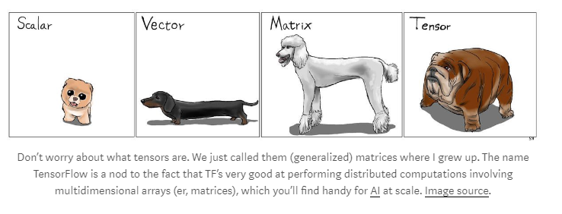

* Google's TensorFlow library is a great choice for building commercial-grade deep learning applications using Python.
* TensorFlow grew out of an earlier Google library called “**DistBelief**”, which is a proprietary deep net library developed as part of the Google Brain project. The project team's vision was to build a system that simplified the deployment of large-scale machine learning models onto a variety of different hardware setups – anything from a smart phone, to single servers, to systems consisting of 100s of machines with 1000s of GPUs. In essence, this library would improve the portability of machine learning so that research models could be more easily applied to commercial-grade applications.
* Much like the Theano library, TensorFlow is based on the concept of a computational graph.
* In a computational graph, nodes represent either persistent data or a math operation, and edges represent the flow of data between nodes. The data that flows through these edges is a multi-dimensional array known as a tensor, hence the library's name, “TensorFlow”.
* The output from one operation or set of operations is then fed as an input into the next. Even though TensorFlow was designed to support neural networks, it can support any domain where computation can be modelled as a data flow graph. TensorFlow also adopts several useful features from Theano such as auto differentiation, shared and symbolic variables, and common sub-expression elimination. And for an open source library, it has comprehensive and informative documentation, in addition to a free massive open online course on Udacity as of March 2016.
* Different types of deep nets can be built using TensorFlow, although there is currently no support for hyper-parameter configuration. TensorFlow has a RoadMap that details some upcoming features, and while hyper-parameter configuration is mentioned, there is no specific timeline for this feature's implementation. For now, TensorFlow users have to work with an additional library called Keras if this flexibility is required. Right now TensorFlow
* has a “no-nonsense” interface for C++, and the team hopes that the community will develop more language interfaces through SWIG, an open-source tool for connecting programs and libraries. Recently, Jason Toy of Somatic announced the release of a SWIG interface to Ruby for the summer of 2016.
* You may have noticed that TensorFlow and Theano are very similar in many ways, but there are a few key differences. When TensorFlow was released in November of 2015, its compile and run times were several orders of magnitude slower than Theano, which was still a reported issue as recent as March 2016.
* The TensorFlow community – both the development team and outside contributors – have worked hard to combat these performance issues. Soumith Chintala of Facebook regularly publishes updates on the performance of different libraries on GitHub; an update in April of 2016 showed that TensorFlow performed reasonably well in the ImageNet category, with no Theano-based libraries listed in the analysis.
* Another improvement over Theano comes in the form of parallelism. As we saw in a prior video, Deeplearning4j supports the training of a machine learning model on a distributed framework through the use of a two-step procedure called Iterative Map-Reduce. The underlying concept, known as data parallelism, is implemented in a recent release known as distributed TensorFlow – v0.8. Data parallelism allows you to train different subsets of the data on different nodes in a cluster for each training pass, followed by parameter averaging and replacement across the cluster.
* v0.8 also implements model parallelism, where different portions of the model are trained on different devices in parallel. For example, you could use model parallelism to train stacked RNNs by deploying each RNN on a different device.
* Even though most Deep Learning Libraries support CUDA, very few support OpenCL, a fast-rising standard for GPU computing. In response to a top community issue currently open on this topic, the TensorFlow team has added OpenCL support to the RoadMap.
* A nice feature is TensorBoard, a visualization tool for network architecture and performance. The tool allows you to zoom in and visualize different levels of the network, as well as view different summary-level metrics and changes over time throughout the training process.
* TensorFlow has achieved significant results in the world of deep learning in a very short amount of time. If this trend continues, it is on track to become the premier library for building deep nets.

Feed forward neural network is also called as MLP(multilayer perceptron). The information flows through the model but there are no feedback connections in which the output of the model are fed back to itself.

**Bidirectional RNN:**

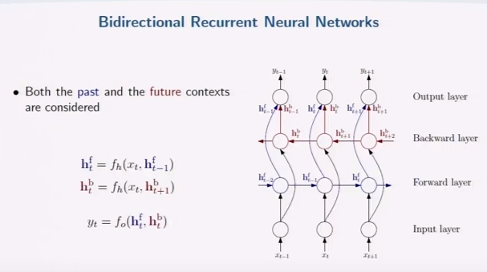

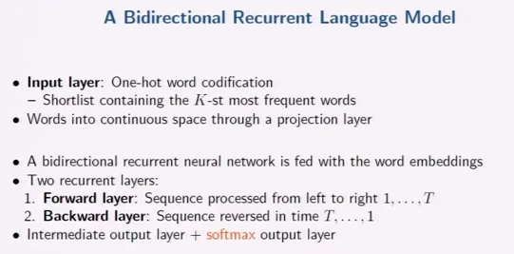

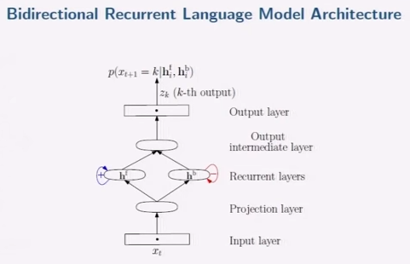

**CHAID: Chi-Square Automatic Interaction Detector.**

CHAID is a tool used to discover the relationship between variables.  CHAID analysis builds a predictive medel, or tree, to help determine how variables best merge to explain the outcome in the given dependent variable. In  CHAID analysis, nominal, ordinal, and continuous data can be used, where continuous predictors are split into categories with approximately equal number of observations.  CHAID creates all possible cross tabulations for each categorical predictor until the best outcome is achieved and no further splitting can be performed.  In the CHAID technique, we can visually see the relationships between the split variables and the associated related factor within the tree.  The development of the decision, or classification tree, starts with identifying the target variable or dependent variable; which would be considered the root.  CHAID analysis splits the target into two or more categories that are called the initial, or parent nodes, and then the nodes are split using statistical algorithms into child nodes. Unlike in regression analysis, the CHAID technique does not require the data to be normally distributed.

**Merging:** In CHAID analysis, if the dependent variable is continuous, the*F*test is used and if the dependent variable is categorical, the [chi-square test](http://www.statisticssolutions.com/academic-solutions/membership-resources/member-profile/conducting-analyses-results/videos/chi-square/) is used.  Each pair of predictor categories are assessed to determine what is least significantly different with respect to the dependent variable.  Due to these steps of merging, a Bonferroni adjusted p-value is calculated for the merged cross tabulation.

**Decision tree components in CHAID analysis:**

In CHAID analysis, the following are the components of the decision tree:

**Root node:** Root node contains the dependent, or target, variable.  For example, CHAID is appropriate if a bank wants to predict the credit card risk based upon information like age, income, number of credit cards, etc.  In this example, credit card risk is the target variable and the remaining factors are the predictor variables.

**Parent’s node:** The algorithm splits the target variable into two or more categories.  These categories are called parent node or initial node.  For the bank example, high, medium and low categories are the parent’s nodes.

**Child node:** Independent variable categories which come below the parent’s categories in the CHAID analysis tree are called the child node.

**Terminal node:** The last categories of the CHAID analysis tree are called the terminal node.  In the CHAID analysis tree, the category that is a major influence on the dependent variable comes first and the less important category comes last.  Thus, it is called the terminal node.

**Bayes Network:**

**Packages:**

**PyMC3 and PyStan**

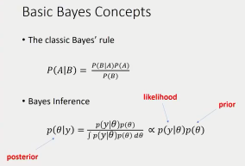

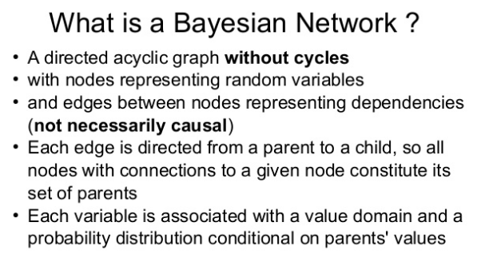

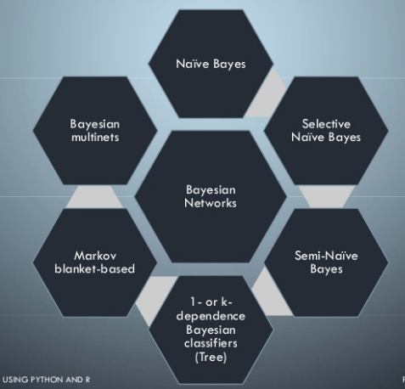

**Word Embeddings:**

Good article link:

<https://www.analyticsvidhya.com/blog/2017/06/word-embeddings-count-word2veec/>

**Neural Networks:**

<https://www.analyticsvidhya.com/blog/2017/05/neural-network-from-scratch-in-python-and-r/>

**Timeseries analysis:**

**strftime (to convert datetime object to string)**

>>> m = datetime(2017,6,7)

>>> m.strftime("%Y-%m-%d")

'2017-06-07'

**strptime (to convert string into datetime object)**

>>> n = "2017-06-07"

>>> datetime.strptime(n,"%Y-%m-%d")

datetime.datetime(2017, 6, 7, 0, 0)

In strptime, we need to give the input format, which would be annoying, instead we can use dateutil.parser.parse

>>> from dateutil.parser import parse

>>> parse("2017/06/07")

datetime.datetime(2017, 6, 7, 0, 0)

>>> parse("Jun 07 2017, 14:30")

datetime.datetime(2017, 6, 7, 14, 30)

>>> parse("07/06/2017", dayfirst= True)

datetime.datetime(2017, 6, 7, 0, 0)

NaT is pandas NA value for timeseries data.

When creating series with index as DatetimeObject, pandas treats it as time series data.

**Checking for index duplication:**

>>> ts

2011-01-07 1.308732

2012-01-07 0.508481

2013-01-07 -1.199164

2013-01-07 -0.878104

dtype: float64

>>> ts.index.is_unique

False

**Anamoly detection Algorithm: package PyOD**

**Ref link: https://www.youtube.com/watch?v=CAvKQHHNmcY**

**Density based approach:**

1. Local Outlier Factor

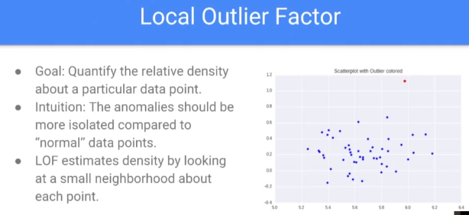

1. K Distance:

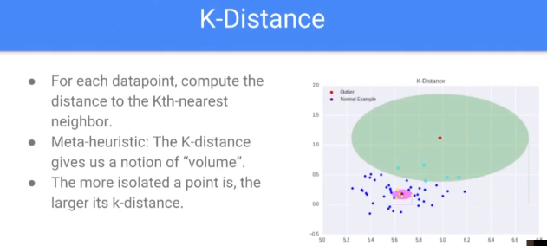

1. Reachability Distance

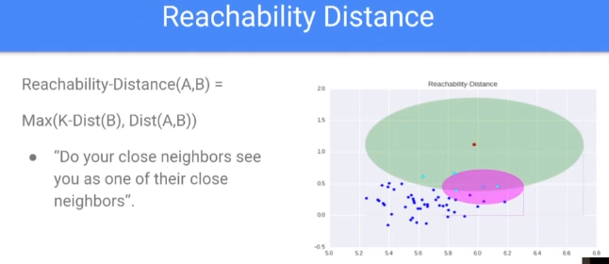

1. Local Reachability Density

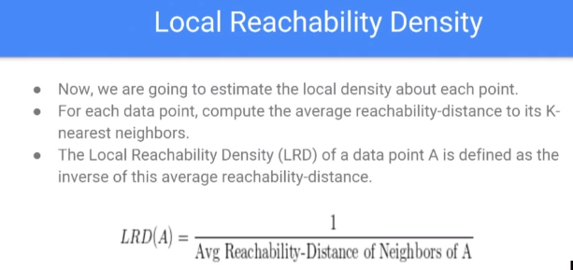

**Time series anomaly detection – Seasonal Hybrid - Extreme Studentized Deviate:**

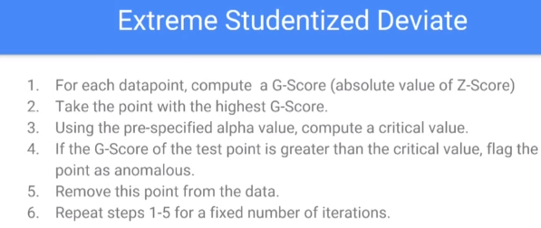

**OneClassCVM:**

SVM is typically associated with supervised learning, but there are extensions ([OneClassCVM,](http://scikit-learn.org/stable/modules/generated/sklearn.svm.OneClassSVM.html) for instance) that can be used to identify anomalies as an unsupervised problems (in which training data are not labeled). The algorithm learns a soft boundary in order to cluster the normal data instances using the training set, and then, using the testing instance, it tunes itself to identify the abnormalities that fall outside the learned region.

**Activation functions or Transfer functions or Threshold functions:**

Activation function is a function which limits the output values or signals to certain finite values.

Activation function can be linear(straight lines or planes) or non-linear(curves). Activation functions used in Neural network are mostly non-linear.

**Types of Activation function:**

1. **Linear function or identity function:**
   1. Output will be equal to input

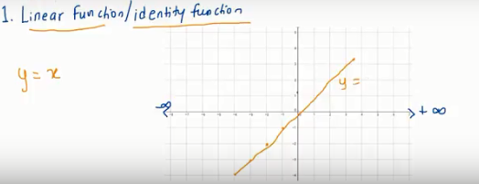

1. Binary step function

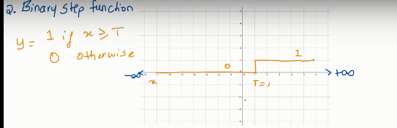

1. Sigmoid or logistic function:

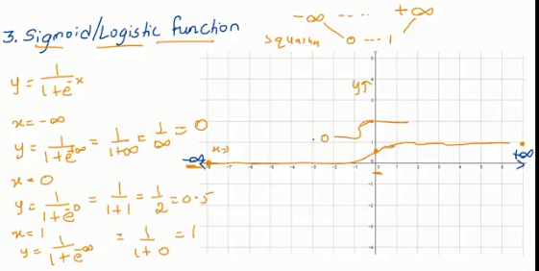

1. Hyperbolic tangent function(tanh(x)):

Similar to sigmoid but ranges from -1 to 1

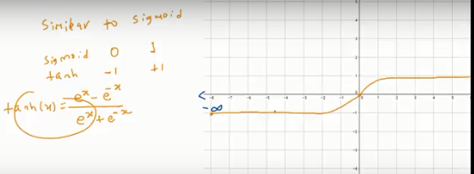

1. Rectified linear units:

Similar to identity function for x>0

Fast for neural network

y=max(0,x)

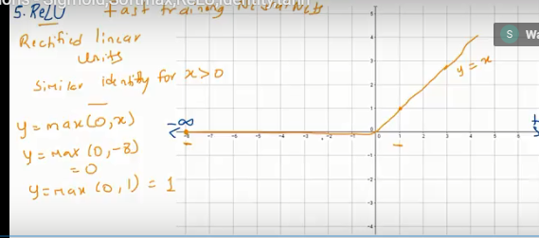

1. **Softmax Classifier or cross entropy loss:**

Softmax converts scores to probabilities

Softmax function is used to force the input values and convert them into output values such that the sum of output values will be equal to

1.

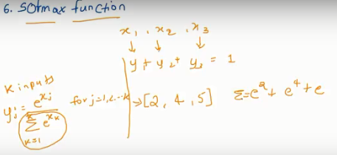

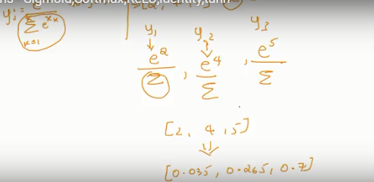

Softmax classifiers give you *probabilities* for each class label while hinge loss gives you the *margin.*

It’s much easier for us as humans to interpret *probabilities* rather than margin scores (such as in hinge loss and squared hinge loss).

**A worked Softmax example**

To demonstrate cross-entropy loss in action, consider the following figure:

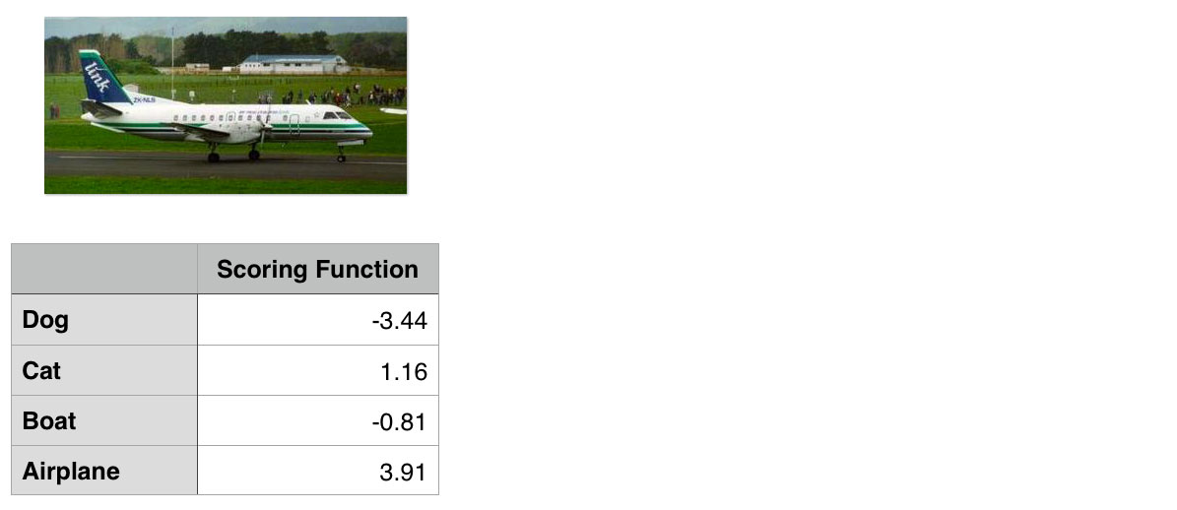

**Figure 1:** To compute our cross-entropy loss, let’s start with the output of our scoring function (the first column).

Our goal is to classify whether the image above contains a dog, cat, boat, or airplane.

Clearly we can see that this image is an “airplane”. But does our Softmax classifier?

To find out, I’ve included the output of our scoring function f for each of the four classes, respectively, in **Figure 1** above. These values are our unnormalized log probabilities for the four classes.

***Note:*** I used a random number generator to obtain these values for this particular example. These values are simply used to demonstrate how the calculations of the Softmax classifier/cross-entropy loss function are performed. In reality, these values would not be randomly generated — they would instead be the output of your scoring function f.

Let’s exponentiate the output of the scoring function, yielding our unnormalized probabilities:

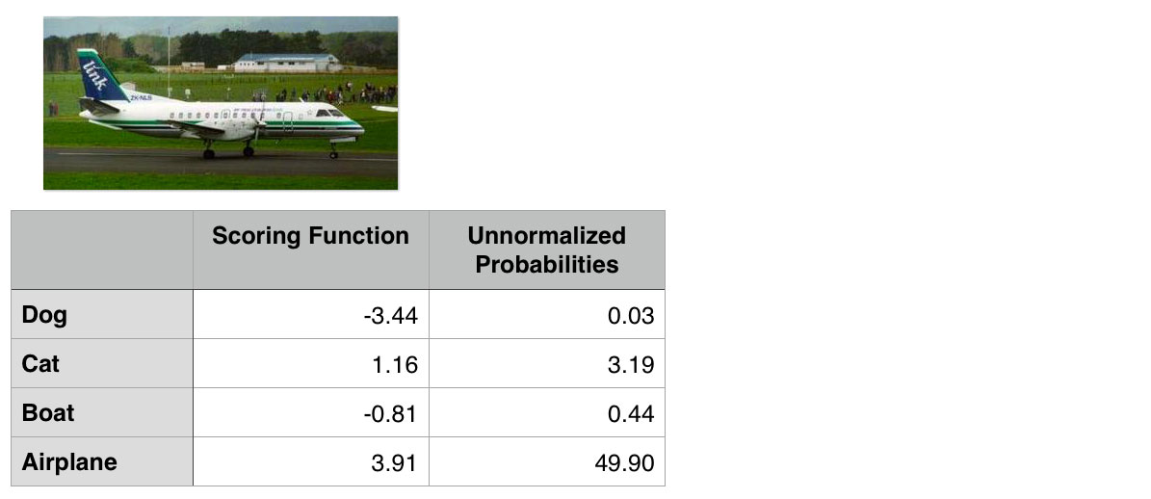

**Figure 2:** Exponentiating the output values from the scoring function gives us our unnormalized probabilities.

The next step is to take the denominator, sum the exponents, and divide by the sum, thereby yielding the actual probabilities associated with each class label:

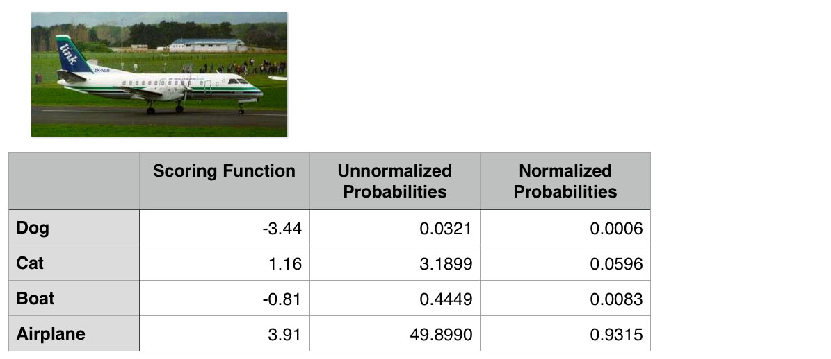

**Figure 3:** To obtain the actual probabilities, we divide each individual unnormalized probability by the sum of unnormalized probabilities.

Finally, we can take the negative log, yielding our final loss:

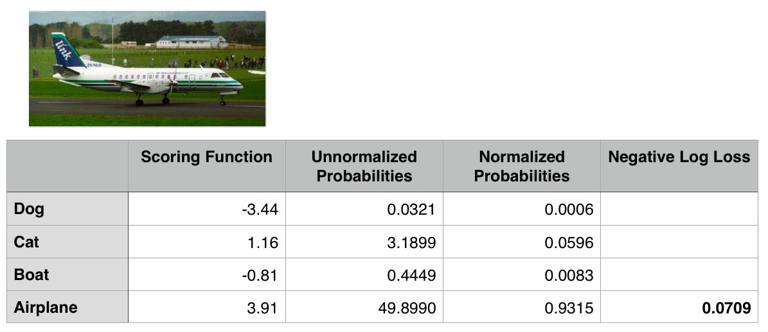

**Figure 4:** Taking the negative log of the probability for the correct ground-truth class yields the final loss for the data point.

In this case, our Softmax classifier would correctly report the image as airplane with 93.15% confidence.

**Normalization techniques:**

**L2 normalization:**

[**http://kawahara.ca/how-to-normalize-vectors-to-unit-norm-in-python/**](http://kawahara.ca/how-to-normalize-vectors-to-unit-norm-in-python/)

each element of the vector will be squared and their sum will be equal to 1 against the axis we apply normalization.

from sklearn import preprocessing

>>> X = np.asarray([[1,2,3],[2,3,4]], dtype=np.float)

>>> X

array([[1., 2., 3.],

[2., 3., 4.]])

>>> Y = preprocessing.normalize(X,norm='l2') 🡪 by default axis = 1 which is rowwise

>>> Y

array([[0.26726124, 0.53452248, 0.80178373],

[0.37139068, 0.55708601, 0.74278135]])

>>> X_Squared = Y**2

>>> X_Squared

array([[0.07142857, 0.28571429, 0.64285714],

[0.13793103, 0.31034483, 0.55172414]])

>>> X_sum_squared = np.sum(X_Squared,axis = 1)

>>> X_sum_squared

array([1., 1.]) 🡪 sum across row is equal to 1 which means the vector is l2 normalized.

**L1 normalization:**

In l1 normalization, just summing across the axis will be equal to 1. Not squaring is required.

>>> Z = preprocessing.normalize(X,norm='l1')

>>> Z

array([[0.16666667, 0.33333333, 0.5 ],

[0.22222222, 0.33333333, 0.44444444]])

>>> np.sum(Z,axis = 1)

array([1., 1.])

**Video series link:**

[**https://www.youtube.com/watch?v=QzhN985hzXQ&list=PLAwxTw4SYaPn_OWPFT9ulXLuQrImzHfOV&index=64**](https://www.youtube.com/watch?v=QzhN985hzXQ&list=PLAwxTw4SYaPn_OWPFT9ulXLuQrImzHfOV&index=64)

**Cross entropy:**

By comparing softmax output and one hot encoding vector on target labels, we will be able to decide how well the model is performing.

Natural way of calculating the distance between 2 probability vectors is called cross entropy.

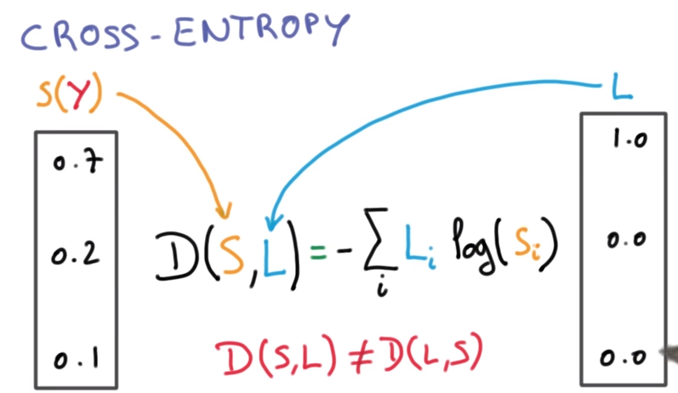

**Multinomial logistic classifier:**

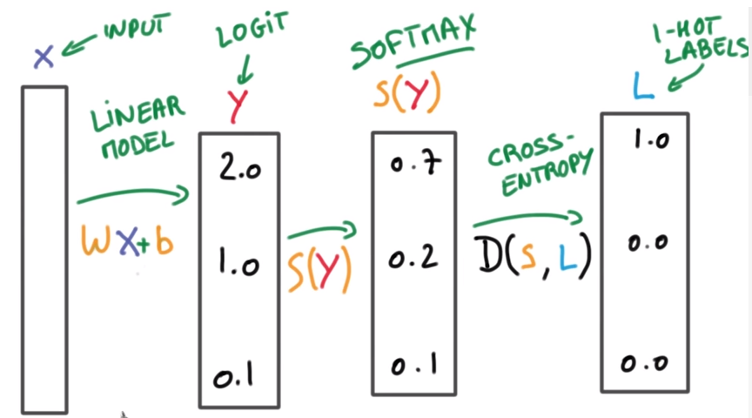

D(S,L) should be low for correct classification and D(S,L) should be high for wrong classification.

Loss will be minimal if the classification is right in most cases.

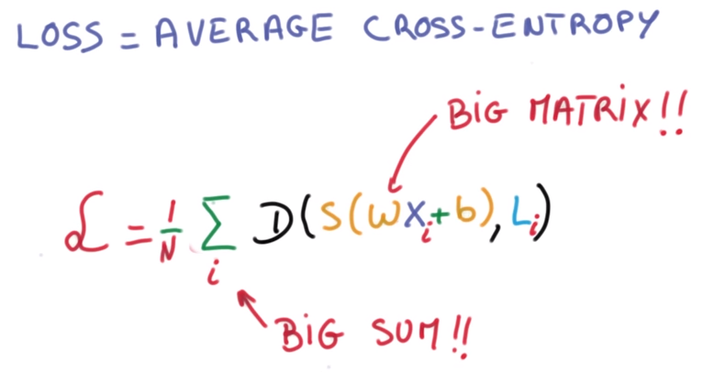

**Training set, Validation set and Testing set:**

* 1. Apply model in training set and check the performance, it will perform well as it will ideally perform well.
  2. Test the model in Validation set. Check the performance and We should tweak the parameters in a way that the model is not memorizing the patterns instead model should generalize the patterns so that it can work well on unseen data.
  3. Finally when the model is finalized, apply it on test set which you have segregated and not seen till this moment to judge the model’s performance.

Models may perform well in validation set but not on test set, it is because, model has learned the way you are trying to tweak parameters to enhance the performance in validation set and thereby it gets the glimpse of validation dataset.

Higher validation set, helps in judging the model better.

In order to have better results on SGD optimization, inputs should be normalized with constant mean and equal variance(small)

Similarly initial weight matrix should be of constant mean and small variance.

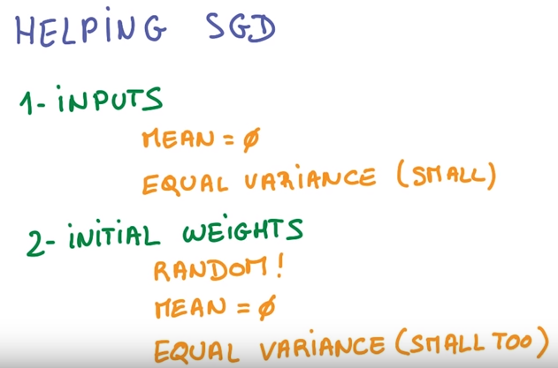

**Momentum and Learning Rate Decay:**

**Momentum:**

In Gradient descent, At each step, we are taking small step in random direction. We can take advantage of knowledge we gained in earlier step about where we should be heading. We can use running average instead of direction of current path, The momentum technique often gives good results.

**Learning Rate:**

How small the step should be.

Lower training rate is better than higher learning rate.

**SGD parameters:**

If things are not working , reduce learning rate as first step

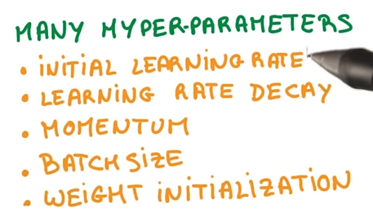

**Adagrad:**

Adagrad is modification of SGD. It implicitly does momentum and learning rate decay. Using adagrad often makes learning less sensitive to hyperparameters but often tends to be little worse than SGD with momentum.

**AdaGrad:**

AdaGrad (for adaptive [gradient](https://en.wikipedia.org/wiki/Gradient_descent) algorithm) is a modified stochastic gradient descent with per-parameter learning rate, first published in 2011. Informally, this increases the learning rate for more sparse parameters and decreases the learning rate for less sparse ones. This strategy often improves convergence performance over standard stochastic gradient descent in settings where data is sparse and sparse parameters are more informative. Examples of such applications include natural language processing and image recognition.

**Regularization:**

One of the best ways to avoid overfitting is stopping the training when the performance is no more increasing further in validation set.

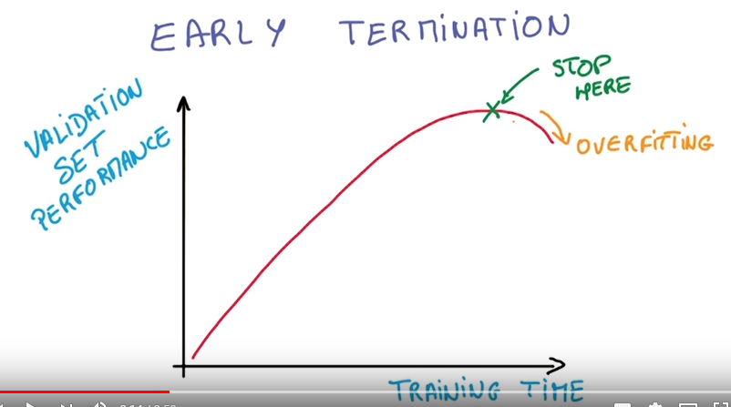

Other option is to use regularization.

Regularizing is Applying artificial constraints on the network that implicitly reduce number of free parameter that making very difficult to optimize.

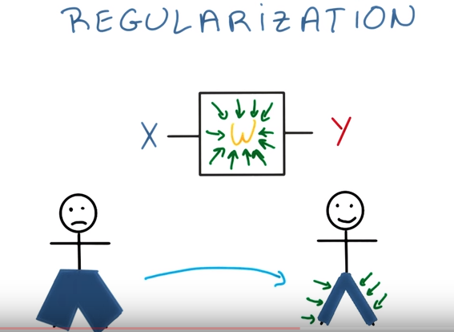

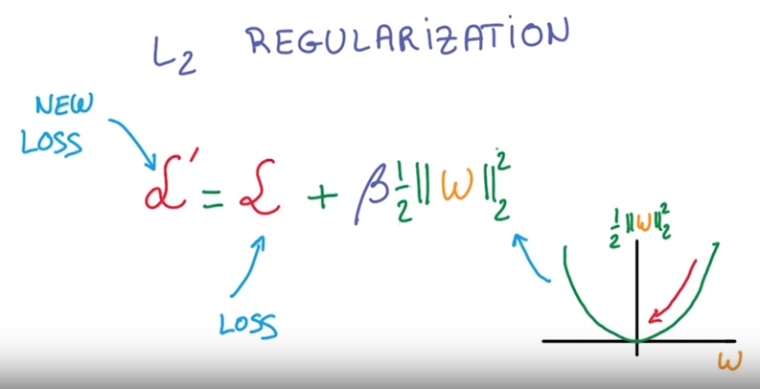

The idea is adding a term to loss which penalizes large weights.

**Dropout:**

Dropout helps protect the model from memorizing or "overfitting" the training data.

Values goes from one layer to next are often called as activations. Now take those activations and randomly for every example you train your network on , set half of them to zero. Completely randomly you basically take half of the data that flowing through your network and just destroy it and then randomly again.

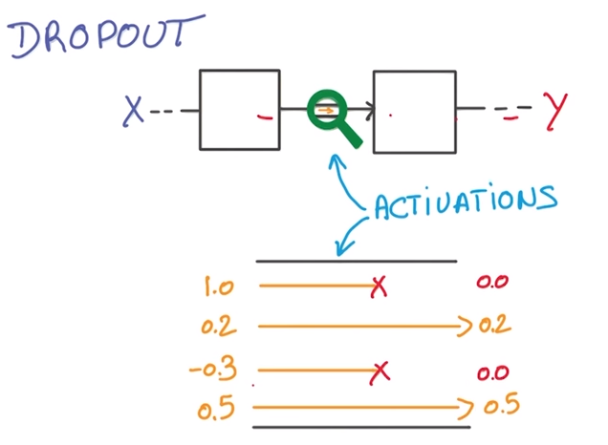

Network is forced to learn a redundant representation for everything to make sure that atleast some of the information remains. Forcing network to learn redundant representation might sound more inefficient. It makes things robust and prevents overfitting. Dropout helps in performance improvement.

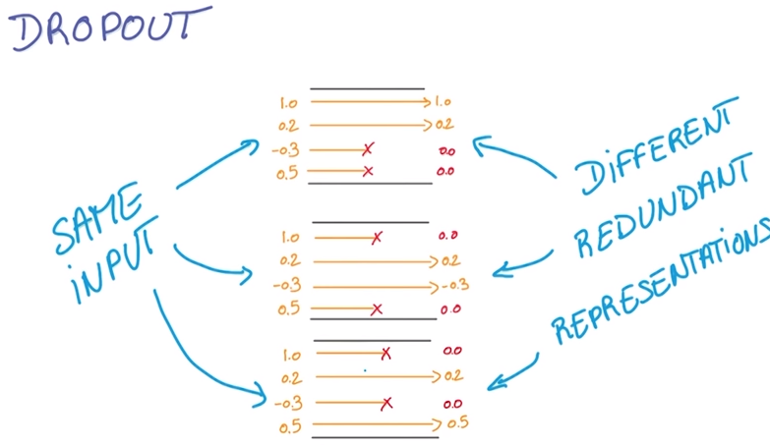

Y€ to be the average of all Y(t). Here is the trick to make sure this expectation holds. During training, not only you zero out the activations to drop out but also you scale the other activations by 2.

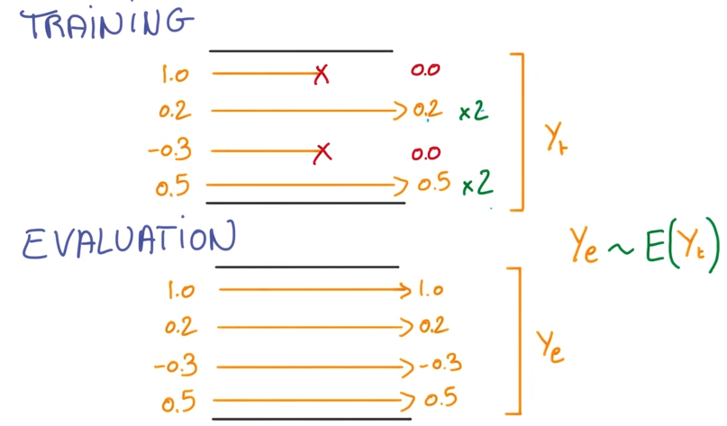

**statistical invariance:**

things that don’t change on average across time and space or everywhere.

**translational invariance:**

Different positions same kitten.

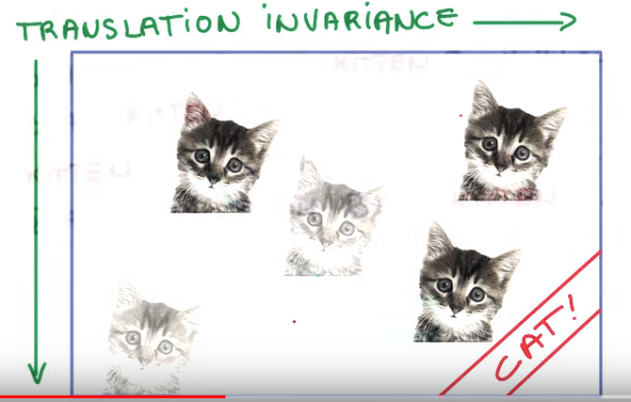

**Weight sharing:**

When you know 2 inputs has same information, then you share their weights and train their weights joinly for input.

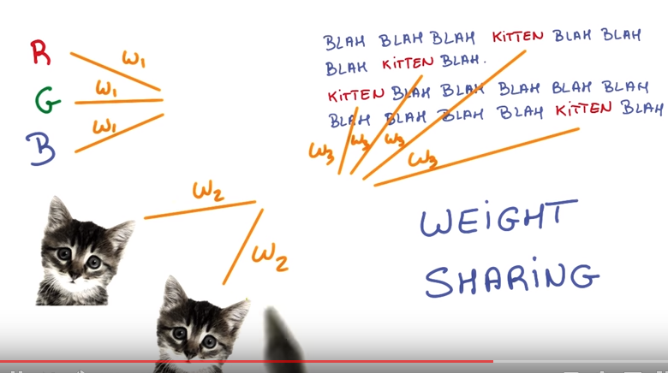

**Convolutional neural nets:**

**Space and depth:**

Special dimension reduces as we move forward while depth increases.

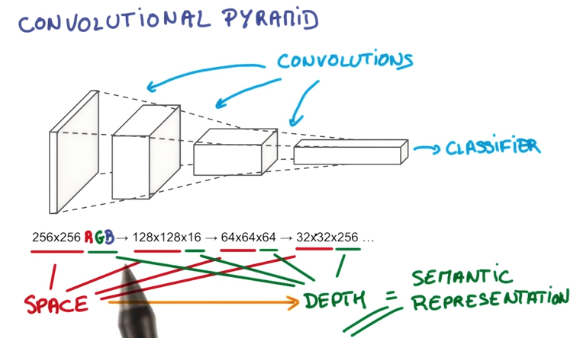

**Stride:**

Number of pixels we are shifting each time you move your filter. If stride is 1, output layer will be roughly same as input. If it is 2 , o/p layer is half the size as input.

**Valid padding:**

In valid padding you don’t go past the edge.

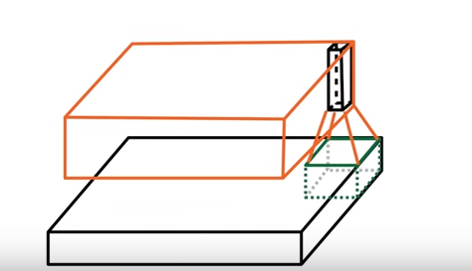

**Same padding:**

You go off the edge and pad with zeros. In this case, output layer will be exactly same as size as input layer.

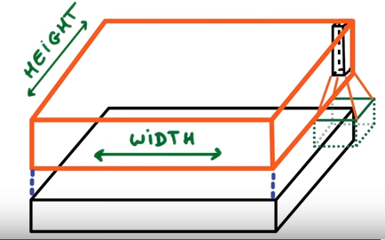

**Pooling:**

Types:

1. Max pooling -> picks the max value in each stride

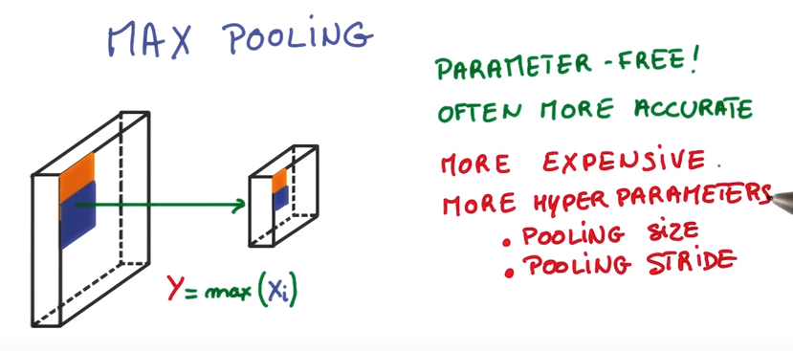

1. Average pooling -> picks the average value in each stride. It takes a Kernel Size and gives you the Average val, then move by the Stride value.

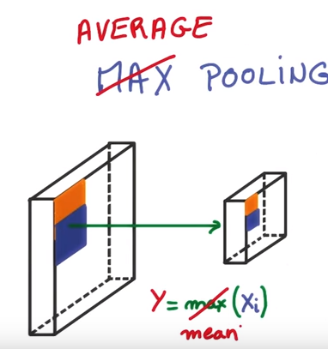

**Global Average Pooling:**

Global Average Pool do, the Kernel size is of dimensions H x W. So, it takes the Global Average across Height and Width and gives you a tensor with dimensions of 1xC for an input of H x W x C

Ref: <https://www.quora.com/What-is-global-average-pooling>

The idea is to generate one feature map for each corresponding category of the classification task in the last mlpconv layer. Instead of adding fully connected layers on top of the feature maps, we take the average of each feature map, and the resulting vector is fed directly into the softmax layer.  One advantage of global average pooling over the fully connected layers is that it is more native to the convolution structure by enforcing correspondences between feature maps and categories. Thus the feature maps can be easily interpreted as categories confidence maps.  Another advantage is that there is no parameter to optimize in the global average pooling thus overfitting is avoided at this layer.  Futhermore, global average pooling sums out the spatial information, thus it is more robust to spatial translations of the input.

We can see global average pooling as a structural regularizer that explicitly enforces feature maps to be confidence maps of concepts (categories).  This is made possible by the mlpconv layers, as they makes better approximation to the confidence maps than GLMs.

In the case of classification with 10 categories (CIFAR10, MNIST).

It means that if you have a 3D 8,8,128 tensor at the end of your last convolution, in the traditional method, you flatten it into a 1D vector of size 8x8x128. And you then add one or several fully connected layers and then at the end, a softmax layer that reduces the size to 10 classification categories and applies the softmax operator.

The global average pooling means that you have a 3D 8,8,10 tensor and compute the average over the 8,8 slices, you end up with a 3D tensor of shape 1,1,10 that you reshape into a 1D vector of shape 10. And then you add a softmax operator without any operation in between. The tensor before the average pooling is supposed to have as many channels as your model has classification categories.

**1*1 convolution:**

Very inexpensive as it is just matrix multiplication. It converts the network to deep.

**Inception Module:**

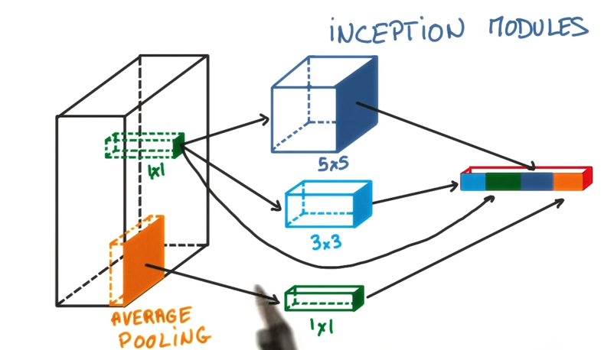

The idea is that at each layer of your conv net you can make a choice, we can have pooling or convolution layer(1*1,3*3,5*5). All these are beneficial to the network. So why choose, lets use all. Instead of having single convolution, we have composition of avg pooling followed by 1*1, then 1*1, then 1*1 followed by 3*3, 1*1 followed by 5*5. You can choose these parameters in such a way that total number of parameters in your model is small.

**Word2vec:**

It’s better to use cosine similarity to measure the closeness between words than l2

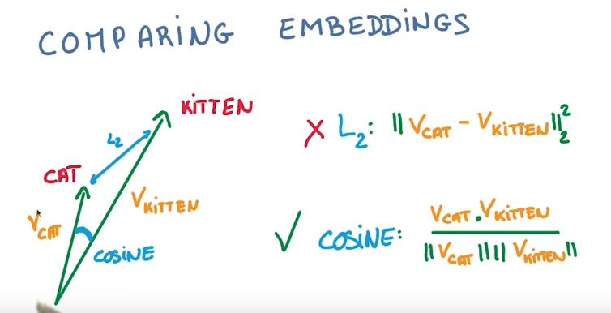

**Semantic analogy and syntactic analogy:**

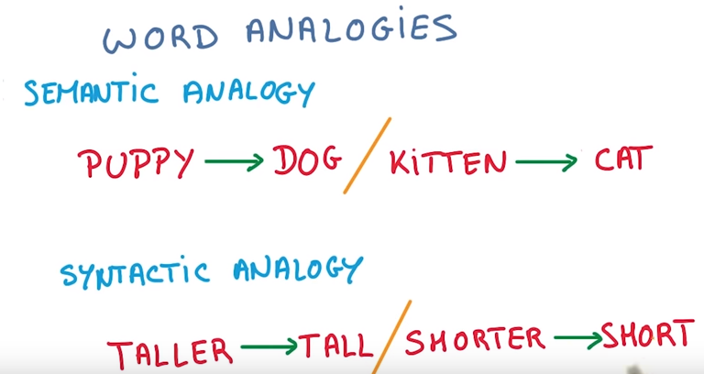

**Exploding and vanishing gradient:**

Exploding gradient:

Gradients grow very quickly and reach infinity. Solution is gradient clipping.

Vanishing gradient:

Gradients grow very slowly and you end up not learning anything. LSTM is the solution

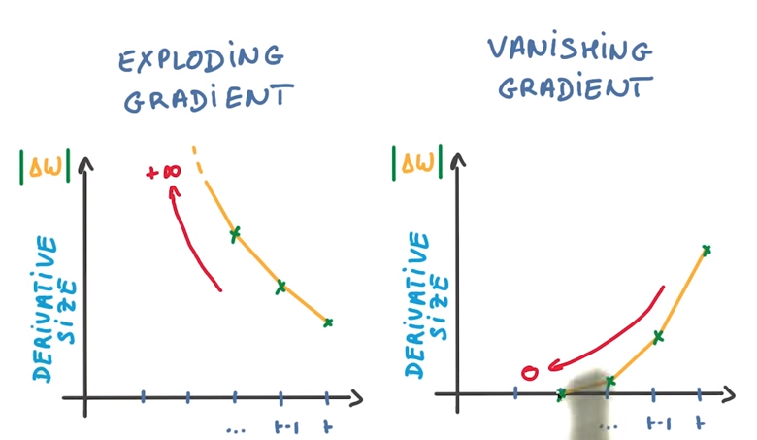

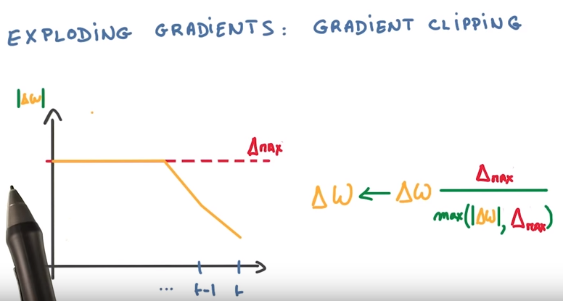

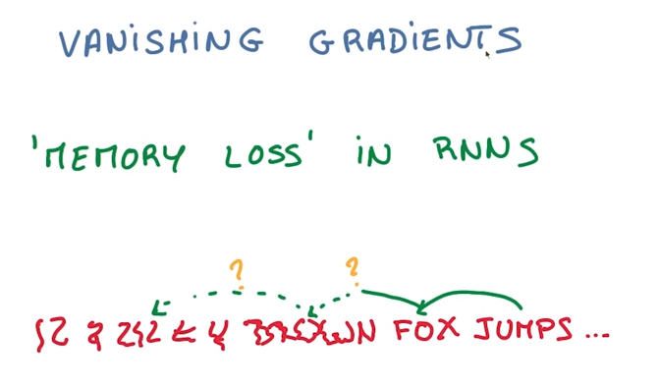

**LSTM:**

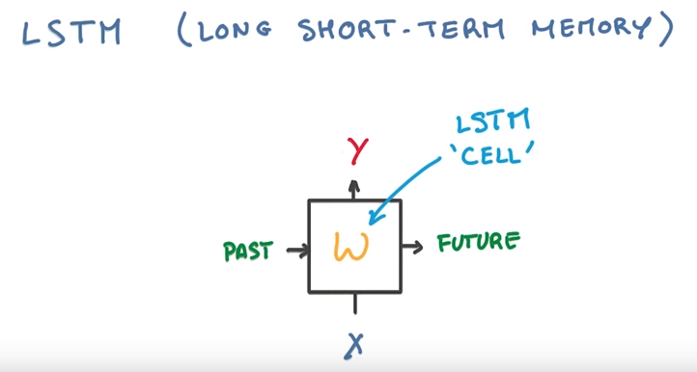

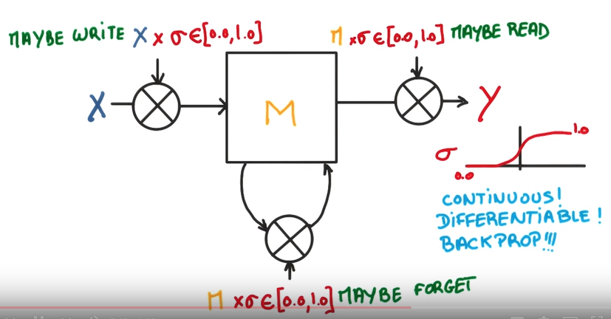

**Keras:**

**Steps:**

1. Model creation
2. Model compilation 🡺 specify loss, optimize, score
3. Model fit 🡺 fit on training data, epoch, batchsize, verbose
4. Model predict , model.predict_classes🡺 fit on test data.
5. Model evaluate 🡪 evaluate the result against test labels and returns score(loss and accuracy by default)

Keras expects labels to be in numpy array format. *Other features also in numpy array format.(doubt)*

Difference between model.predict() and model.predict_classes() 🡺 model.predict() gives the probabilities of each classes. Model.predict_classes() provides the rounded values. i.e the class details like either it is 1 or 0 classes.

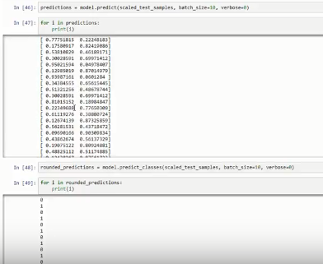

Keras examples

[**https://github.com/keras-team/keras/tree/master/examples**](https://github.com/keras-team/keras/tree/master/examples)

Keras tutorials:

[**https://github.com/fchollet/keras-resources**](https://github.com/fchollet/keras-resources)

Keras codes:

<https://ustczen.gitbooks.io/keras/content/callbacks.html>

# Import `Sequential` from `keras.models

from keras.models import Sequential

# Import `Dense` from `keras.layers`

from keras.layers import Dense

# Initialize the constructor

model = Sequential()

# Add an input layer

model.add(Dense(12, activation='relu', input_shape=(11,)))

# Add one hidden layer

model.add(Dense(8, activation='relu'))

# Add an output layer

model.add(Dense(1, activation='sigmoid'))

# Model output shape

model.output_shape

# Model summary

model.summary()

# Model config

model.get_config()

# List all weight tensors

model.get_weights()

#To view the optimizer

model.optimizer

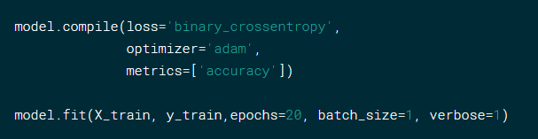

[**https://www.kaggle.com/dansbecker/a-deeper-understanding-of-deep-learning**](https://www.kaggle.com/dansbecker/a-deeper-understanding-of-deep-learning)

Changing weights would change predictions so good weight indicates good predictions. 3 factors determine weights.

* 1. Loss function – if predictions are good, then loss will be less.
  2. Optimizer –like SGD, we need to choose optimizer which can give low loss value. In SGD, you look at the data to see which way we can change the weights to have little loss value.
  3. Back propagation – is process of determining by which way to change the weight at each step of gradient decent.

Batchsize – number of samples taken to decide next step.

Learning rate – low learning rate means model takes long time training before it gets accurate. Optimizer =’adam’ automatically identifies best learning rate throughout the gradient descent process.

In compiling, you configure the model with the adam optimizer and the binary_crossentropyloss function. Additionally, you can also monitor the accuracy during the training by passing ['accuracy'] to the metrics argument.

The optimizer and the loss are two arguments that are required if you want to compile the model. Some of the most popular optimization algorithms used are the Stochastic Gradient Descent (SGD), ADAM and RMSprop. Depending on whichever algorithm you choose, you’ll need to tune certain parameters, such as learning rate or momentum. The choice for a loss function depends on the task that you have at hand: for example, for a regression problem, you’ll usually use the Mean Squared Error (MSE). As you see in this example, you used binary_crossentropy for the binary classification problem of determining whether a wine is red or white. Lastly, with multi-class classification, you’ll make use of categorical_crossentropy.

After, you can train the model for 20 epochs or iterations over all the samples in X_train and y_train, in batches of 1 sample. You can also specify the verbose argument. By setting it to 1, you indicate that you want to see progress bar logging.

verbose: Integer. 0, 1, or 2. Verbosity mode. 0 = silent, 1 = progress bar, 2 = one line per epoch.

In other words, you have to train the model for a specified number of epochs or exposures to the training dataset. An epoch is a single pass through the entire training set, followed by testing of the verification set. The batch size that you specify in the code above defines the number of samples that going to be propagated through the network. Also, by doing this, you optimize the efficiency because you make sure that you don’t load too many input patterns into memory at the same time.

**Crossentropy:**

The cross-entropy is a measure of how different your predicted distribution is from the target distribution.

**Epoch:**

Training neural networks often involves the concept of "minibatching", which means showing the network a subset of the data, adjusting the weights, and then showing it another subset of the data. When the network has seen all the data once, that's called an "epoch".

If epoch increases, idealy in a perfect world one would expect the test accuracy to increase. If the test accuracy starts to decrease it might be that your network is overfitting. You might want to stop the learning just before you reach that point or take other steps to counter the overfitting problem.

Also, it could be a result of noise in the test dataset, i.e. wrongly labeled example

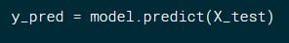

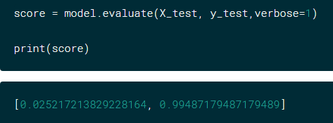 🡺loss and accuracy

**Constraints layer:**

**maxnorm(m):**

if the L2-Norm of your weights exceeds m, scale your whole weight matrix by a factor that reduces the norm to m.

Aditionally, maxnorm has an axis argument, along which the norm is calculated. In your example you don't specify an axis, thus the norm is calculated over the whole weight matrix. If for example, you want to constrain the norm of every convolutional filter, assuming that you are using tfdimension ordering, the weight matrix will have the shape (rows, cols, input_depth, output_depth). Calculating the norm over axis = [0, 1, 2] will constrain each filter to the given norm.

**Why to do it?**

Constraining the weight matrix directly is another kind of regularization. If you use a simple L2 regularization term you penalize high weights with your loss function. With this constraint, you regularize directly. As also linked in the keras code, this seems to work especially well in combination with a dropoutlayer.

**Max norm constraints.** Another form of regularization is to enforce an absolute upper bound on the magnitude of the weight vector for every neuron and use projected gradient descent to enforce the constraint. In practice, this corresponds to performing the parameter update as normal, and then enforcing the constraint by clamping the weight vector w⃗ of every neuron to satisfy ∥w⃗ ∥2<c. Typical values of c are on orders of 3 or 4. Some people report improvements when using this form of regularization. One of its appealing properties is that network cannot “explode” even when the learning rates are set too high because the updates are always bounded.

**NLTK:**

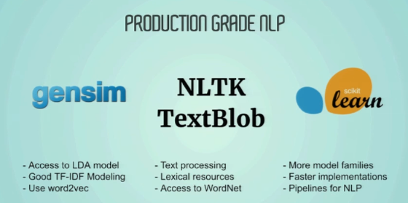

If we want to perform supervised learning like classification, then scikit learn should be used.

If we want to do unsupervised learning like topic modelling, then gensim.

**>>>import** nltk  
*#nltk.download() 🡪 downloads all nltk directories, we need to choose ‘books’ to be specific etc.***>>>for** i **in** dir(nltk.corpus): *# lists all directories in nltk.corpus* print(i)

o/p:

_LazyModule__lazymodule_globals

_LazyModule__lazymodule_import

_LazyModule__lazymodule_init

_LazyModule__lazymodule_loaded

_LazyModule__lazymodule_locals

_LazyModule__lazymodule_name

__class__

__delattr__

…

…

>>>print(nltk.corpus.gutenberg.fileids()) *# lists all gutenberg books which are available for public domain*

o/p:

['austen-emma.txt', 'austen-persuasion.txt', 'austen-sense.txt', 'bible-kjv.txt', 'blake-poems.txt', 'bryant-stories.txt', 'burgess-busterbrown.txt', 'carroll-alice.txt', 'chesterton-ball.txt', 'chesterton-brown.txt', 'chesterton-thursday.txt', 'edgeworth-parents.txt', 'melville-moby_dick.txt', 'milton-paradise.txt', 'shakespeare-caesar.txt', 'shakespeare-hamlet.txt', 'shakespeare-macbeth.txt', 'whitman-leaves.txt'] *#print(nltk.corpus.shakespeare.fileids()) # lists all shakespeare's plays, provided nltk.download('shakespeare') is done  
  
#text.Text class is a wrapper around the sequence of simple (string) tokens.*>>>hamlet = nltk.text.Text(nltk.corpus.gutenberg.words(**'shakespeare-hamlet.txt'**))  
>>>print(hamlet)  
o/p:

<Text: The Tragedie of Hamlet by William Shakespeare 1599>

***#concordance()*** *-> performs search for a token and returns surrounding context*>>>hamlet.concordance(**"queen"**,55,lines = 5) 🡪 displays totally 55 characters and 5 lines

o/p:

am too much i ' th ' Sun Queen . Good Hamlet cast thy n

. I Madam , it is common Queen . If it be ; Why seemes

presently . Exit King & Queen . Oh giue me leaue . How

o , had seen the inobled Queen Ham . The inobled Queene

me they are strong . The Queen his Mother , Liues almose inobled Queen Ham . The

ong . The Queen his Mothe

**Similar():**

Identifies similar words, words that appear mostly in same context.

>>>hamlet.similar(**"marriage"**)

o/p:

that it t heauen time together forme greefe funerall clouds loue eare

thewes paris faculty reputation wrath

**common_contexts():**

gives trigram, in below case a king that, a father tha, my king that, my father and

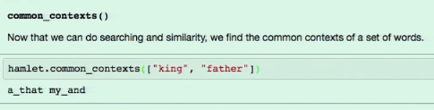

**Dispersion plot:** view the dispersion of words in the corpus.

>>>inaugural = nltk.text.Text(nltk.corpus.inaugural.words())  
>>>inaugural.dispersion_plot([**"citizen"**,**"democracy"**,**"freedom"**])

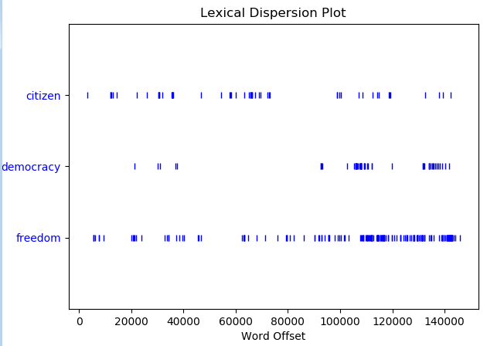

**import** string  
print(string.punctuation)

o/p:

!"#$%&'()*+,-./:;<=>?@[\]^_`{|}~

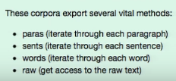

Brown corpus is the first million words corpus in 1956

>>> corpus = nltk.corpus.brown

>>>print(corpus.paras())

o/p:

[[['The', 'Fulton', 'County', 'Grand', 'Jury', 'said', 'Friday', 'an', 'investigation', 'of', "Atlanta's", 'recent', 'primary', 'election', 'produced', '``', 'no', 'evidence', "''", 'that', 'any', 'irregularities', 'took', 'place', '.']], [['The', 'jury', 'further', 'said', 'in', 'term-end', 'presentments', 'that', 'the', 'City', 'Executive', 'Committee', ',', 'which', 'had', 'over-all', 'charge', 'of', 'the', 'election', ',', '``', 'deserves', 'the', 'praise', 'and', 'thanks', 'of', 'the', 'City', 'of', 'Atlanta', "''", 'for', 'the', 'manner', 'in', 'which', 'the', 'election', 'was', 'conducted', '.']], ...] 🡪 ellipsis is because it’s loaded only first chunk as it is generator.

>>>print(corpus.sents())

o/p: It is just one level down compared to paras.

Basically, sents is collection of words and collection of sents is paras and everything is returned as list.

[['The', 'Fulton', 'County', 'Grand', 'Jury', 'said', 'Friday', 'an', 'investigation', 'of', "Atlanta's", 'recent', 'primary', 'election', 'produced', '``', 'no', 'evidence', "''", 'that', 'any', 'irregularities', 'took', 'place', '.'], ['The', 'jury', 'further', 'said', 'in', 'term-end', 'presentments', 'that', 'the', 'City', 'Executive', 'Committee', ',', 'which', 'had', 'over-all', 'charge', 'of', 'the', 'election', ',', '``', 'deserves', 'the', 'praise', 'and', 'thanks', 'of', 'the', 'City', 'of', 'Atlanta', "''", 'for', 'the', 'manner', 'in', 'which', 'the', 'election', 'was', 'conducted', '.'], ...]

>>>print(corpus.words())

['The', 'Fulton', 'County', 'Grand', 'Jury', 'said', ...]

>>>print(corpus.raw()[:200]) Note: careful! Don’t return all.

The/at Fulton/np-tl County/nn-tl Grand/jj-tl Jury/nn-tl said/vbd Friday/nr an/at investigation/nn of/in Atlanta's/np$ recent/jj primary/nn election/nn produced/vbd ``/`` no/at evidence/nn ''/'' tha

**FreqDist():**

Used to determine the unique tokens and their corresponding counts in dictionary format.

>>>reuters = nltk.corpus.reuters  
>>>counts = nltk.FreqDist(reuters.words())  
>>>vocab = len(counts.keys())  
>>>words = sum(counts.values())  
>>>lexdiv = float(words) / float(vocab)  
>>>print(**"%i, %i , %0.3f"** %(vocab,words, lexdiv))

o/p

41600, 1720901 , 41.368

>>>print(counts.B()) *#Number of bins or unique words/tokens*>>>print(counts.N()) *# total number of tokens*>>>print(counts.most_common(30))

o/p

41600

1720901

[('.', 94687), (',', 72360), ('the', 58251), ('of', 35979), ('to', 34035), ('in', 26478), ('said', 25224), ('and', 25043), ('a', 23492), ('mln', 18037), ('vs', 14120), ('-', 13705), ('for', 12785), ('dlrs', 11730), ("'", 11272), ('The', 10968), ('000', 10277), ('1', 9977), ('s', 9298), ('pct', 9093), ('it', 8842), (';', 8762), ('&', 8698), ('lt', 8694), ('on', 8556), ('from', 7986), ('cts', 7953), ('is', 7580), ('>', 7449), ('that', 7377)]

>>>print(counts.max())

o/p:

.

**hapaxes():**

**hapaxelegomena (words that appear only once in the corpus)**

>>>print(counts.hapaxes()[:20])

o/p:

['RIFT', 'Mounting', 'inflict', 'Move', 'Unofficial', 'Sheen', 'Safe', 'avowed', 'VERMIN', 'EAT', 'vermin', 'kilolitres', 'kl', 'Janunary', 'pineapples', 'Hasrul', 'Paian', 'sawn', 'Goodall', 'Bundey']

**freq():**

frequency of the word in the corpus.

>>>print(counts.freq(**"and"**)*100)

o/p:

1.4552260705293332

**Plotting the frequency:**

**>>>import** matplotlib.pylab **as** plt  
>>>counts.plot(50,cumulative=**False**) # plotting 50 most commonly occurring words frequencies

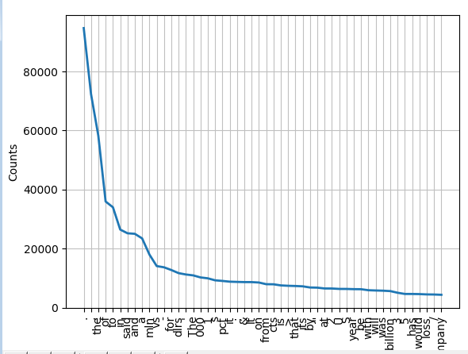

>>>counts.plot(50,cumulative=**True**)

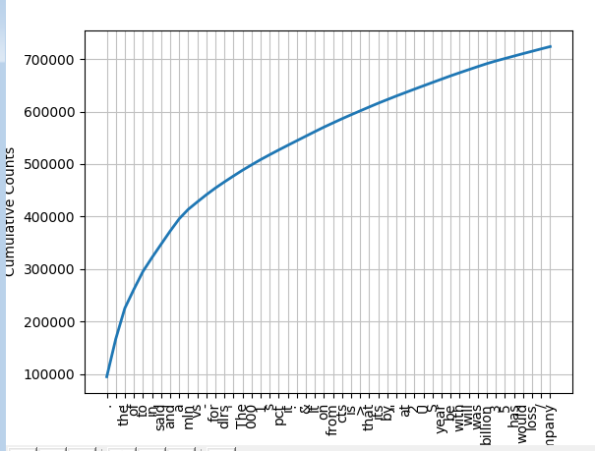

**ConditionalFreqDist():**

Used to perform freq distribution based on some condition. Eg: identifying lexical distribution category wise in corpus.

**Ngram:**

**>>>for** ngram **in n**ltk.ngrams([**'Saranya'**,**'likes'**,**'Data'**,**'Analysis'**,**'concepts'**,**'very'**,**'much'**],5):  
 print(ngram)

o/p:

('Saranya', 'likes', 'Data', 'Analysis', 'concepts')

('likes', 'Data', 'Analysis', 'concepts', 'very')

('Data', 'Analysis', 'concepts', 'very', 'much')

**Pre-Processing Text:**

Working with custom corpus:

CorpusReader:

Text Analytics involves:

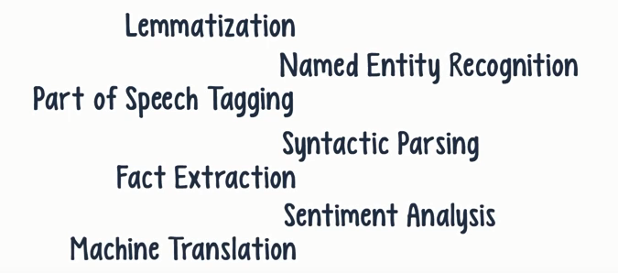

**Language model:**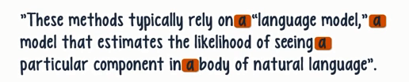

**How to install package in Azure notebooks:**

!conda install gensim –y 🡺 this will install the package.

<https://en.wikipedia.org/wiki/Word2vec>

**Word2vec**is a group of related models that are used to produce [word embeddings](https://en.wikipedia.org/wiki/Word_embedding). These models are shallow, two-layer [neural networks](https://en.wikipedia.org/wiki/Neural_network) that are trained to reconstruct linguistic contexts of words. Word2vec takes as its input a large corpus of text and produces a [vector space](https://en.wikipedia.org/wiki/Vector_space), typically of several hundred [dimensions](https://en.wikipedia.org/wiki/Dimensions), with each unique word in the [corpus](https://en.wikipedia.org/wiki/Corpus_linguistics) being assigned a corresponding vector in the space. [Word vectors](https://en.wikipedia.org/wiki/Word_vectors) are positioned in the vector space such that words that share common contexts in the corpus are located in close proximity to one another in the space

Official link: <https://radimrehurek.com/gensim/models/word2vec.html>

Google pre-training model:

wv = Word2Vec.load_word2vec_format("GoogleNews-vectors-negative300.bin.gz")

**Word Embeddings/word2vec/distributed representation:**

Method of extracting features from text so that we can input features to ML model to work with text data

Word embeddings try to preserve the syntactical information.

Cython should be installed inorder to execute word2vec as parallel processing otherwise it will take days.

**One hot vector**: is the representation where only one bit in a vector is 1

Eg: there are 10,000 words in our corpus, so the vector length will be 10,000 and first bit will be 1 for the first word and rest will all be 0. And so on.

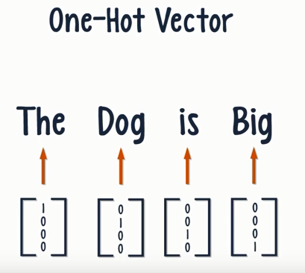

Usually one hot vector will be initialized as word vector and then we take a window size and iterate through the document. When we do that, there are 2 models which come into picture. 1. CBOW (Continuous Bag of words)

2.skip gram

**One hot vector creation:**

def one_hot_encode_object_array(arr):

'''One hot encode a numpy array of objects (e.g. strings)'''

uniques, ids = np.unique(arr, return_inverse=True)

return np_utils.to_categorical(ids, len(uniques))

train_y_ohe = one_hot_encode_object_array(train_y)

test_y_ohe = one_hot_encode_object_array(test_y)

**CBOW:**

We try to fit the neighboring words to the central word. It’s like fill in the blanks.

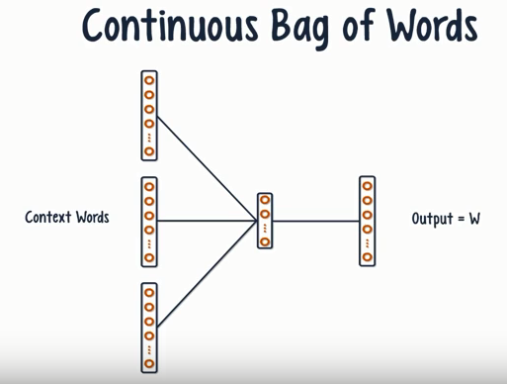

**skipgram:**

Good Ref link: <http://mccormickml.com/2016/04/19/word2vec-tutorial-the-skip-gram-model/>

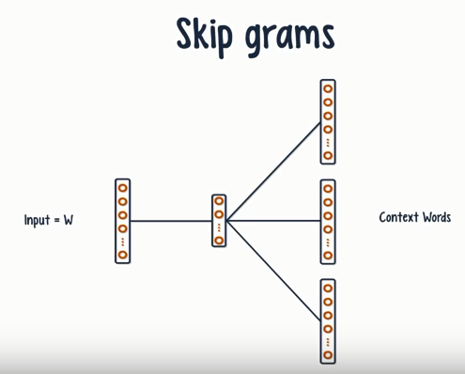

We try to make the central word closer to the neighboring words

In this process, after lot of iterations, we get trained vector of each word which preservers syntactical information.

In word2vec, word vectors which are close in context should appear close to each other. Closeness of the vectors should resemble closeness of the words.

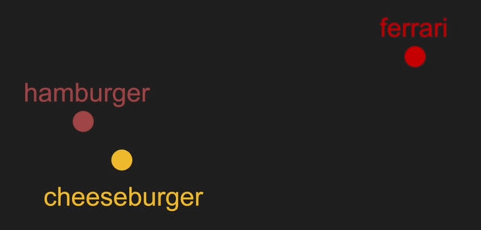

**Simple word2vec neural network:**

Word2vec is the first word embedding algorithm. In between hidden layer is the word embedding

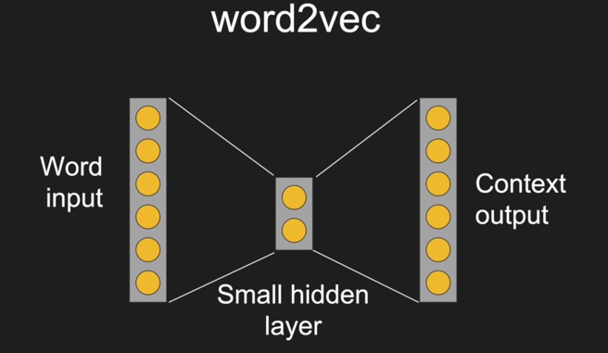

Eg:given a word to word2vec neural net we need to predict the context words.

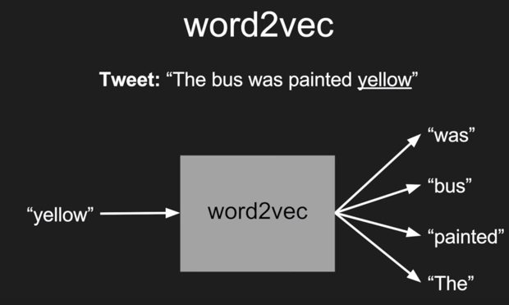

We set 1 for the input neuron in the big corpus and neural net calucaltes the embedding layer with just 64 bit representing the whole information about the input neural and in o/p layer we bring out all the context words as 1 and rest as 0.

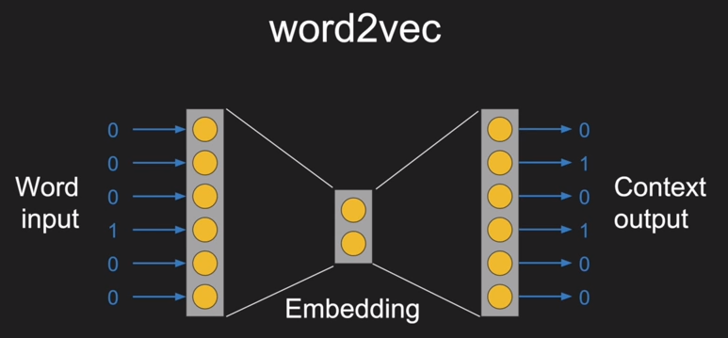

**Why we expect small vector to be meaningful?**

If 2 words have similar context, the embedding vector will be similar. NN will make sure to map all the similar middle embedding vector as under same context.

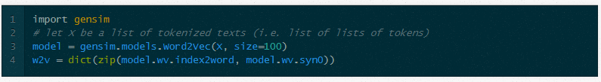**syn0:**

The number of rows in syn0 is the number of words in the model's vocabulary, and the number of columns corresponds to the size of the feature vector, which we set in Part 2

**index2word:**

index2word contains the vocabulary.

# Index2word is a list that contains the names of the words in   
 # the model's vocabulary. Convert it to a set, for speed   
 index2word_set = set(model.index2word)

**Kaggle – word2vec tutorial:**

<https://www.kaggle.com/c/word2vec-nlp-tutorial#part-3-more-fun-with-word-vectors>

**Other methods for word embeddings:**

Majority of other techniques are based on co-occurance matrix.

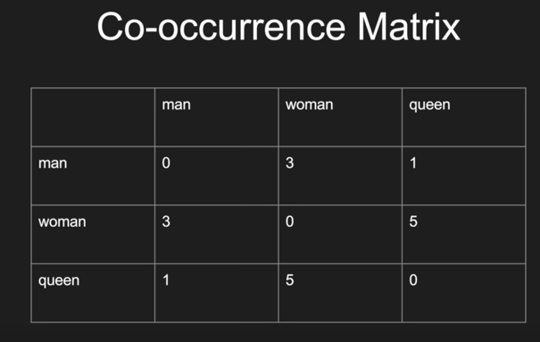

Decomposing big co-occurrence matrix, we compress the information in 2 small matrixes

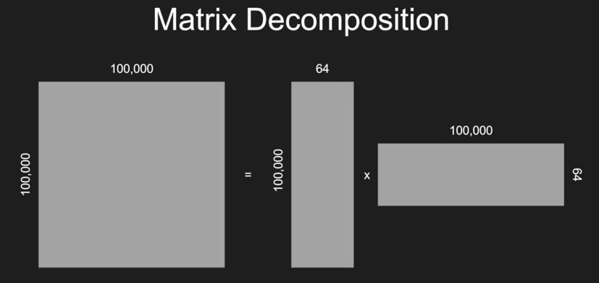

Instead of selecting 100,000 size vector, 64 bit vector represents same word.

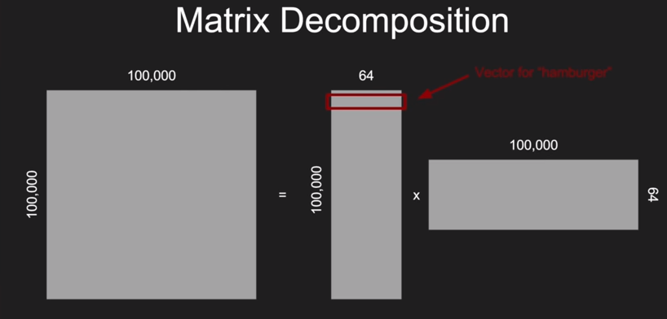

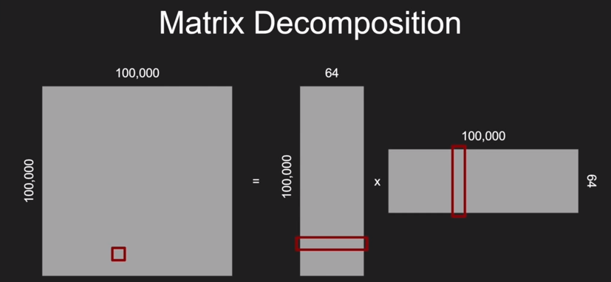

GloVe technique is based on matrix decomposition

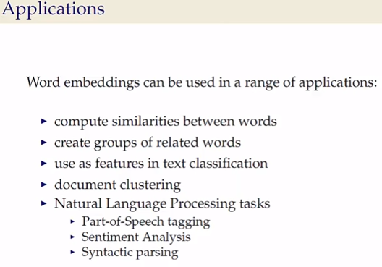

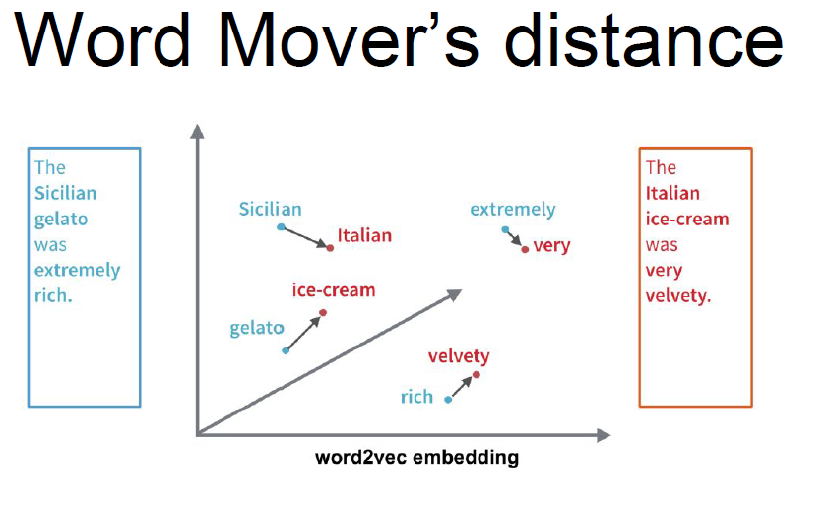

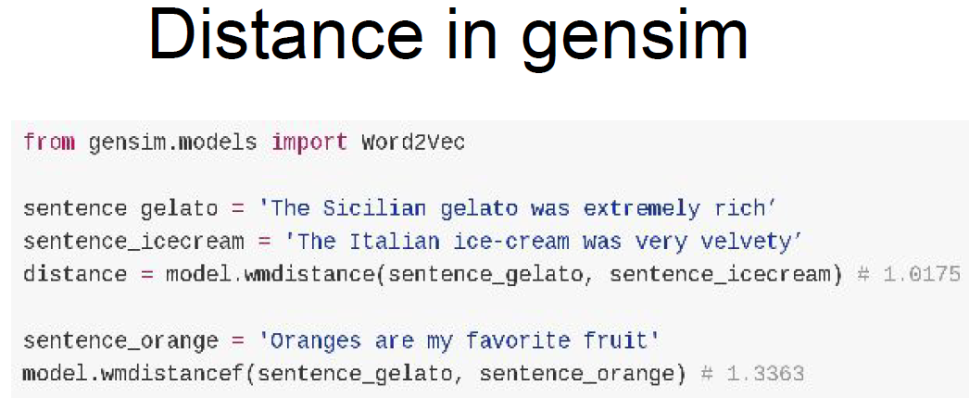

**Subsampling:**

In a nutshell, subsampling is a method of diluting very frequent words, akin to removing stop-words. The subsampling method presented in (Mikolov et al., 2013) randomly removes words that are more frequent than some threshold with a probability of p.  
  
The recommended value for t is t=10^−5

Another (important) implementation detail of subsampling in word2vec is that the random removal of tokens is done before the corpus is processed into word-context pairs (i.e. before word2vec is actually run). This essentially enlarges the context window’s size for many tokens, because  
they can now reach words that were not in their original L-sized windows.  
  
For example, "the quick brown fox jumped over the lazy dog" might be reduced to "quick brown fox jumped lazy dog". In this case, "dog" is now in the 2-word context window of "jumped", even though it was originally 4 tokens away from "jumped".  
  
Subsampling can indeed improve performance for some tasks, while decreasing performance for others; there is no clear-cut rule for when subsampling helps.

**Negative Sampling:**

Training a neural network means taking a training example and adjusting all of the neuron weights slightly so that it predicts that training sample more accurately. In other words, each training sample will tweak *all* of the weights in the neural network.

As we discussed above, the size of our word vocabulary means that our skip-gram neural network has a tremendous number of weights, all of which would be updated slightly by every one of our billions of training samples!

Negative sampling addresses this by having each training sample only modify a small percentage of the weights, rather than all of them. Here’s how it works.

When training the network on the word pair (“fox”, “quick”), recall that the “label” or “correct output” of the network is a one-hot vector. That is, for the output neuron corresponding to “quick” to output a 1, and for *all* of the other thousands of output neurons to output a 0.

With negative sampling, we are instead going to randomly select just a small number of “negative” words (let’s say 5) to update the weights for. (In this context, a “negative” word is one for which we want the network to output a 0 for). We will also still update the weights for our “positive” word (which is the word “quick” in our current example).

The paper says that selecting 5-20 words works well for smaller datasets, and you can get away with only 2-5 words for large datasets.

Recall that the output layer of our model has a weight matrix that’s 300 x 10,000. So we will just be updating the weights for our positive word (“quick”), plus the weights for 5 other words that we want to output 0. That’s a total of 6 output neurons, and 1,800 weight values total. That’s only 0.06% of the 3M weights in the output layer!

In the hidden layer, only the weights for the input word are updated (this is true whether you’re using Negative Sampling or not).

**Hierarchical softmax: helps in improving speed.**

Neural net usually have softmax as output layer which contains the probability that a word belong to a context. It will be contain 1 unit for every input context carrying the probability values for all the input values. It is computationally inefficient.

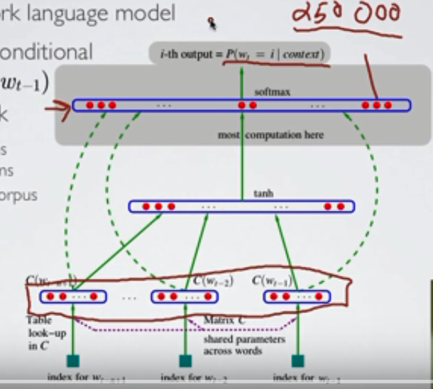

In hierarchical softmax, we decompose probability of observing a word into sequence of probabilities which corresponds to which group the word more likely to belong.

In below screenshot, we need to find probability that the word cat belong to the context. So the hidden layer will connect to the tree of nodes which can lead to the searching word. Probability of cat belonging to the content

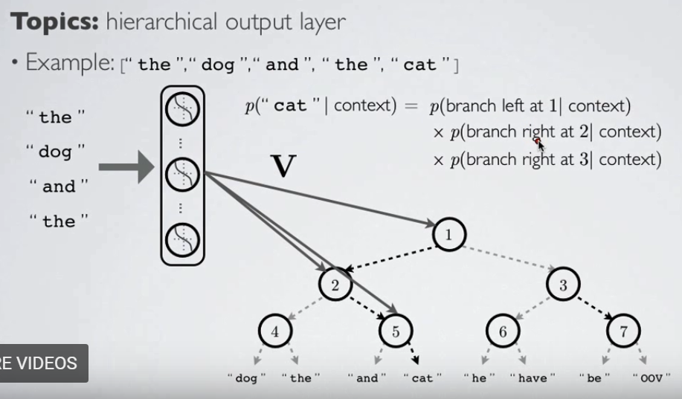

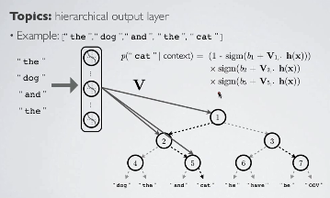

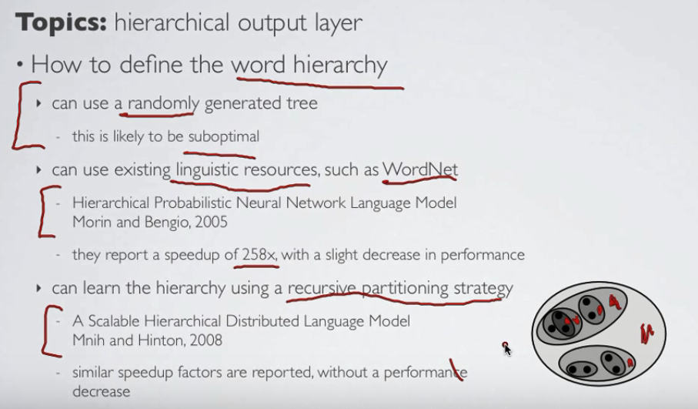

Hierarchical softmax is useful if we want to evaluate probability of few words, if we want full distribution of all words, we won’t get the benefit as we need to get the probability of branching left and right for the whole tree. If we want to predict the next word in a context,then hierarchical softmax helps.

**TSNE:** It is a dimensionality reduction technique**.**

t-distributed Stochastic Neighbor Embedding

t-SNE [1] is a tool to visualize high-dimensional data. Like PCA.

**Different layers:**

1. **Keras Embedding layer:**

This layer can only be used as the first layer in a model.

It has below parameters

* 1. **Initializer** -> initializes the embedding vector with zeros, or ones or with some constant

Initializations define the way to set the initial random weights of Keras layers.

* 1. Regularizer -> Regularizers allow to apply penalties on layer parameters or layer activity during optimization. These penalties are incorporated in the loss function that the network optimizes.

Available penalties:

* + - keras.regularizers.l1(0.)
    - keras.regularizers.l2(0.)
    - keras.regularizers.l1_l2(0.)

Drop out is a regularization technique

* 1. constraint ->Functions from the constraints module allow setting constraints (eg. non-negativity) on network parameters during optimization.

**Other layers:**

Dense, Dropout, Activation, TimeDistributedDense, Flatten, Merge, Reshape

**Difference between Dense and TimeDistributedDense:**

|  |  |
| --- | --- |
| **Dense** | **TimeDistributedDense** |
| Dense layer deal with 2D tensor, and output a 2D tensor | TimeDistributedDense layer deal with 3D tensor, and output a 3D tensor. Time is the 3rd dimension. |
|  |  |

**Difference between Dense and Dropout:**

|  |  |
| --- | --- |
| **Dense** | **TimeDistributedDense** |
| dense layer is simply a layer where each unit or neuron is connected to each neuron in the next layer. | Dropout is a regularization technique, which aims to reduce the complexity of the model with the goal to prevent overfitting. |
| The dense layer is fully connected layer, so all the neurons in a layer are connected to those in a next layer. | Dropout is only applied during training, and you need to rescale the remaining neuron activations. E.g., if you set 50% of the activations in a given layer to zero, you need to scale up the remaining ones by a factor of 2. Finally, if the training has finished, you’d use the complete network for testing (or in other words, you set the dropout probability to 0).  The Dropout method in keras.layers module takes in a float between 0 and 1, which is the fraction of the neurons to drop. |

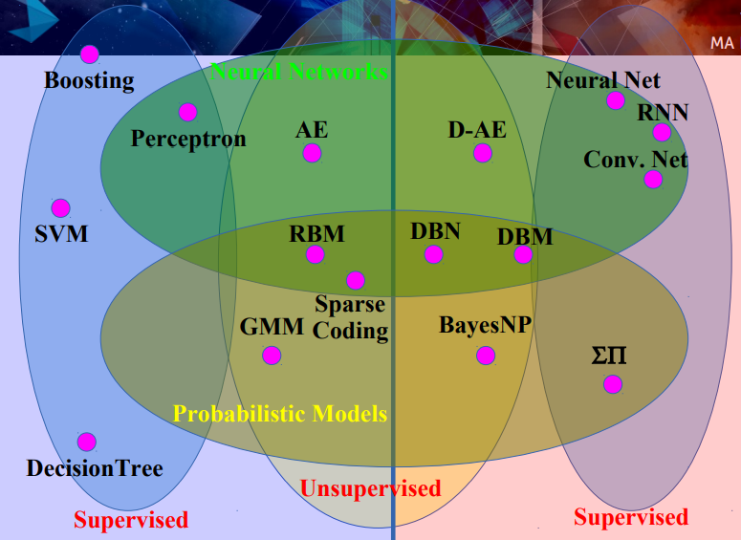

**Glove (global vector for word representation):**

**2 popular word embedding techniques:**

1. **word2vec**
2. **Glove**

**gensim.models.Word2Vec.init_sims:**

Word2Vec.init_sims(*replace=False)*

Precompute L2-normalized vectors.

If *replace* is set, forget the original vectors and only keep the normalized ones = saves lots of memory!

**Note** that you cannot continue training after doing a replace. The model becomes effectively read-only = you can call *most_similar*, *similarity* etc., but not *train*.

**Loading a pre-trained model:**

wv = Word2Vec.load_word2vec_format(“/data/w2v_googlenews/GoogleNews-vectors-negative300.bin.gz",binary=True)

wv.init_sims(replace = True)

**To access the frequency of each word:**

After having called `model.build_vocab` (implicit if you've already built a model -- that calls build_vocab automatically, internally), then

model.vocab['dog'].count

**To access the index of each word:**

model.vocab['dog'].index

**Character Embedding:**

<https://offbit.github.io/how-to-read/>

**part 1 -** [**http://colinmorris.github.io/blog/1b-words-char-embeddings**](http://colinmorris.github.io/blog/1b-words-char-embeddings)

**part 2 -** [**http://colinmorris.github.io/blog/1b-words-filters**](http://colinmorris.github.io/blog/1b-words-filters)

**Doc2vec or paragraph2vev or sentence embeddings:**

Official link:

https://radimrehurek.com/gensim/models/doc2vec.html

simple tutorial:

[**https://medium.com/@mishra.thedeepak/doc2vec-in-a-simple-way-fa80bfe81104**](https://medium.com/@mishra.thedeepak/doc2vec-in-a-simple-way-fa80bfe81104)

notebook tutorial:

[**https://github.com/RaRe-Technologies/gensim/blob/develop/docs/notebooks/doc2vec-IMDB.ipynb**](https://github.com/RaRe-Technologies/gensim/blob/develop/docs/notebooks/doc2vec-IMDB.ipynb)

[**https://rare-technologies.com/doc2vec-tutorial/**](https://rare-technologies.com/doc2vec-tutorial/)

[https://github.com/RaRe-Technologies/movie-plots-by-genre](https://www.google.com/url?q=https%3A%2F%2Fgithub.com%2FRaRe-Technologies%2Fmovie-plots-by-genre&sa=D&sntz=1&usg=AFQjCNEkcjhGqAfY8tr-u-_e84qbnkFR8w)

**Doc2vec:**

The algorithm then runs through the sentences iterator twice: once to build the vocab, and once to train the model on the input data, **learning a vector representation for each word and for each label** in the dataset.

**Paragraph Vector**

Le and Mikolov 2014 introduces the Paragraph Vector, which outperforms more naïve representations of documents such as averaging the Word2vec word vectors of a document. The idea is straightforward: we act as if a paragraph (or document) is just another vector like a word vector, but we will call it a paragraph vector. We determine the embedding of the paragraph in vector space in the same way as words. Our paragraph vector model considers local word order like bag of n-grams, but gives us a denser representation in vector space compared to a sparse, high-dimensional representation.

**Paragraph Vector - Distributed Memory (PV-DM**)

This is the Paragraph Vector model analogous to Continuous-bag-of-words Word2vec. The paragraph vectors are obtained by training a neural network on the fake task of inferring a center word based on context words and a context paragraph. A paragraph is a context for all words in the paragraph, and a word in a paragraph can have that paragraph as a context.

**Paragraph Vector - Distributed Bag of Words (PV-DBOW)**

This is the Paragraph Vector model analogous to Skip-gram Word2vec. The paragraph vectors are obtained by training a neural network on the fake task of predicting a probability distribution of words in a paragraph given a randomly-sampled word from the paragraph.

>>>model.doc2vecs[0] and so on will display the corresponding doc2vec values for each document.

Input to doc2vec model should contain, **words and tags** as namedtuples

# Import libraries

from gensim.models import doc2vec

from collections import namedtuple

# Load data

doc1 = ["This is a sentence", "This is another sentence"]

# Transform data (you can add more data preprocessing steps)

docs = []

analyzedDocument = namedtuple('AnalyzedDocument', 'words tags')

for i, text in enumerate(doc1):

words = text.lower().split()

tags = [i]

docs.append(analyzedDocument(words, tags))

# Train model (set min_count = 1, if you want the model to work with the provided example data set)

model = doc2vec.Doc2Vec(docs, size = 100, window = 300, min_count = 1, workers = 4)

# Get the vectors

model.docvecs[0]

model.docvecs[1]

Doc2Vec is expecting the corpus to be an iterable collection, where each individual item (document) is shaped like a TaggedDocument. (That is, it has a words list and tags list.)

**from** **gensim.models** **import** Doc2Vec

**from** **gensim.models.doc2vec** **import** TaggedDocument

train_tagged = train_data.apply(l**ambda** r: TaggedDocument(words=tokenize_text(r['plot']), tags=[r.tag]), axis=1)

test_tagged = test_data.apply(**lambda** r: TaggedDocument(words=tokenize_text(r['plot']), tags=[r.tag]), axis=1)

test_tagged.values[50]

TaggedDocument(words=['troubled', 'psychologist', 'is', 'sent', 'to', 'investigate', 'the', 'crew', 'of', 'an', 'isolated', 'research', 'station', 'orbiting', 'bizarre', 'planet'], tags=['sci-fi'])

**infer_vector:**

infer_vector(doc_words, alpha=0.1, min_alpha=0.0001, steps=5)

Infer a vector for given post-bulk training document.

|  |  |
| --- | --- |
| Parameters: | **doc_words** – Document should be a list of (word) tokens.  **alpha** (float) – The initial learning rate.  **min_alpha** (float) – Learning rate will linearly drop to min_alpha as training progresses.  **steps** (int) – Number of times to train the new document. |
| Return: | Returns the inferred vector for the new document. |
| Return type | numpy.ndarray |

Eg:

ivec = model.infer_vector(doc_words=tokens_list, steps=20, alpha=0.025)

print(model.most_similar(positive=[ivec], topn=10))

 Larger steps (at least as large as the number of model training iterations, but perhaps even many times larger) is often helpful. Also, a smaller starting alpha, perhaps just the common default for bulk training of 0.025, may give better results.

Your test of whether inference gets a vector close to the same vector from bulk-training is a reasonable sanity-check, on *both* your inference parameters and the earlier training – is the model as a whole learning generalizable patterns in the data? But because most modes of Doc2Vec inherently use randomness, or (during bulk training) can be affected by the randomness introduced by multiple-thread scheduling jitter, you shouldn't expect identical results. They'll just get generally closer, the more training iterations/steps you do.

Finally, note that the most_similar() method on Doc2Vec's docvecs component can also take a raw vector, to give back a list of most-similar already-known vectors.

**Popular algorithms:**

Latent Semantic Analysis(LSA/LSI/SVD), Latent Dirichlet Allocation(LDA), Random Projections(RP), hierarchical Dirichlet Process (HDP) and word2vec Deep Learning

**Hypothesis testing:**

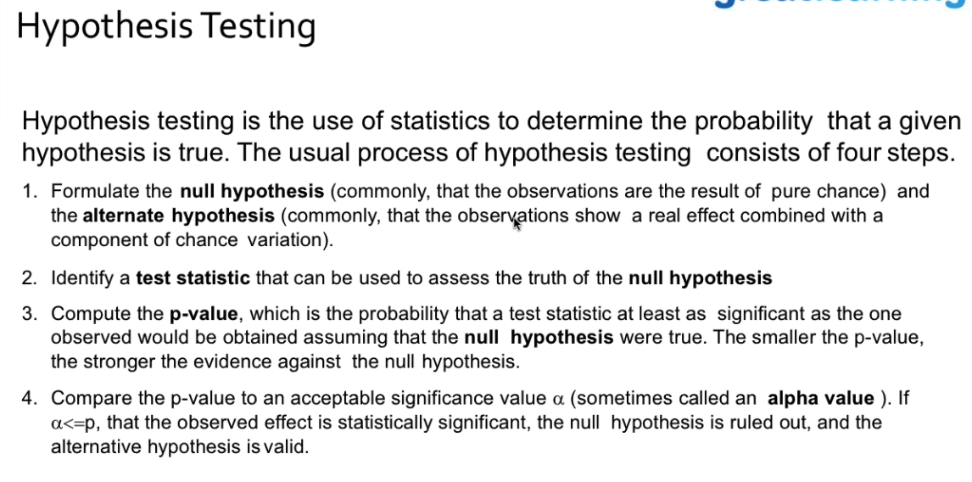

**Sequence 2 Sequence:**

[**https://blog.keras.io/a-ten-minute-introduction-to-sequence-to-sequence-learning-in-keras.html**](https://blog.keras.io/a-ten-minute-introduction-to-sequence-to-sequence-learning-in-keras.html)

Sequence-to-sequence learning (Seq2Seq) is about training models to convert sequences from one domain (e.g. sentences in English) to sequences in another domain (e.g. the same sentences translated to French).

**smart_open:**

What?

=====

``smart_open`` is a Python 2 & Python 3 library for **efficient streaming of very large files** from/to S3, HDFS, WebHDFS, HTTP, or local (compressed) files.

**NLP:**

**CountVectorizer/ Bag of words:**

**CountVectorizer** takes each text, and creates a column for each word that exists on the corpus, and sets the number of times that that word repeats, on the column, for a given text.

>>> from sklearn.feature_extraction.text import CountVectorizer

>>> text = ["This is a wonderful book","This is my son"]

>>> CountVectorizer().fit_transform(text).A

array([[1, 1, 0, 0, 1, 1],

[0, 1, 1, 1, 1, 0]], dtype=int64)

CountVectorizer(analyzer =’word’) 🡪 indicates bag of words

CountVectorizer(analyzer =’char’,ngram_range =([2,5])) 🡪 indicates ngram from CountVectorizer features

**TfidfVectorizer:**

TfidfVectorizer(use_idf=False, normalize=None, ...) is supposed to behave the same as CountVectorizer.

>>> from sklearn.feature_extraction.text import TfidfVectorizer

>>> TfidfVectorizer(use_idf = False).fit_transform(text).A

array([[0.5, 0.5, 0. , 0. , 0.5, 0.5],

[0. , 0.5, 0.5, 0.5, 0.5, 0. ]])

>>> TfidfVectorizer(use_idf = False,norm=None).fit_transform(text).A

array([[1., 1., 0., 0., 1., 1.],

[0., 1., 1., 1., 1., 0.]]) 🡪 Note, o/p is same as CountVectorizer

get_feature_names() on vectorizer will return the features..

eg:

count_vec = CountVectorizer()

TfidfVectorizer(analyzer=’char’,ngram_range=(2,5)) 🡪 trying out ngram from TfidfVectorizer features.

**pad_sequences:**

from Keras.preprocessing.sequence import pad_sequences

sequence.pad_sequences([[1,2,3],[4,5,6,7],[8,9]])

array([[0, 1, 2, 3],

[4, 5, 6, 7],

[0, 0, 8, 9]], dtype=int32)

sequence.pad_sequences([[1,2,3],[4,5,6,7],[8,9]],padding= "post")

array([[1, 2, 3, 0],

[4, 5, 6, 7],

[8, 9, 0, 0]], dtype=int32)

sequence.pad_sequences([[1,2,3],[4,5,6,7],[8,9]],maxlen=5)

array([[0, 0, 1, 2, 3],

[0, 4, 5, 6, 7],

[0, 0, 0, 8, 9]], dtype=int32)

**37 reasons why your neural network is not working properly:**

[**https://blog.slavv.com/37-reasons-why-your-neural-network-is-not-working-4020854bd607**](https://blog.slavv.com/37-reasons-why-your-neural-network-is-not-working-4020854bd607)

**How to save and load keras model for later use:**

>model.save(“name.h5”)

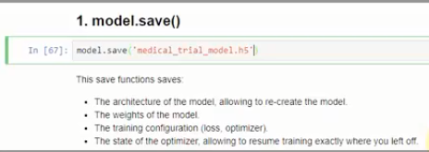

**Loading model.**



**To save just the architecture:**

>json_string = model.to_json()

To load:

>from keras.models import model_from_json

>model_archi = model_from_json(json_string)

>model_archi.summary() # will display the complete model architecture like the layers and their dimensions.

**To save only the weights:**

We can save the weights and then create model explicitly and then load the weights on top of it.

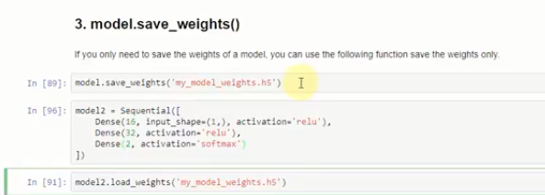

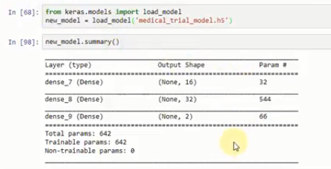

**Keras validation set:**

It’s learning over and over on training features and on each epoch it predicts on validation set. We will see, loss and accuracy of validation set as well in output. Model has not seen the validation data, it uses the learning from training set and generalizes and applies on validation data.

**2 ways to create validation set:**

1. We can hold back validation set and then in fit() function we can give validation_data = (test_X,test_Y)

Eg: model.fit(train_X, train_Y, epochs=4, batch_size=128, verbose=1, validation_data=(test_X, test_Y))

1. We can specify validation_split = 0.1 in fit(). Keras will hold out last 10% of the data as validation data and it does not train on the validation set. It only trains on remaining 90% and applies on validation data.

Eg: model.fit(train_X, train_Y, epochs=4, batch_size=128, verbose=1, validation_split=0.1))

Ideally loss should decrease on each epoch and accuracy should steadily increase. Similarly validation loss and accuracy have steady trend.

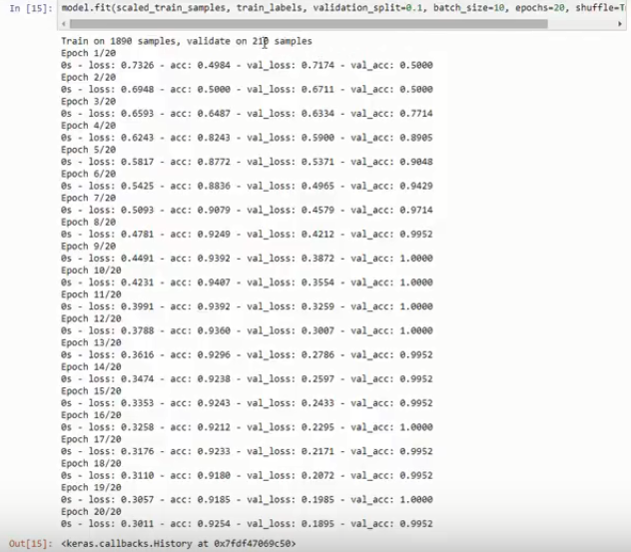

This is best way to check if model is overfitting on training data. In case the model is overfitting, then validation loss and accuracy will not have a same steady trend, like accuracy might start to reduce after certain epoch. It means the model has learnt the training data and not able to generalize on validation data.

Shuffle=True parameter is fit(), indicates, on each epoch the data will be shuffled. Validation data will not be included in shuffling. It will be kept aside.

**How to verify model’s predictions are right:**

**plot_confusion_matrix()**  function is available in scikit-learn website. We can copy over this function from the website and invoke it for our scenario.

This helps in viewing the performance of our prediction.

**Keras Callbacks:**

from keras.callbacks import ModelCheckpoint

<https://machinelearningmastery.com/check-point-deep-learning-models-keras/>

Deep learning models can take hours, days or even weeks to train.

If the run is stopped unexpectedly, you can lose a lot of work.

It is an approach where a snapshot of the state of the system is taken in case of system failure. If there is a problem, not all is lost. The checkpoint may be used directly, or used as the starting point for a new run, picking up where it left off.

The ModelCheckpoint callback class allows you to define where to checkpoint the model weights, how the file should named and under what circumstances to make a checkpoint of the model.

The API allows you to specify which metric to monitor, such as loss or accuracy on the training or validation dataset. You can specify whether to look for an improvement in maximizing or minimizing the score. Finally, the filename that you use to store the weights can include variables like the epoch number or metric.

The ModelCheckpoint can then be passed to the training process when calling the fit() function on the model.

**Note**, you may need to install the [h5py library](http://www.h5py.org/) to output network weights in HDF5 format.

A good use of checkpointing is to output the model weights each time an improvement is observed during training.

**To save the best checkpoint only:**

# checkpoint

filepath="weights.best.hdf5"

checkpoint = ModelCheckpoint(filepath, monitor='val_acc', verbose=1, save_best_only=True, mode='max')

callbacks_list = [checkpoint]

# Fit the model

model.fit(X, Y, validation_split=0.33, epochs=150, batch_size=10, callbacks=callbacks_list, verbose=0)

**To save each instance of checkpoint where validation accuracy increases:**

# checkpoint

filepath="weights-improvement-{epoch:02d}-{val_acc:.2f}.hdf5"

checkpoint = ModelCheckpoint(filepath, monitor='val_acc', verbose=1, save_best_only=True, mode='max')

callbacks_list = [checkpoint]

# Fit the model

model.fit(X, Y, validation_split=0.33, epochs=150, batch_size=10, callbacks=callbacks_list, verbose=0)

**CNN for image classification:**

model.fit is generally used to train the models. In case out dataset is quite large and cannot be fit in memory, we use generator to processes specific batch of samples. model.fit_generator() is used in that case.

In an example,

Batch sizes

In fit, you're using the standard batch size = 32.

In fit_generator, you're using a batch size = 10.

Keras probably runs the weight updates after each batch, so, if you're using batches of different size, there is a chance of getting different gradients between the two methods. And once there a different weight update, both models will never meet again.

Try to use fit with batch_size=10, or use a generator with batch_size=32.

**Difference between steps_per_epoch and epochs:**

model.fit_generator requires the input dataset generator to run infinitely. steps_per_epoch is used to generate the *entire dataset* once by calling the generator steps_per_epoch times where as epochs gives the number of times the model is trained over the *entire dataset*.

steps_per_epoch: Total number of steps (batches of samples) to yield from generator before declaring one epoch finished and starting the next epoch. It should typically be equal to the number of unique samples of your dataset divided by the batch size.

In fit_generator(steps_per_epoch= , epochs = )

In predict_generator(steps = )

**Validation_steps**

[**https://stackoverflow.com/questions/45943675/meaning-of-validation-steps-in-keras-sequential-fit-generator-parameter-list**](https://stackoverflow.com/questions/45943675/meaning-of-validation-steps-in-keras-sequential-fit-generator-parameter-list)

The validation generator works exactly like the training generator. You define how many batches it will wield per epoch.

* The training generator will yield steps_per_epoch batches.
* When the epoch ends, the validation generator will yield validation_steps batches.

**Keras – Loading pre-trained model and finetuning:**

Keras has stored pre-trained model which can be imported and fine tuned.

vgg16 model won imagenet competition in 2014 to classify 1000 categories based on images.

vgg16_model = keras.applications.vgg16.VGG16() 🡺 this will load the model into memory

In Keras, 2 types of models.

1. Sequential
2. Functional API

Sequential model can be converted into functional and viceversa.

>type(model_name)

o/p:

keras.engine.training.model 🡺 this indicates it is functional API model

>type(model_name)

o/p:

keras.models.Sequential 🡺 indicates it is sequential model.

To convert functional API model to sequential:

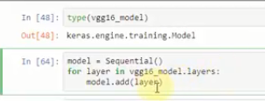

If we want to use vgg16_model to predict cat or dog, we need to pop the last layer where it is classifying 1000 catgories and add a new layer with 2 classes.

>model.layers.pop()

>for layer in model.layers:

layer.trainable = False # to freeze the layers i.e. excluding from future training so weights will not be updated.

>model.add(Dense(2,activation=”softmax”))

>modelsummary() 🡺 will diplay all the layers with last layer as Dense with 2 classes



Now compile and fit_generator():

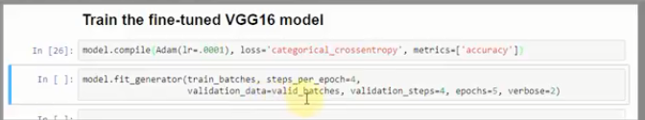

Data Augmentation:

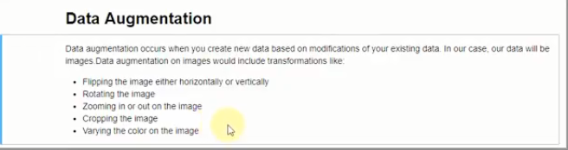

**Why we need:**

1. To make training data larger by augmenting.
2. To reduce overfitting

**Function to plot image within jupyter notebook:**

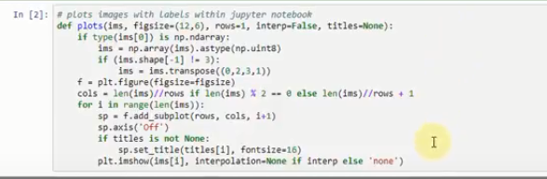

**Data augmentation example:**

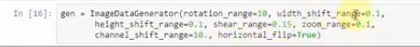

To identify which class denotes which numbering we can use class_indices on any ImageDataGenetor batches:

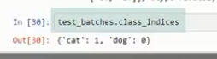 This indicates, cat will be represented as 1 in one hot encoding vector at 1st index. Dog will be represented as 1 in 0th index.

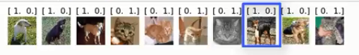

**Reproducible results:**

Since the weights are initialized with random number, at every instance,we will not achieve the same accuracy. In order to reproduce the results, we need to set seed for numpy generated random numbers, python generated random numbers, and tensorflow random numbers.

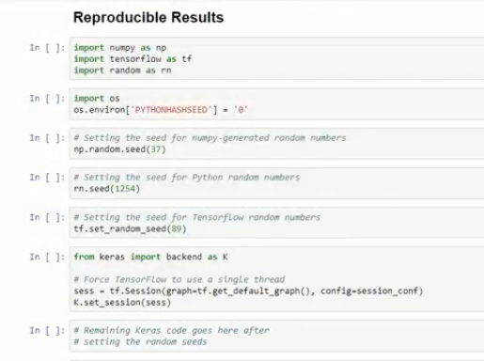

Spyder ide shortcuts:

<https://www.spyder-ide.org/>

To view help = ctrl + i

Integrate jupyter notebook in spyder

conda install -c spyder-ide spyder-notebook

write scientific reports in Markdown

conda install -c spyder-ide spyder-reports

terminal inside spyder

conda install -c spyder-ide spyder-terminal

**conda commands:**

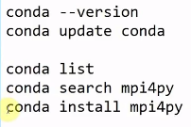

**Open CV: Image processing:**

More generally, type name of a Mat object consists of several parts. Here's example for CV_64FC1:

CV_ - this is just a prefix

64 - number of bits per base matrix element (e.g. pixel value in grayscale image or single color element in BGR image)

F - type of the base element. In this case it's F for float, but can also be S (signed) or U(unsigned)

Cx - number of channels in an image as I outlined earlier.

Edge detection : Sobel

<https://www.cs.auckland.ac.nz/courses/compsci373s1c/PatricesLectures/Edge%20detection-Sobel_2up.pdf>

comparing two images

<https://www.pyimagesearch.com/2014/09/15/python-compare-two-images/>

**Keras Tensorflow backend setup:**

* Python 3.7.1 version is not compatible with Tensorflow. At this moment, it is compatible with Python 3.5 and 3.6 version.
* Created a virtual environment for 3.6 and activated.
  + conda create -n py36 python=3.6
  + activate py36
* Need to install spyder for py36 virtual environment.
  + conda install spyder
  + spyder

This will open spyder with python 3.6 version.

* We need to install keras and tensorflow using below commands in py36 anaconda command prompt using below commands.
  + pip install keras
  + pip install --upgrade tensorflow
* To come out of virtual environment, use below command.
  + deactivate

Difference between loss and cost function:

Loss function is applied to single training example

Cost is cost of defining parameters in training for example, in logistic regression, we try and find the values of parameters w an b that minimizes overall cost function.

**Curvilinear Relationship**

A Curvilinear Relationship is a type of relationship between two variables where as one variable increases, so does the other variable, but only up to a certain point, after which, as one variable continues to increase, the other decreases. If you were to graph this kind of curvilinear relationship, you will come up with an inverted-U. The other type of curvilinear relationship is one where as one variable increases, the other decreases up to a certain point, after which, both variables increase together. This will give you a U-shaped curve.   
  
An example of a curvilinear relationship would be staff cheerfulness and customer satisfaction. The more cheerful a service staff is, the higher the customer satisfaction, but only up to a certain point. When a service staff is too cheerful, it might be perceived by customers as fake or annoying, bringing down their satisfaction level.

**Intent Detection:**

Link <https://developer.kore.ai/docs/bots/concepts/natural-language-processing-nlp-guide/intent-detection/>

Chatbot tasks can be broken down to a few words that describe what a user intends to do, usually a verb and a noun such as Find an ATM, Create an event, Search for an item, Send an alert, and Transfer fund.

The goal of intent recognition isn’t just to match an utterance with a task, it’s to match an utterance with its correctly intended task.

Spyder shortcuts:

* **Single line comment**

Ctrl + 1

* **Multi-line comment** select the lines to be commented

Ctrl + 4

* **Unblock Multi-line comment**

Ctrl + 5

* The shortcut for replace is Ctrl + R.